Profit & Loss Statement (Income statement)
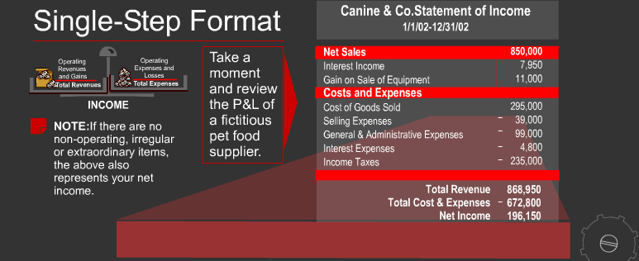
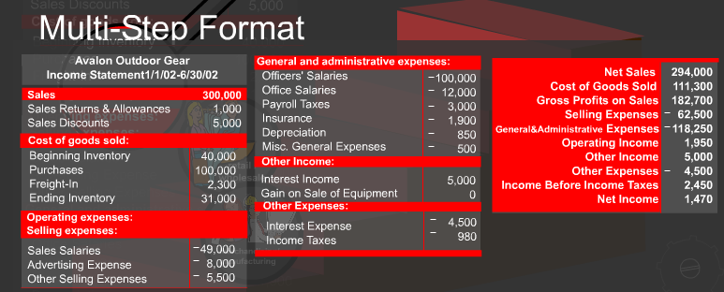
- Net sales - COGS= Gross margin
- Gross margin - selling & Administration expenses= Net operating profit
- Net operating profit + Other income - Other expenses= Net profit before tax
- Net profit before tax – Income tax= Net profit (Or Net loss)

Recognition of revenue & expenses
  - Recognition when Product carried & before cash actually received in Manufacturing, merchandizing & wholesale company: AGN- Invoice issued=Revenue recognized
  - Recognition when paid by customer in service company: IMS- ROH=Income, that is income=payment

