2006. 12. 29
It's Your Fault, Stupid
(aka Oral Leadership)

You should be perfectly led by me. Otherwise, it's your entire fault, stupid. I have become "a world best CEO," and that of Napoleonic style, through 26 years of experience as such. I presented in a great detail to you our Vision, Goals, Strategies, Core Values, and Missions encompassing all the good things in the management world. Accordingly, this should be a world best performing organization in industry. (Right, we could put strategy before mission if we wish!)

This is supposed to be a workplace of "exciting delightness." Otherwise, it's your fault, idiots. I repeatedly ordered you to implement, collectively and individually, "Joyful and Healthy Workplace Program." (Aha! Now I understand why I experience “disgusting delight” every once in a while.)

You should get things decided “damn“ quickly. If not, it’s all your fault, stupid. You know, we are living in an era of speed. I reshuffle the organizational structure on a regular or irregular basis to expedite decision-making. In addition, I put such mechanisms as Routine Audit, CFO, and Executive Meeting in place in order to make the decision-making process more effective.

I can hardly understand why you fools habitually miss deadlines. I keep offering you numerous seminars, workshops, conferences, retreats, programs, courses, and the like, all about how to enhance office productivity.

It's a shame for you guys to drag feet indefinitely with assigned tasks, like in “treating shit.” I would have completed each and every one of them in just three hours. Take "A True World-Class Logistics Hub" road-map for example, those pea brains could not get it done in months, if not weeks. (Who knows Rwandans may wish for a False Hub or even a Mirage Hub? Beware this might be fatal!)

You shouldn’t be sacred of me. Otherwise, it's your fault, stupid. Yes, I do oftentimes bully, intimidate, and even insult executives and senior managers. But when it comes to front-line managers I am so nice and gentle to. Especially I must be lively and lovely to female workers. There is no reason whatsoever why those at rank 4 and below feel uncomfortable with me. Remember I have never yelled directly at them? It couldn’t possibly be my fault, stupid.
You should’ve given me opportunities to commingle with you by say inviting me to your office or having me join departmental gatherings. If not, it is totally your fault, stupid. It’s my management philosophy, so to speak, to keep my mind as well as my door wide-open.

I hardly understand why you misinterpret me more often than not. You see, I’m always straightforward and my sayings are clear-cut and consistent. Never second-guess me. If you do, it's your fault, stupid.

Which comes first, the big picture or an action plan, for a certain project? Don't try to come up with a universal answer. It simply is my call as CEO. Don't get me wrong, stupid.

You shouldn't just be self-motivated but self-initiating. Otherwise, it's completely your fault. I do confess I am a hands-on manager and I’m proud of it. Nonetheless, I strongly demanded the Administration make and maintain an autonomy environment.

If you don’t understand “The Sustainable Management,” it’s your entire fault, stupid. In just three months of my inauguration, I got no less than 31 road-maps made in encyclopedic volume covering all relevant subjects. Moreover, I introduced to you unlimited number of management tips and ideas including 7 Habits, Blue Ocean, Best Practices, Yuhan Kimberly, and Druckerians, to name just a few.

If transfer passengers stay in yawning and napping without having “delightness,” it’s entirely their fault. They surely are supposed to have “The Exciting New Experience” at and around our facilities. They should appreciate our efforts in that respect for the past year or so. (Oho! Even cookie-cutter “The Experience” could be new and exciting the next time around.)

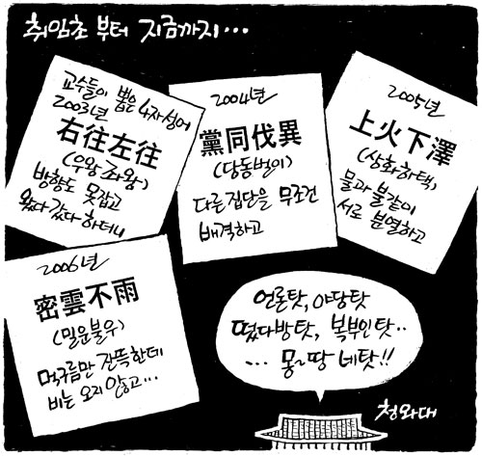
<Chosun-ilbo Dec. 19, 2006>

