Stabilization techniques

After a disaster, you may experience physical and mental changes or may even feel pain. They are normal reactions to stress anyone could experience. However, if your symptoms are severe, you always can get professional help. There are a few mind-calming skills you can try after you have experienced a disaster.
1. Deep Breathing | 2. Abdominal breathing
“When you get tense, you would exhale deeply and give a big sigh with a sound ‘hoo~’, without realizing it. That’s exactly what a deep breathing is like. Inhale through your nose, and then exhale slowly through your mouth with a ‘hoo~’ sound, as if you are blowing a balloon, until the last air in your lung. Focus on the feeling of the air going out from your chest and breathe slowly. | “For abdominal breathing, inhale deeply so that your lower abdomen expands like a balloon, and then exhale making your belly being drawn inwards. Breathe in and out only through your nose. Imagine you are slowly sending the breath all the way down to your lower abdomen. Breathe slowly and evenly, and focus on the feeling of your abdomen becoming firm.”
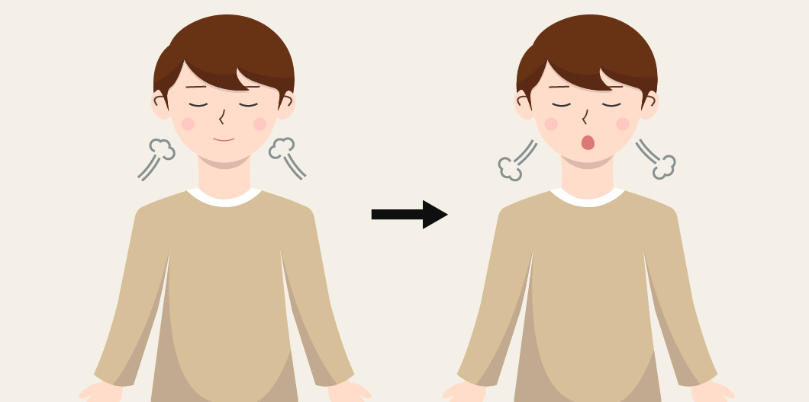 | 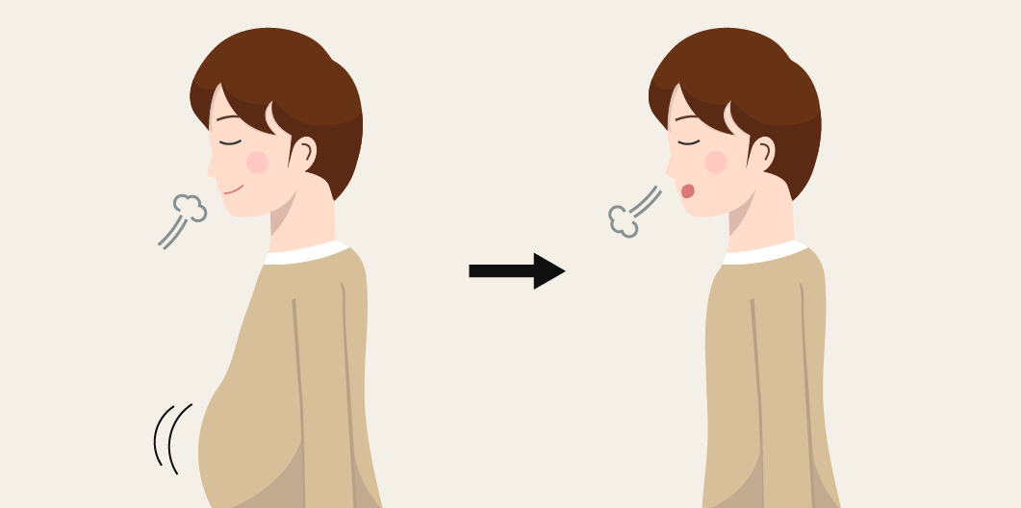

3. Grounding technique | 4. Butterfly hug
“Grounding technique is to come back to ‘here and now’, feeling your feet touching the ground. Lay your sole flat on the ground, and focus on the feeling of your sole touching the ground. Slightly lift your heel, then drop it on the ground with a ‘thud.’ Continue to gently press down the heel towards the ground and feel the hard ground.” | “When you suddenly get tense and your hear throbs, or when a traumatic memory comes back to you, you can use a method called butterfly hug. With the butterfly hug, you can calm yourself by ‘patting yourself’ on both sides of your arms so that such symptoms can pass away fast. Cross your arms over your chest, and place your hand on the forearm, and mildly pat our arms 10-15 times, alternating your hands like the flapping wings of a butterfly.
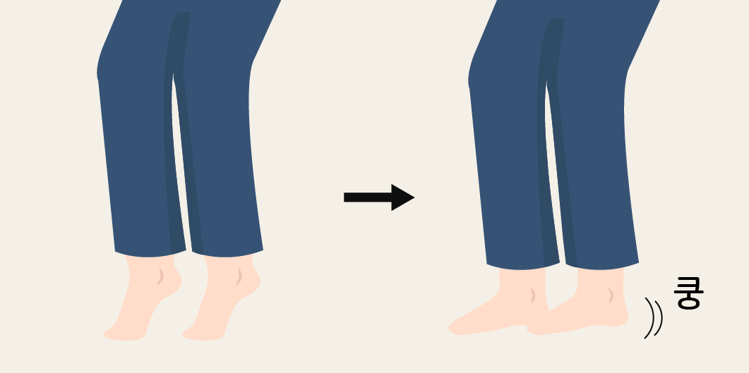 | 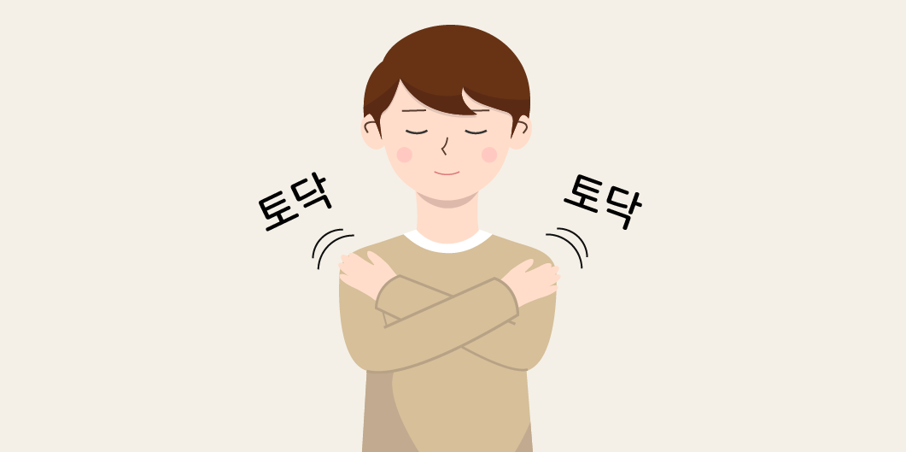
This research is funded by Korea Mental Health Technology R&D Project, under Ministry of Health and Welfare (HM15C1112)
Suggested citation: Disaster Mental Health Support Information Contents & Platform Development Research
출처: 재난 정신건강지원 정보콘텐츠 및 플랫폼 개발 연구(보건복지부 정신건강기술개발사업)

