NGiNX + Gunicorn + Django : Platform : CentOS 8.2
http://dveamer.github.io/backend/PythonWAS.html
1. NGiNX설치
2. Gunicorn설치
3. Django 프로젝트 생성
4. Gunicorn+ Django
5. NGiNX + Gunicorn + Django

NGiNX설치

1. SELiux제거

[root@localhost~]# vi /etc/selinux/config
SELINUX=permissive

*리부팅

2. 방화벽 설정
[root@localhost~]# vi /usr/lib/firewalld/services/vi http.xml
[root@localhostservices]# firewall-cmd --zone=public --add-service=http --permanent
[root@localhostservices]# firewall-cmd --reload

3. NGiNX 설치
[root@localhost~]# yum install -y nginx
[root@localhost~]#systemctl start nginx

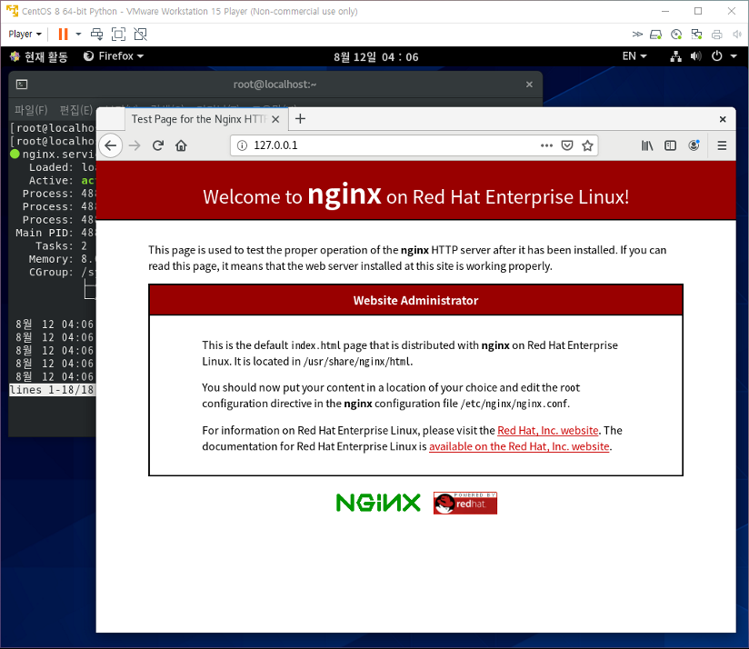

Gunicorn설치

1. Gunicorn설치
[root@localhost~]# pip3 --version
[root@localhost~]# pip3 install gunicorn
[root@localhost~]#gunicorn --version

2. Gunicorn확인
[master@localhost~]$ vi myapp.py

# -*- coding: utf-8 -
def app(environ, start_response):
data = b'Hello, World!\n'
start_response( '200 OK', [
( 'Content-Type', 'text/plain' ),
( 'Content-Length', str( len( data ) ) )
])
return iter([data])

[master@localhost~]$gunicorn -w 4 myapp:app

3. Django 프로젝트 생성
[master@localhost~]$django-admin startprojectmysite
[master@localhost~]$ cd mysite/
[master@localhostmysite]$ python3 manage.py runserver

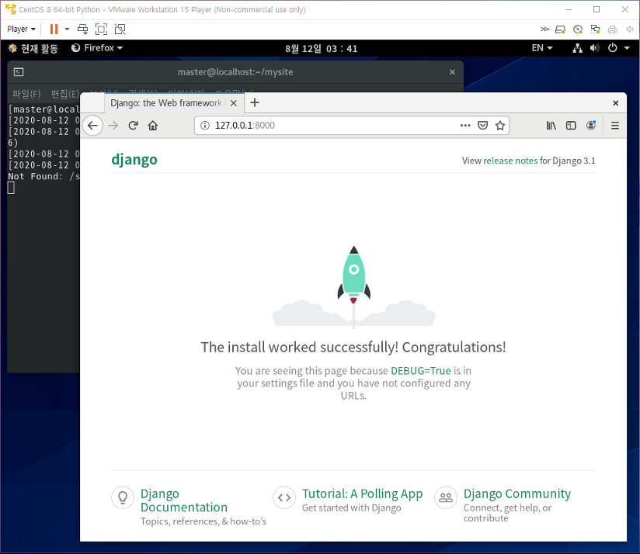

4. Gunicorn+ Django

1. 실행 확인
[master@localhostmysite]$gunicorn --bind 127.0.0.1:8000 mysite.wsgi:application

2. 서비스 구축
[root@localhost~]#vi /etc/systemd/system/gunicorn.service

[Unit]
Description=gunicorn daemon
After=network.target

[Service]
User=master
Group=master
WorkingDirectory=/home/master/mysite
ExecStart=/usr/local/bin/gunicorn --workers 3 --bind 0.0.0.0:8000 mysite.wsgi:application

[Install]
WantedBy=multi-user.target

[root@localhost~]#systemctl start gunicorn

5. NGiNX + Gunicorn + Django

1. NGiNX설정

[root@localhostnginx]# vi nginx.conf
server {
# listen 80 default_server;
# listen [::]:80 default_server;

listen 80;
listen [::]:80;

server_name _;
root /usr/share/nginx/html;

# Load configuration files for the default server block.
include /etc/nginx/default.d/*.conf;

location / {
proxy_passhttp://127.0.0.1:8000;
}

location /static {
root /home/master/mysite
}

error_page 404 /404.html;
location = /40x.html {
}

error_page 500 502 503 504 /50x.html;
location = /50x.html {
}
}

[root@localhostnginx]#systemctl start nginx
[root@localhostnginx]#systemctl start guncorn

