Control systems – E35 ESE 541
Homework Assignment #8
Prof. : Christopher I. Byrnes
Student : Hyunjin Cho

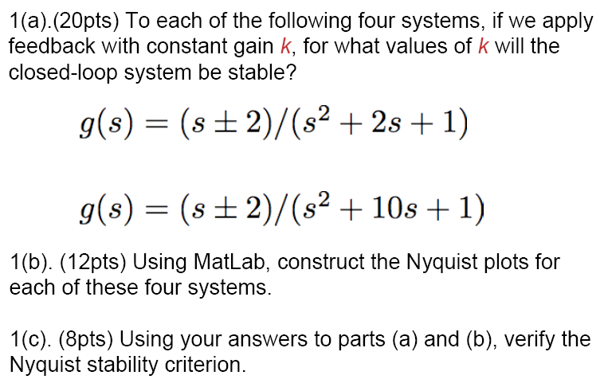

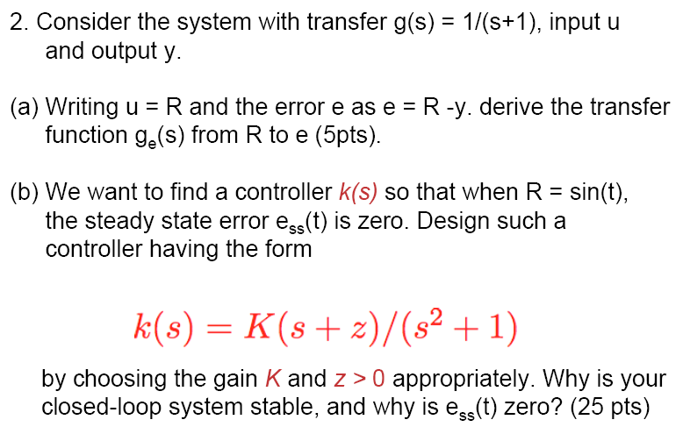
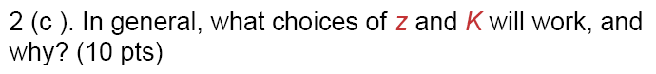
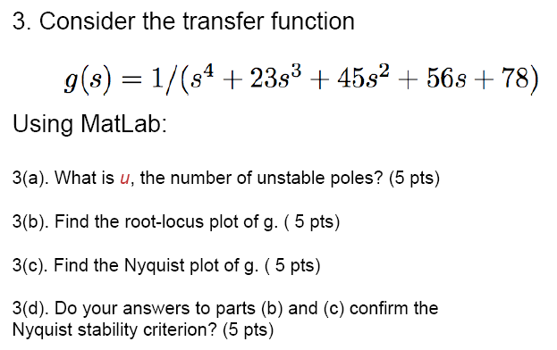

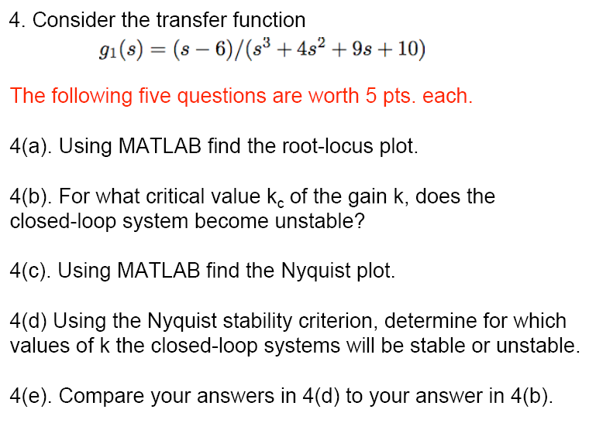
5. Problem 6.4, text p. 198
