Control systems – E35 ESE 541
Homework Assignment #7
Prof. : Christopher I. Byrnes
Student : Hyunjin Cho

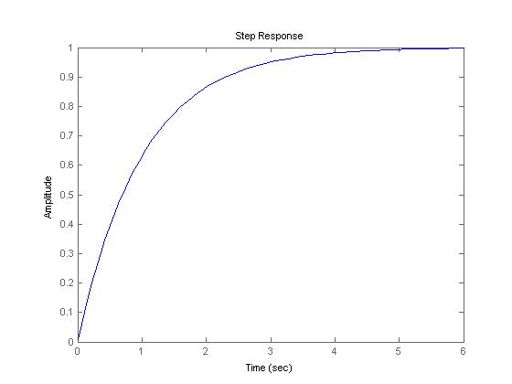
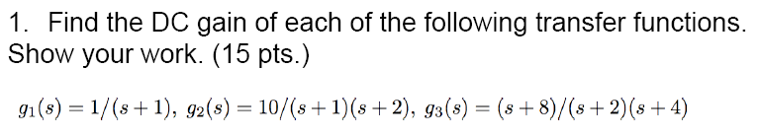

%% problem 1
clc; clear all; close all;

% problem 1a
num1=[1];
den1=[1 1];
g1=tf(num1, den1);

figure(1)
step(g1)
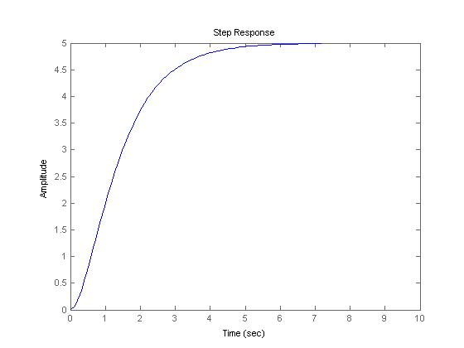
dcgain(g1)

% problem 1b
num2=[10];
den2=[1 3 2];
g2=tf(num2, den2);

figure(2)
step(g2)

dcgain(g2)

% problem 1c
num3=[1 8];
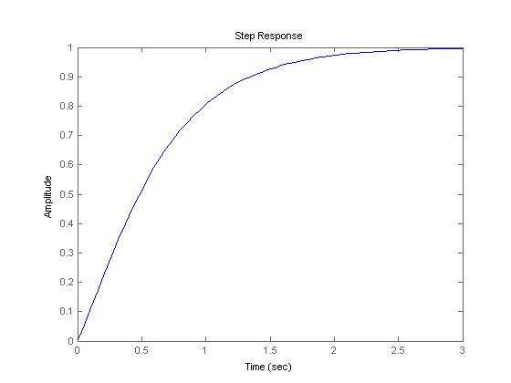
den3=[1 6 8];
g3=tf(num3, den3);

figure(3)
step(g3)

dcgain(g3)

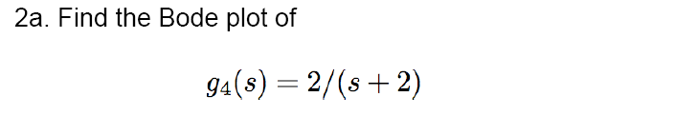
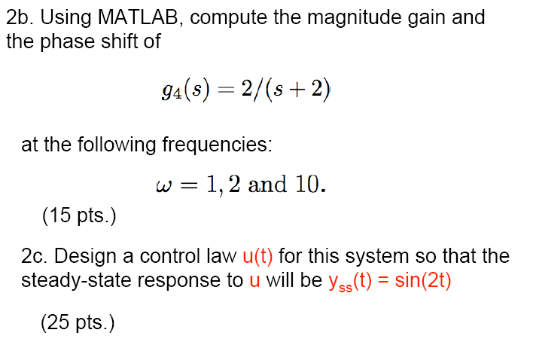

%% problem 2
clc; clear all; close all;

% problem 2a
num4=[2];
den4=[1 2];
g4=tf(num4, den4);
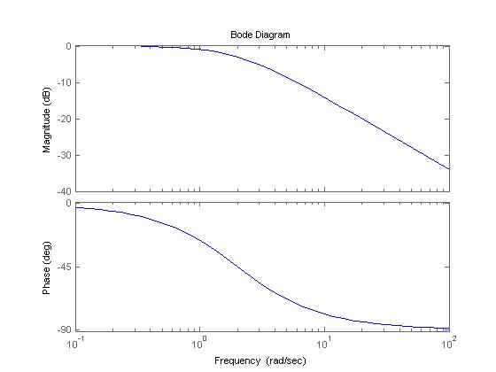
figure
bode(g4)

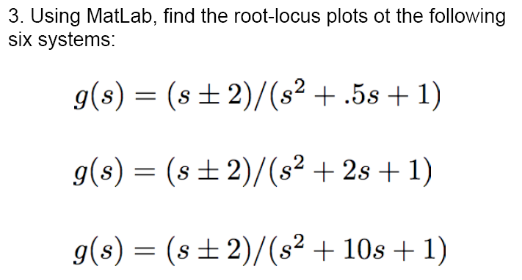

%% problem 4
clc; clear all; close all;

% problem 4a
num11=[1 2];
den11=[1 0.5 1];
g11=tf(num11, den11);

figure(11)
rlocus(g11)

num12=[1 -2];
den12=[1 0.5 1];
g12=tf(num12, den12);

figure(12)
rlocus(g12)
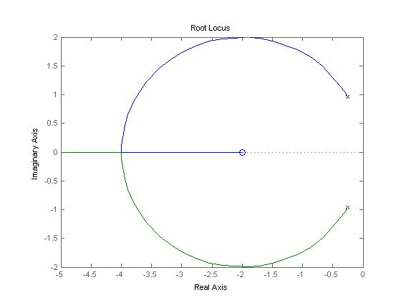
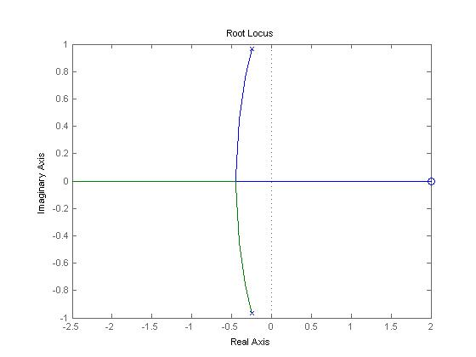
% problem 4b
num21=[1 2];
den21=[1 2 1];
g21=tf(num21, den21);

figure(21)
rlocus(g21)

num22=[1 -2];
den22=[1 2 1];
g22=tf(num22, den22);

figure(22)
rlocus(g22)

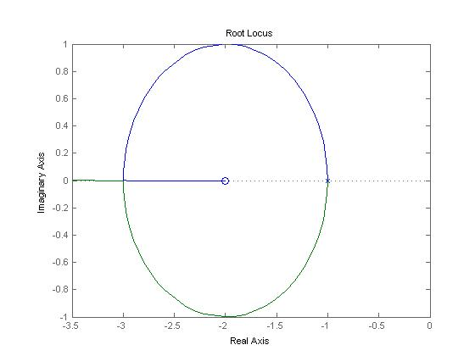
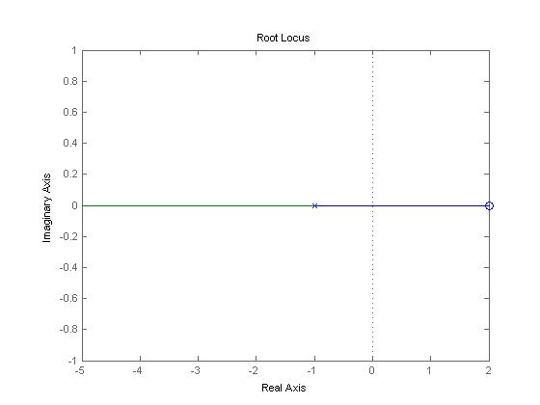
% problem 4c
num31=[1 2];
den31=[1 10 1];
g31=tf(num31, den31);

figure(31)
rlocus(g31)

num32=[1 -2];
den32=[1 10 1];
g32=tf(num32, den32);

figure(32)
rlocus(g32)
