Control systems – E35 ESE 541
Homework Assignment #4
Prof. : Christopher I. Byrnes
Student : Hyunjin Cho

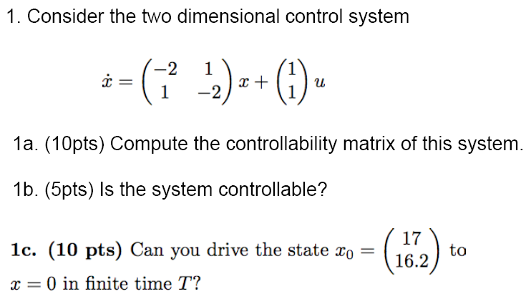
2. Problem 6.1, text p. 197
(Double integrator) Consider the double integrator. Find a piecewise constant control strategy that drives the system from the origin to the state x = (1, 1).
