Control systems – E35 ESE 541
Homework Assignment #5
Prof. : Christopher I. Byrnes
Student : Hyunjin Cho

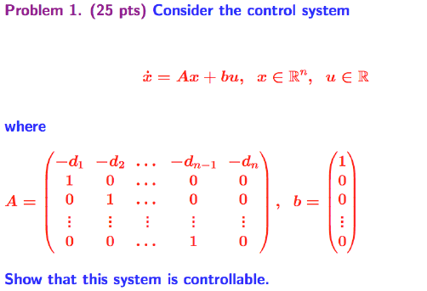
2. Problem 7.1, text p. 226
(coordinate transformations) Consider a system under a coordinate transformation $z=\text{Tx}$, where $T∈ℜ^{n×n}$ is an invertible matrix. Show that the observability matrix for the transformed system is given by ${\tilde{W}}_{0}=W_{0}T^{−1}$ and hence observability is independent of the choice of coordinates.
