Control systems – E35 ESE 541
Homework Assignment #8
Prof. : Christopher I. Byrnes
Student : Hyunjin Cho

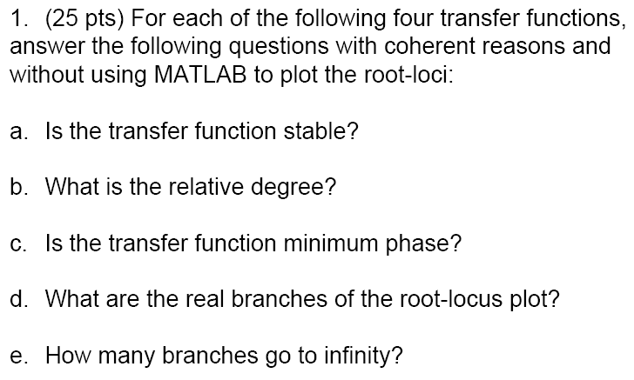
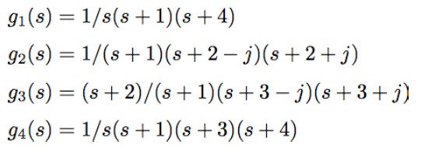
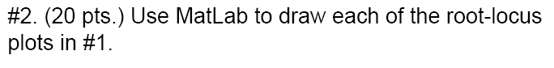

%% problem 2
clc; clear all; close all;

% problem 2
num21=[1];
den21=[conv([1 0],conv([1 1],[1 4]))];
g21=tf(num21, den21);
figure (1)
rlocus(g21)

num22=[1];
den22=[conv([1 1],conv([1 2-i],[1 2+i]))];
g22=tf(num22, den22);
figure (2)
rlocus(g22)

num23=[1 2];
den23=[conv([1 1],conv([1 3-i],[1 3+i]))];
g23=tf(num23, den23);
figure (3)
rlocus(g23)

num24=[1];
den24=[conv([1 0],conv([1 1],conv([1 3],[1 4])))];
g24=tf(num24, den24);
figure (4)
rlocus(g24)

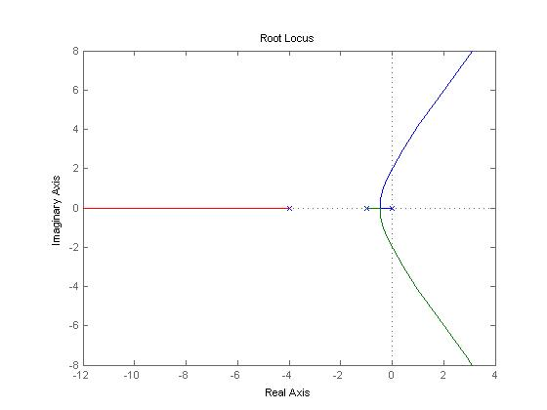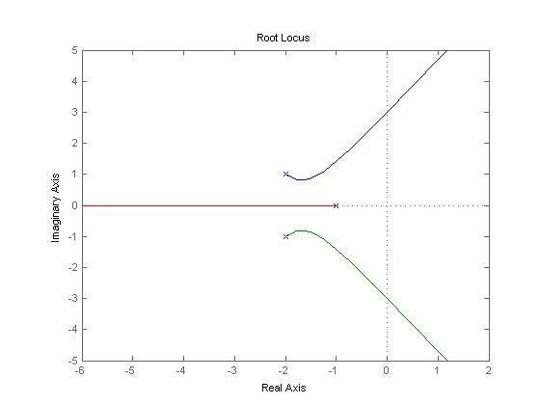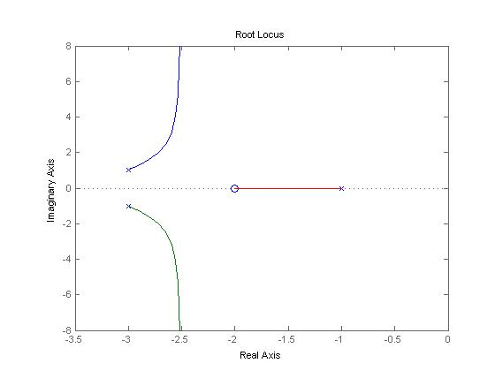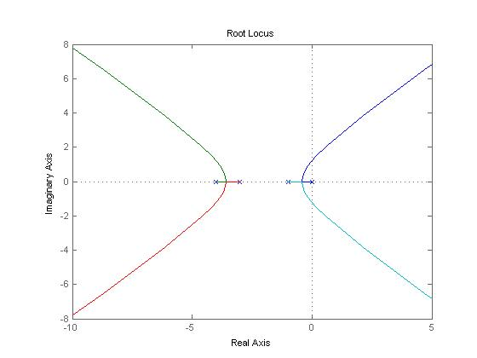
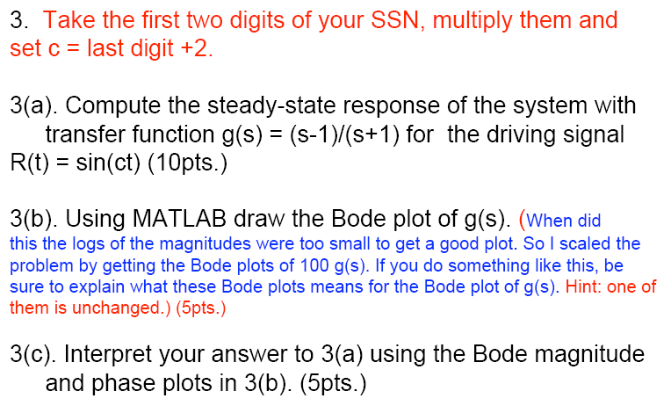
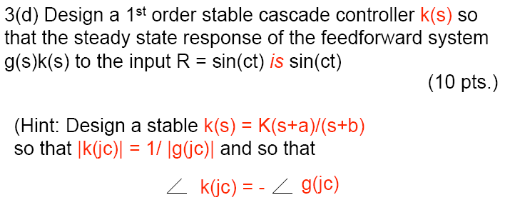

clc; clear all; close all;

% problem 3b
num3=[1 -1];
den3=[1 1];
g3=tf(num3, den3);

figure (1)
bode(g3)
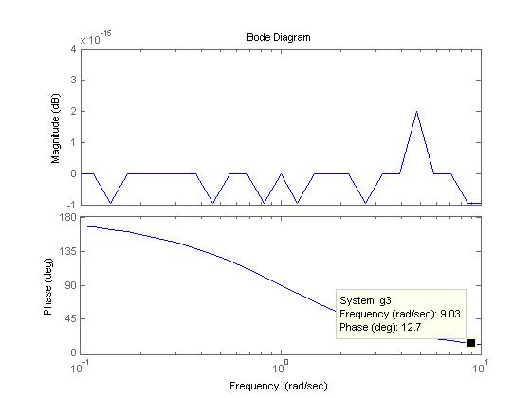
figure (2)
bode(g3*100)

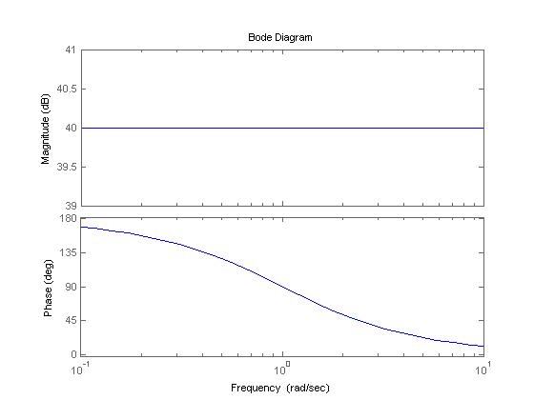
4. Problem 6.14, text p. 200
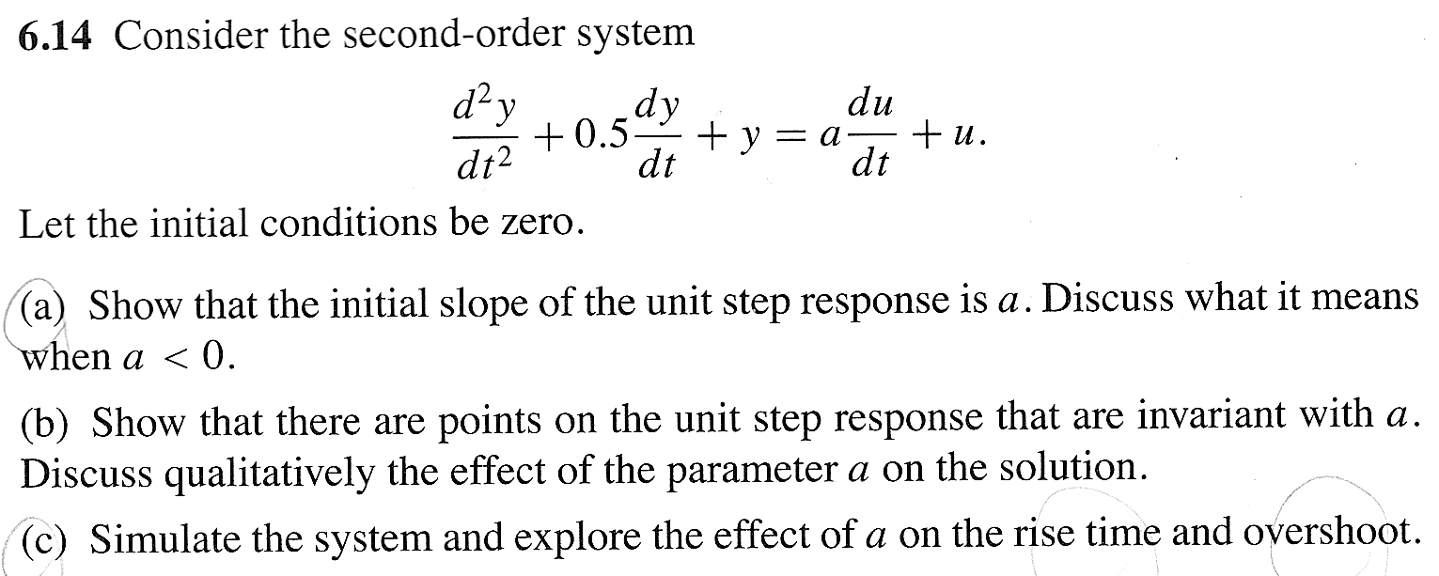

% g=tf([a 1],[1 0.5 1]); transfer function

% set a=-5
h1=tf([-5 1],[1 0.5 1]);

figure(1)
subplot(2,1,1); impulse(h1)
subplot(2,1,2); step(h1)

% set a=-3
h2=tf([-3 1],[1 0.5 1]);

figure(2)
subplot(2,1,1); impulse(h2)
subplot(2,1,2); step(h2)

% set a=0
h3=tf([0 1],[1 0.5 1]);

figure(3)
subplot(2,1,1); impulse(h3)
subplot(2,1,2); step(h3)

% set a=3
h4=tf([3 1],[1 0.5 1]);

figure(4)
subplot(2,1,1); impulse(h4)
subplot(2,1,2); step(h4)

% set a=5
h5=tf([5 1],[1 0.5 1]);

figure(5)
subplot(2,1,1); impulse(h5)
subplot(2,1,2); step(h5)

