Web Service
This section describes how a Web service works, what security risks are inherent to a Web service, and how an NC-Gateway can protect a Web service. It covers the following topics:
- Web Service Uses
- Web Service Implementation
- Web Service Vulnerabilities
- Web Service Protections
Web Service Uses
A traditional Web application is designed to take input from a human user and display output to a human user. In contrast, a Web service is an application that is accessible on the Web but is intended to be used by another application. Web services share business logic, data, and processes through a programmatic interface. Web services are emerging as the new standard for organizations to streamline business processes with increased efficiency and reduced application integration costs. Web services are used primarily as a means for businesses to communicate with each other and clients, and they allow organizations to communicate without intimate knowledge of each other's infrastructure and security configurations.
Typical uses for Web services include the following:
- Business-to-business integration: Web services provide a common mechanism to integrate business processes. By using Web services, a company can expose key functions to authorized suppliers and customers. For example, a company can create ordering and invoicing Web services, thereby integrating customer ordering and supplier invoicing applications. While this is not a new concept, Web services are generally easier to implement than other options, are portable regardless of the platform and programming language used, and operate over the Internet.
- Application integration: Much development effort is spent on integrating applications written in various languages and running on disparate systems. Even on the same platform, applications from different vendors often need to be integrated. By exposing functionality and data through a Web service, an application provides a standard mechanism to integrate with other applications. For example, one application might be used to enter new orders while a separate application from another vendor is used to fulfill orders. The order-entry application can define an add-order Web service that notifies the fulfillment application to ship the order whenever an order is placed.
- Software reuse: Software code reuse for multiple purposes is limited because the associated data cannot easily be distributed when the data is not static. Web services provide a mechanism to distribute current (dynamic) data. For example, a user enters a mailing address that requires validation. The original application could send the request to an address verification Web service to check the address through a service provider.
Web Service Implementation
Web services use a universal language to send data and instructions to one another over the Internet with no translation required. The term Web service describes a standardized way of integrating Web-based applications using the eXtensible Markup Language (XML), Simple Object Access Protocol (SOAP), Web Services Description Language (WSDL), and Universal Description, Discovery, and Integration (UDDI) open standards over an Internet protocol (usually HTTP). XML is used to tag the data, SOAP is used to transfer the data, WSDL is used for describing the services available, and UDDI is used for listing what services are available.
For example, consider two banks that want to set up a Web service to share account balance information. Figure Web Services example llustrates the steps:
- Bank A creates a Web service description (in the XML-based WSDL format) that describes what the Web service requires as input and what information should be returned, such as the customer's account number and password, and sends a SOAP request to register it with a UDDI service.
- Bank B sends a SOAP request to the UDDI service to look up information about Bank A's Web service. (While using a UDDI service is common practice, it is not a requirement for a Web service.)
- Bank B sends a SOAP request to Bank A's Web service to retrieve the WSDL definition and bind to that Web service.
- Bank B sends a SOAP request to Bank A's Web service that conforms to the WSDL definition.
In this example, access to account information must be limited to a select list of approved intermediaries, which requires authentication through passwords, public keys, or other mechanisms. In addition, the bank might want to prioritize requests (such as by how much customers are paying for the service), confirm that payment for the service is received, and send a receipt. At each step, information must be secured from unauthorized access, attack, and data theft.
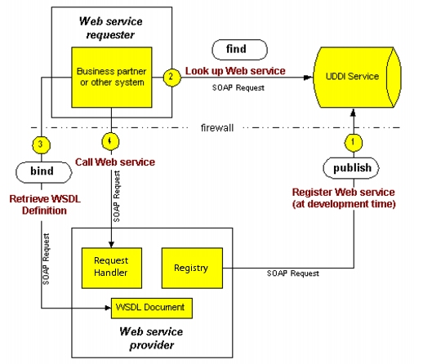
A business can combine multiple Web services to accomplish a task. For example, a travel service might define one Web service for interacting with its client application, another Web service for communicating with a credit card service (with the travel service acting as the client of the credit card service), another Web service for communicating with one or more hotel services, and another Web service for communicating with one or more airline services.
A Web service description (WSDL document) is a machine-readable document that describes the expectations and functionality of a particular Web service, so a potential client can read the description and understand how to correctly interact with the service. Even though it is written solely from the point of view of the Web service, it is inherently intended for use by both the client and the service. It specifies the rules for how they should interact.
WSDL defines an XML grammar for describing network services as collections of communication end points capable of exchanging messages. WSDL service definitions provide documentation for distributed systems and serve as a recipe for automating the details involved in application communications.
A WSDL document defines services as collections of network end points (ports). In WSDL, the abstract definitions of end points and messages are separated from their concrete network deployment or data format bindings. This allows the reuse of abstract definitions. The concrete protocol and data format specifications for a particular port type constitutes a reusable binding. A port is defined by associating a network address with a reusable binding, and a collection of ports defines a service. Hence, a WSDL document uses the following elements in the definition of network services:
- Types: a container for machine- and language-independent data type definitions using a system such as XSD that provides information about complex data types used in the WSDL document
- Message: an abstract definition of the data being communicated
- Operation: an abstract description of an action supported by the service
- Port Type: an abstract set of operations supported by one or more end points that describes the interfaces (legal operations) exposed by a Web service
- Binding: a concrete protocol and data format specification for a particular port type that describes how the operation is invoked for a Web service
- Port: a single end point defined as a combination of a binding and a network address that specifies a single communication end-point (binding) address
- Service: a collection of related end points (ports) that specifies the address(es) of the binding
See "WSDL 1.2 Syntax" in Appendix A, "WSDL Files," for the complete syntax defined in WSDL version 1.2.
Web Service Vulnerabilities
Web services are vulnerable to many of the same risks as Web applications, such as cross site scripting, SQL injection, and denial of service. (See Chapter 1, "What is the Problem?" in the NetContinuum Application Security Gateway Overview (449-000019-00) for a description of Web application attack types.) In addition, Web services come with their own specific vulnerabilities and security needs. Web service-specific risks include the following:
- Each Web service has an associated WSDL document that is basically a blueprint for the service. The document details the messaging request and response for the service in XML, what parameters (including data type) the service expects, and what operations are available through the service. By analyzing a service's WSDL document, a hacker knows exactly what the service is supposed to do and which parts are open to attack through techniques such as malformed SOAP messages and other XML parser attacks. A WSDL document might also reveal what tools generated the Web service, providing attackers with additional information on the environment.
- SOAP and XML are standards used to wrap data for easy consumption. SOAP provides enveloping information to deliver messages in a seamless fashion between heterogeneous applications. XML includes metadata to describe the structure of the information. Malicious code can be embedded into the elements or CDATA of the information. CDATA is used to delineate information in the message that should not be parsed. Embedded characters or malicious code can be sent. The receiving application may display or execute the data in unintended ways. Cross-site scripting referred to as XML encapsulation can be used to embed commands that can tie up system resources or gain unauthorized access.
- XML-based attacks take advantage of the XML parsers that process the SOAP message. Web services and existing infrastructure do not provide protection for XML-based attacks. Putting in recursive relationships to create entity expansions, bogus parameters, and significant amounts of white space can cause XML parsers to be overloaded or to perform unexpected problems.
- Any type of application can be behind the Web service interface, including packaged applications, internally developed applications, desktop applications, and legacy mainframe applications. These applications carry their own security vulnerabilities, which are likely to be even more exposed through a Web services interface. In addition, they all approach security in different ways. This presents a significant security challenge to protect these services consistently.
Web Service Protections
The NC-Gateway allows you to secure a Web service as part of a Web application. All the standard Web application protections apply to a Web service, and the NC-Gateway provides additional security specifically for a Web service. Web Service Risks and Protections table describes the possible attack techniques and how an NC-Gateway can protect against each technique.
Technique | Description | Protection
Schema Poisoning | Manipulating the WS schema to alter the data processed by the application | An NC-Gateway protects against schema poisoning by validating that content adheres to the defined WSDL and schema.
XML Parameter Tampering | Injection of malicious scripts or content into XML parameters | An NC-Gateway protects against parameter tampering by validating that parameter values are consistent with the WSDL and schema specifications.
Inadvertent XDoS | Sending poorly encoded SOAP messages that cause the application to fail | An NC-Gateway inspects SOAP at the header, envelope, and message level to ensure proper structure and content.
WSDL Scanning | Scanning the WSDL (business API) to reveal sensitive information about the data format of the application | An NC-Gateway uses Web services cloaking to hide the true internal URI of sensitive Web services.
Coercive Parsing | Injection of malicious content into the XML | An NC-Gateway utilizes real-time WS-I checking and content inspection to block malicious payloads.
Oversized Payload | Sending oversized files to create an XDoS attack (similar to a buffer overflow attack) | An NC-Gateway inspects the payload and enforces element, document, and other maximum payload sizes.
Recursive Payload | Sending mass amounts of nested data to create an XDoS attack against the XML parser | An NC-Gateway validates WSDL and schema formats, inspects SOAP headers, envelopes, and messages, and ensures that WS-I standards are met.
XML Routing Detours | Redirecting sensitive data within the XML path | An NC-Gateway conducts WSDL virtualization and schema validation to enforce strict routing behavior.
SQL Injection | Disguising a malicious SQL command inside a SOAP wrapper in an attempt to disclose or modify back-end data | An NC-Gateway utilizes real-time WS-I checking and content inspection to block malicious payloads.
Replay Attacks | The use of repetitive SOAP messages to force an XDoS attack | An NC-Gateway includes request-level throttling technology to ensure resources cannot reach a fail state.
External Entity Attack | An attack on an application that parses XML input from untrusted sources using an incorrectly configured XML parser | An NC-Gateway can suppress external URI references to protect against external manipulation of data.
Information Disclosure | Unencrypted data in a Web service message is exposed to anyone watching application traffic | An NC-Gateway has extensive SSL security capabilities at the ASIC level and can ensure that no unencrypted XML traffic traverses the network under any circumstance.
Malicious Code Injection | Scripts embedded deep within a SOAP message can be delivered directly to applications and databases | An NC-Gateway has extensive SSL security capabilities at the ASIC level and can ensure that no unencrypted XML traffic traverses the network under any circumstance.
Identity Centric Attack | Credentials are forged or impersonated in an attempt to access sensitive data | An NC-Gateway enforces basic or strong authentication at the SOAP message level.
Creating Web Service
This chapter describes the tasks required to create a Web service. It includes the following topics:
- Tasks
- Importing a Web Services License
- Viewing License Information
- Creating a WSDL File
- Importing a WSDL File
- Exporting a WSDL File
Tasks
The NC-Gateway allows you to protect a Web service as part of a Web application. The protections configured for the parent Web application apply to any Web services configured under that Web application, and you can configure additional security specific to a Web service. The following steps are required to protect a Web service:
- The NC-Gateway Web services edition is a separately licensed feature. Obtain and import a license for the NC-Gateway Web services. The NC-Gateway Web services edition includes an XML parser to analyze SOAP messages and apply policies defined in a WSDL file.
- Create a Web service description and save it to a file. (The NC-Gateway is not used to create the WSDL file; you must create it independently.)
- Create a Web application (see Chapter 3, "Creating a Web Application," in the NetContinuum Application Security Gateway Application Configuration Guide (449-000018-00)).
- Import a WSDL file into the NC-Gateway and associate it with the target Web application. The NC-Gateway can then validate SOAP messages that pass through the NC-Gateway against the Web service policies defined in the WSDL file.
- Configure a Web services firewall (see Configuring a Web Service Firewall"). Under the Web firewall container, a WSDL policy container is created for each imported WSDL file. Within this container, you can set the following firewall features:
  - Set SOAP validation parameters to ensure requests conform to SOAP standards.
  - Enable WSI basic profile test assertions applied during run-time validation of SOAP messages.
  - Add intrusion, detection, and prevention (IDP) rules to ensure SOAP messages conform to customized policies such as size limits, time of day restrictions, and XML filters.
  - Configure the Web service access point.
- Create a URL ACL to allow access to a Web service, and configure standard Web application security features for a Web service (see Enabling Web Service Security").
Importing a Web Services License
Web services support is a separately licensed feature on the NC-Gateway. You must have the NC-Gateway Web services edition to get a license. To import a Web services license, do the following:
- Send E-mail to licensing@netcontinuum.com and request a license file. Include your name, organization, Web Services Firewall software version number, and hardware ID in the E-mail message. To determine the software version and hardware ID, do the following:
  - From the Front Panel, select Tools > Import Web Services Firewall License.
  - The Import License dialog appears. Select the Get a License button, and copy the displayed software version and hardware ID into your E-mail request. (You supply the name and organization.)
- After receiving the license file, copy it to the management PC or other appropriate location.
- Again select Tools > Import Web Services Firewall License from the Front Panel to display the Import License dialog.
- Click the browse button (the one displaying an ellipse). The Choose License File window appears. Select the target license file, and click the Open button.
- The license file should appear in the File: field. Click the Submit button.
- A success message appears when the license is confirmed; a failure message appears if it is not. If you get a failure message, follow the instructions and repeat this procedure. If it still does not work, contact customer support.
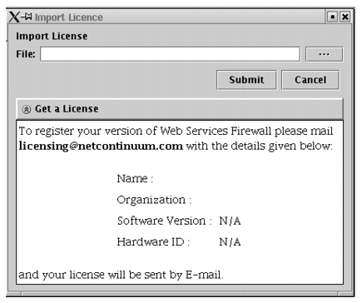
Viewing License Information
To view information about imported Web Services Firewall licenses, do the following:
- From the Front Panel, select Tools > System > Software Version.
- In the Software Version window, scroll down to the Web Services Firewall Information section.
- Click the OK button to close the window.
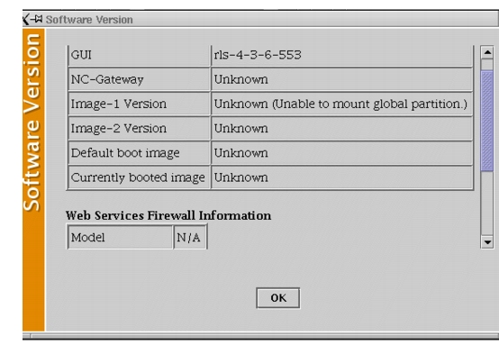
The system behaves inconsistently when a machine is upgraded/rebooted with an expired Web Services Firewall license. This may be due to:
Import Web Services Firewall License and View Web Services Firewall Information have the feature of detecting whether Web Services Firewall is running or not, and restarting it (irrespective of whether it is licensed properly) if it is not running. If Import Web Services Firewall License and View Web Services Firewall Information doesn't find Web Services Firewall, it arranges for the startup and returns immediately with the Web Services Firewall_RESTART error.
When Web Services Firewall comes up, it takes a while to realize that it is not licensed. Till then, it considers itself as licensed, and allows a command or two (like import wsdl or delete) to go through. When it decides that it is unlicensed, it shuts itself down.
Creating a WSDL File
Create a WSDL description for your Web service and save it to a file. The NC-Gateway is not used to create the WDSL file; you must create this before you can configure a Web service through the NC-Gateway. The WSDL is a World Wide Web Consortium (W3C) standard. For information about the WSDL standard, see the W3C web site (www.w3.org) and the Web Services link. "WSDL 1.2 Syntax" in Appendix A, "WSDL Files," includes the syntax definitions for WSDL version 1.2.
Programmers or automated development tools can create WSDL files to describe a service. The techniques for writing or generating a Web service description is beyond the scope of this document. "Sample WSDL Code" in Appendix A, "WSDL Files," is a sample WSDL file that illustrates a simple service for doing math calculations.
Importing a WSDL File
Once a WSDL file has been created, you can import that Web services description into the NC-Gateway. To import a WSDL file, do the following:
- From the Configuration Window, select Tools > Import WSDL File.
- The Choose WSDL File window appears. Browse as necessary, select the WSDL file to import, and click the Open button.
- The Import WSDL dialog appears. In this dialog do the following (in the indicated lines):
  - Web Application: Click the expand button (at the end of the line) to display a tree of available Web applications. Select the target Web application.
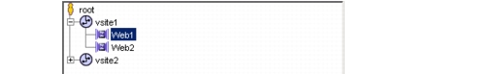
  - WSDL Policy: Enter a name for the Web service. This will appear in the configuration tree under web_app > Web Services.
  - Web Service Published Host: Enter the domain name of the published host. This sets the external host address that can be published to users of this Web service.
  - Description: Enter a line to describe the imported Web service (optional).
  - Additional Links: Click this button to see the additional links display. A WSDL file can include links to other files, which will be displayed here. If one or more of these links are unresolved, import will fail. If the Unresolved field is not zero, do the following:
i. Check the Status column for unresolved, and identify the corresponding link from the Location column (for example, http://example.com/ws/schema/hello.xsd)
ii. Download and save the file using the same name (hello.xsd).
iii. Select the unresolved link, click the Status button, and select the downloaded file (hello.xsd). The Status field will change to resolved.
iv. Repeat for all unresolved links.
v. The WSDL could reference additional files not in the link list. If so, enter the URL address for such a file in the URL field and click Add. The file will appear in the additional links list. If the added file appears as unresolved, resolve it as described in step iii. Repeat for each additional file.
- Click the Upload button.
  - After successfully importing the WSDL file, a success dialog appears. Click OK to close the dialog.
  - The NC-Gateway now automatically creates a URL ACL that corresponds to the imported Web service. Upon completion, a success dialog listing the URL ACL name appears. Click OK to close the dialog.
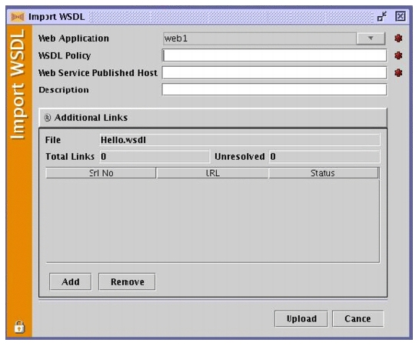
Exporting a WSDL File
When you make changes to a Web service configuration, you can save the updated configuration externally by exporting it as a WSDL file. To export a WSDL file, do the following:
- From the Configuration Window, select Tools > Export WSDL File.
- The Export WSDL dialog appears. Select the Web service to export and click the Export button.
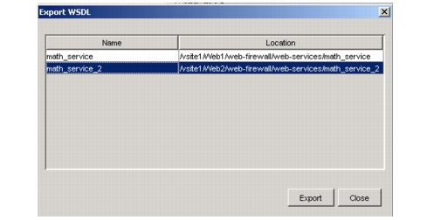
- The Choose WSDL File window appears. Browse to the desired directory, enter a name for the WSDL file to export (include a .xml extension), and click the Save button.
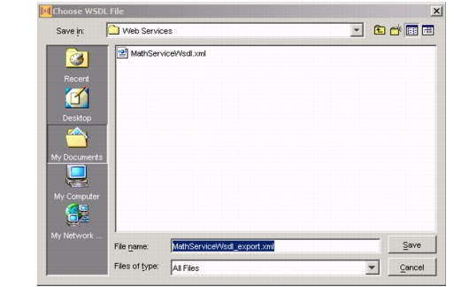
Configuring Web Service Firewall
When you import a WSDL file (see Importing a WSDL File"), a WSDL policy container is created automatically under the Web firewall of the target Web application. This chapter describes how to configure the Web service firewall policies in this container. This chapter covers the following topics:
- Configuring Web Service Protection
  - Configure SOAP Validations
  - Enable WS-I Basic Profile Tests
  - Configure Request IDP Rules
  - Configure Response IDP Rules
- Enabling Web Service Access
Configuring Web Service Protection
The imported WSDL file defines the Web service. The associated Web service policy container allows you to specify which WSDL file policies and SOAP standards to enforce. The Web services policy container includes the following subcontainers:
- SOAP Validations: Sets what SOAP conformance policies to apply.
- WSI Basic Profile Tests: Sets what WSI 1.0 basic profile tests to apply.
- Request IDP Rules: Sets what IDP rules to apply against requests.
- Response IDP Rules: Sets what IDP rules to apply against responses.
The Web service policy container also includes a General tab where you can enter a longer description of the Web service. This is descriptive only; there are no configuration parameters under the General tab.
Configure SOAP Validations
SOAP is the transfer mechanism protocol for sending Web service descriptions in an HTTP message, and the SOAP validation parameters set the SOAP validation checks to apply. (These checks ensure the message adheres to SOAP standards.) By default, these SOAP standards are not validated.
To change any of these settings, do the following:
- From the Configuration Window, select vsite > web_app > Web Firewall > Web Services > wsdl_policy and the SOAP Validations tab.
- There are four validation parameters, which are set to either Yes or No. Yes means apply this validation test; No means ignore this validation test. To change the setting, select the opposite value from the pull-down menu for that parameter. When set to Yes, a SOAP message that does not conform to this policy is considered an intrusion. (An exception is the Allow Additional SOAP Headers parameter, in which Yes means allow and No means do not allow.)
- Click Upload to save and activate the new settings.
While these SOAP validations and the WS-I Basic Profile tests (described in the next section) determine whether a SOAP message is valid, they only mark an invalid message as an intrusion. Blocking invalid messages is enabled through an IDP rule. To ensure invalid messages are treated as an intrusion (denied or redirected as configured in the Web firewall policies), verify that the default request and response InvalidWSDLMessage rules are enabled, which they are by default (see Configure Request IDP Rules").
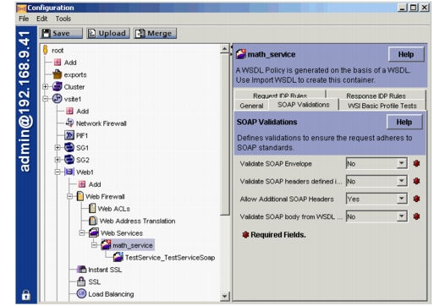
The following table describes the SOAP Validations container parameters.
Parameter | Description | Values
Validate SOAP Envelope | If set to Yes, a SOAP message with an envelope that does not conform to the SOAP standard is considered an intrusion. | Yes  No (default)
Validate SOAP headers defined in WSDL | If set to Yes, a SOAP message with a header that does not conform to the policies defined in the WSDL file is considered an intrusion. | Yes  No (default)
Allow Additional SOAP Headers | If set to No, a SOAP message with a header not specified in the WSDL file is considered an intrusion. | Yes (default)  No
Validate SOAP body from WSDL schema | If set to Yes, a SOAP message with a body that does not conform to the schema defined in the WSDL file is considered an intrusion.
Enable WS-I Basic Profile Tests
The Web Services Interoperability Organization (WS-I) published the Basic Profile 1.0 (www.ws-i.org/Profiles/BasicProfile-1.0.html) to help customers validate their Web services. This profile contains implementation guidelines for the core Web services specifications: XML 1.0, XML Schema 1.0, SOAP 1.1, WSDL 1.1, and UDDI 2.0. These guidelines are a set of requirements that define how these specifications should be used to develop interoperable Web services. The WS-I test tools (www.ws-i.org/Testing/Tools/2004/10/BasicProfileTestAssertions.xml) can be used to verify that a Web service conforms to these requirements.
The NC-Gateway performs these tests during run time validation for SOAP messages. However, they are not enabled by default.
To enable basic profile testing (all or a select set), do the following:
While these WS-I Basic Profile tests (and the SOAP validations described in the previous section) determine whether a SOAP message is valid, they only mark an invalid message as an intrusion. Blocking invalid messages is enabled through an IDP rule. To ensure invalid messages are treated as an intrusion (denied or redirected as configured in the Web firewall policies), verify that the default request and response InvalidWSDLMessage rules are enabled, which they are by default (see Configure Request IDP Rules").
- From the Configuration Window, select vsite > web_app > Web Firewall > Web Services > wsdl_policy and the WSI Basic Profile Tests tab.
- Change the Status parameter to Yes to enable WS-I basic profile testing. (Default is No. None of the test cases are applied when this is set to No.)
- There are 40 test case parameters, which are all set to Yes by default. Yes means apply this test; No means ignore this test. To change the setting, select the opposite value from the pull-down menu for that parameter.
- Click Upload to save and activate the new settings.
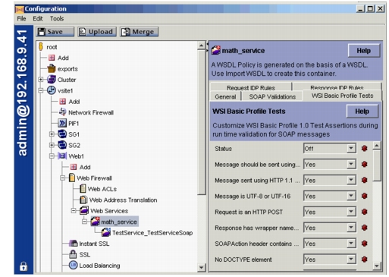
The following table describes the WSI Basic Profile Test container parameters.
Parameter | Description | Values
Status | Enables the test profile. If set to Off, the NC-Gateway will disable (not perform) the entire test profile. | On  Off (default)
Message should be sent using HTTP 1.1 | If set to Yes, a message not sent using HTTP version 1.1 is considered an intrusion. | Yes (default)  No
Message sent using HTTP 1.1 or HTTP 1.0 | If set to Yes, a message sent using either HTTP version 1.0 or 1.1 is considered valid; all others are considered intrusions.  Note: The previous parameter takes precedence if both are set to Yes. However, if this is set to No, the previous parameter is automatically disabled because this parameter is a prerequisite. | Yes (default)  No
Message is UTF-8 or UTF-16 | If set to Yes, a message that does not conform to UTF-8 or UTF-16 is considered an intrusion. | Yes (default)  No
Request is an HTTP POST | If set to Yes, a request that is not an HTTP POST is considered an intrusion. | Yes (default)  No
Response has wrapper named after the operation | If set to Yes, a response with a wrapper that is not named after the wsdl:operation name is considered an intrusion. | Yes (default)  No
SOAP Action header contains a quoted string | If set to Yes, a message with an HTTP soapAction header that does not contain a quoted string is considered an intrusion. | Yes (default)  No
No DOCTYPE element | If set to Yes, a message that contains a DOCTYPE element is considered an intrusion. | Yes (default)  No
Message part accessors have proper namespaces | If set to Yes, a message with an rpc-literal binding that places any part accessor elements in a namespace is considered an intrusion. | Yes (default)  No
Message includes all specified headers | If set to Yes, a message that does not contain all the soapbind:headers specified in the WSDL file is considered an intrusion. | Yes (default)  No
One way responses have an empty body | If set to Yes, an HTTP one-way response that includes a SOAP envelope (that is, does not have an empty body) is considered an intrusion. | Yes (default)  No
Request content matches WSDL | If set to Yes, a request whose content does not conform to the WSDL file definition is considered an intrusion. | Yes (default)  No
soap:fault generated for bad envelope namespace | If set to Yes, a message with an envelope element with a namespace name other than http://schemas.xmlsoap.org/soap/envelope/ is considered an intrusion. | Yes (default)  No
Response content matches WSDL | If set to Yes, a response whose content does not conform to the WSDL file definition is considered an intrusion. | Yes (default)  No
Faults do not use dot notation | If set to Yes, a message with a fault code that includes dot notation is considered an intrusion. | Yes (default)  No
Good response uses 200 OK status | If set to Yes, an HTTP response that contains a SOAP message (other than a fault) and a status other than 200 OK is considered an intrusion. | Yes (default)  No
Processed response uses either 200 or 202 status | If set to Yes, an HTTP response (no embedded SOAP message) that includes a successful request outcome with a status other than 200 or 202 is considered an intrusion. | Yes (default)  No
Non POST request gets 405 response | If set to Yes, an HTTP response to a non-POST request with a status other than 405 is considered an intrusion. | Yes (default)  No
Non XML request gets 415 response | If set to Yes, an HTTP response to a non-XML request with a status other than 415 is considered an intrusion. | Yes (default)  No
Fault response is defined in wsdl:binding | If set to Yes, a message that generates a fault not defined in the wsdl:binding (that is, a soapbind:fault describing each known fault) is considered an intrusion. | Yes (default)  No
WS-I conformance claims are in soap:header | If set to Yes, a message with a conformance claim not carried as a SOAP header block is considered an intrusion. | Yes (default)  No
WS-I conformance claims are well-formed | If set to Yes, a message with a conformance claim that is not well formed is considered an intrusion. | Yes (default)  No
WS-I conformance claims are not mustUnderstand | If set to Yes, a message with a conformance claim that includes a soap:mustUnderstand attribute is considered an intrusion. | Yes (default)  No
SOAPAction header matches op soapAction | If set to Yes, a message whose SOAPAction HTTP header field does not match the WSDL soapAction attribute in soapbind:operation (either the same value or a blank quoted string if not present) is considered an intrusion. | Yes (default)  No
Message body is a soap:envelope with namespace | If set to Yes, a message with an Envelope element that includes a namespace other than http://schemas.xmlsoap.org/soap/envelope/ is considered an intrusion. | Yes (default)  No
soap:body children are namespace qualified | If set to Yes, a message with a child of the soap:Body element that is not namespace qualified is considered an intrusion. | Yes (default)  No
soap:fault detail has only non env namespaces | If set to Yes, a message that contains a soap:fault element with a qualified namespace is considered an intrusion. | Yes (default)  No
No soapenc:arrayType attribute | If set to Yes, a message with serialized arrays that contains a soapenc:arrayType attribute is considered an intrusion. | Yes (default)  No
No XML processing instructions in body | If set to Yes, a message with XML processing instructions in the body is considered an intrusion. | Yes (default)  No
Part accessors do not have xsi:nil valued 1 or true | If set to Yes, a message with an xsi:nil value of 1 or true is considered an intrusion. | Yes (default)  No
mustUnderstand is 1 or 0 | If set to Yes, a message with a soap:mustUnderstand value other than 1 or 0 is considered an intrusion. | Yes (default)  No
soap:faultcode is standard or NS qualified | If set to Yes, a message that contains a fault code that is neither a SOAP 1.1 default nor namespace qualified is considered an intrusion. | Yes (default)  No
soap:fault contained in HTTP 500 message | If set to Yes, a soap:fault response whose HTTP status code is not 500 is considered an intrusion. | Yes (default)  No
soap:fault has only allowed children | If set to Yes, a soap:fault response with an unallowed child element (one other than faultcode, detail, faultstring, or faultactor) is considered an intrusion. | Yes (default)  No
No encodingStyle in env namespaced elements | If set to Yes, a message that contains soap:encodingStyle attributes on any elements whose namespace is http://schemas.xmlsoap.org/soap/envelope/ is considered an intrusion. | Yes (default)  No
No soap:encodingStyle on body children | If set to Yes, a message with soap:encodingStyle attributes on any element that is a child of soap:Body is considered an intrusion. | Yes (default)  No
Envelope does not have children after body | If set to Yes, a message with any element children of soap:Envelope following the soap:Body element is considered an intrusion. | Yes (default)  No
soap:fault children are unqualified | If set to Yes, a message that contains a soap:Fault element with a qualified child is considered an intrusion. | Yes (default)  No
No encodingStyle in grandchildren of rpc literal | If set to Yes, a message in an rpc-literal binding with a soap:encodingStyle attribute on any element that is a grandchild of soap:Body is considered an intrusion. | Yes (default)  No
soap:envelope and soap:body are good XML 1.0 | If set to Yes, a message with a soap:envelope or soap:body that does not conform to XML 1.0 is considered an intrusion. | Yes (default)  No
soap:envelope conforms to SOAP schema | If set to Yes, a message whose soap:envelope does not conform to the SOAP schema is considered a intrusion. | Yes (default)  No
Configure Request IDP Rules
Intrusion, detection, and prevention (IDP) rules allow you to set custom validation criteria for SOAP requests (or responses). For example, you can create an IDP rule that aborts request processing if there are more than 50 total elements in the XML or if the document does not match a WSDL message. You can limit the message size or total number of bytes per minute, hour, or day, minimizing the chance of an unknown attacker overwhelming the service with too much data.
There are four IDP request rules configured and active by default:
- authentication failure
- invalid WSDL message
- large document
- process error
To create or modify a request (or response) IDP rule, do the following:
- From the Configuration Window, select vsite > web_app > Web Firewall > Web Services > wsdl_policy, the Request IDP Rules tab (or the Response IDP Rules tab), and the Add (or the target rule and the Edit) button.
- The Request (or Response) IDP Rule dialog appears. In this dialog, do the following (in the indicated parameter fields):
  - Name (Add parameter only; does not appear on the Edit screen): Enter a name for this rule.
  - Status: Keep the default of On.
  - Mode: Select (from the pull-down menu) whether to enable this rule in Active (blocking) or Passive (monitoring and logging only) mode.
  - Detection Criteria: Select (from the pull-down menu) the message criterion to evaluate, such as the maximum byte count.
  - Value: Enter the quantity or count for the detection criterion. For example, if this rule is to check for a maximum byte count of 10 gigabytes, enter 10 in the field. (This parameter is irrelevant when the detection criterion does not need a value.)
  - Units: Select (from the pull-down menu) the unit size for the detection criterion. For example, if this rule is to check for a maximum byte count in gigabytes, select GB for this field. (This parameter is irrelevant when the detection criterion does not need a value.)
  - Accumulate Over: Select (from the pull-down menu) the time duration to accumulate the detection criterion data. For example, if this rule is to check for a maximum byte count per hour, select One Hour for this field. (This parameter is irrelevant when the detection criterion does not need a time duration.)
  - Click OK to save and close the dialog.
- Click Upload in the Configuration Window to save and activate the new settings.
The following figure illustrates an IDP request rule to limit requests to a maximum of 10 GB per hour (to protect against DoS attacks).
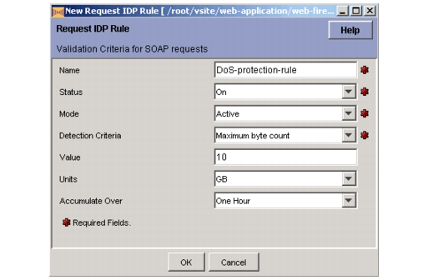
The following tabledescribes the Request and Response IDP Rules container parameters.
Parameter | Description | Values
Name | Sets a name for this rule. (Names cannot contain spaces, slashes, punctuation, or special characters.) | User defined
Status | Enables this rule. If a rule is turned off, the NC-Gateway will not use that rule for any Web services traffic inspections. | On (default)  Off
Mode | Sets whether to apply the rule in active (blocking) or passive (monitoring and logging) mode. (See the "Passive versus Active Mode" section in Appendix C, "Usage Guidelines," of the NetContinuum Application Security Gateway Application Configuration Guide (449-000018-00) for information about passive versus active mode.) | Active (default)  Passive
Detection Criteria | Sets the criterion to evaluate for this rule. For example, selecting Maximum byte count causes the NC-Gateway to check the message size and determine whether it exceeds the maximum byte count.  When selecting a criterion that requires an amount, the amount is specified in the Value and Units parameters. If a duration is needed, that is entered in the Accumulate Over parameter. | ² Attempted XML external URI reference  ² Authentication Failed  ² Document does not match any WSDL message  ² Document does not match any XML filter  ² Document processing error  ² Maximum byte count  ² Maximum document count  ² Maximum document size  ² Maximum element children  ² Maximum element count  ² Maximum element depth  ² Minimum document size  See Detection Criteria Descriptions for descriptions.
Value | Sets the numeric size or count value for the selected detection criterion. This is required for criteria that need a value. (For other criteria, it is ignored and can be left blank.) | User defined
Units | Sets the unit size (byte, kilobyte, megabyte, or gigabyte) for the selected detection criterion. This is required for criteria that need a unit size. (For other criteria, it is ignored and can be left blank.) | Bytes  GB  KB  MB
Accumulate Over | Sets the time period (minute, hour, or day) to use when aggregating data. This represents a moving window for that interval; for example, one day means any 24 hour interval rather than a calendar day. This is required for criteria that need a time interval. (For other criteria, it is ignored and can be left blank.) For example, you set this to specify an interval for the maximum byte or document count. If an interval is not set for these detection criteria, all subsequent requests are denied once the maximum amount is reached. | One Day  One Hour  One Minute
The following table describes the Detection Criteria parameter values in more detail.
Rule | Description
Attempted XML external URI reference | Setting for managing unsuccessful XML external URI reference requests on this policy.
Authentication Failed | Setting for documents on which authentication fails on this policy.
Document does not match any WSDL message | Setting for a document that does not match any WSDL message on this policy.
Document does not match any XML filter | Setting for a document request that does not match any XML filter on this policy.
Document processing error | Setting for managing processing errors on this policy.
Maximum byte count | Setting for a maximum byte count allowed for the SOAP messages or XML documents. The system cumulatively adds the byte count of processed requests and when reaching the value set, triggers the rule. The rule continues to be triggered as more requests are processed through the system until the specified period of time expires. Note: Must enter Value, Units, and Accumulate Over parameters when this is set.
Maximum document count | Setting for the maximum number of documents allowed on this policy. The system examines one single request. Note: Must enter Value parameter when this is set.
Maximum document size | Setting for a maximum document size allowed on this policy. Any documents that exceed this maximum, are considered an intrusion. Note: Must enter Value and Units parameters when this is set.
Maximum element children | Setting for the maximum number of children per document allowed on this policy. Note: Must enter Value parameter when this is set.
Maximum element count | Setting for the maximum number of elements per document allowed on this policy. Note: Must enter Value parameter when this is set.
Maximum element depth | Setting for the maximum nesting depths of elements allowed on this policy. Note: Must enter Value parameter when this is set.
Minimum document size | Setting for the minimum document size allowed on this policy. Note: Must enter Value and Units parameters when this is set.

Configure Response IDP Rules
As with requests, you can create IDP rules for responses. The same set of choices and options apply to both request and response rules. See Configure Request IDP Rules" for the procedure to configure a response IDP rule.
There are three IDP response rules configured and active by default:
- invalid WSDL message
- large document
- process error
The following figure illustrates an IDP response rule to limit the element depth in any response to a maximum of 25.
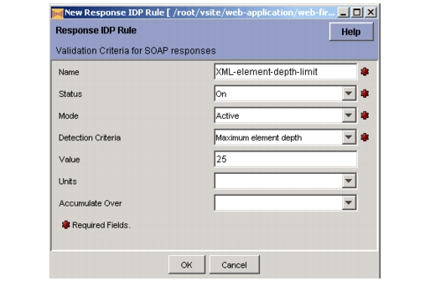
Enabling Web Service Access
A Web service access container is created automatically when the WSDL file is imported, but access is not enabled by default. To enable Web service access (or modify one or more parameter values), do the following:
- From the Configuration Window, select vsite > web_app > Web Firewall > Web Services > wsdl_policy > wsdl_access.
- Status: Change the default (No) to Yes to enable access to the Web service.
- Web Service Name: This is the name of the Web service as defined in the WSDL file. (You cannot change it.)
- Web Service Port Name: This is the port name as defined in the WSDL file. (You cannot change it.)
- Web Service Published Host: Enter the host domain that requesters should use to access this Web service.
- Web Service Published URL: Enter the URL that requesters should use to access this Web service.
- Enable WSDL Access: Change the default (No) to Yes to allow direct access to the WSDL file, which allows requesters to see the policies for this Web service.
- Click Upload in the Configuration Window to save and activate the new settings.
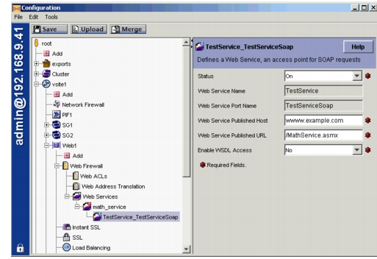
The following table describes the Web service access container parameters.
Parameter | Description | Values
Status | Enables access to this Web service. | On  Off (default)
Web Service Name | Specifies the name for the Web service. This is derived from the WSDL file and cannot be changed without importing a new file. | WSDL file defined
Web Service Port Name | Specifies the port name for the Web service. This is derived from the WSDL file and cannot be changed without importing a new file. | WSDL file defined
Web Service Published Host | Sets the external host address that can be published to users of this Web service.This parameter is not automatically updated when a VIP or domain was changed.  Example:  ² www.netcontinuum.com | User defined
Web Service Published URL | Sets the external URL that can be published to users of this Web service. Example:  ² /soap/MathService.asmx  Note: This is for an external URL only. There is no parameter for an internal URL. To establish an internal URL, create a URL translation rule (see Chapter 7, "Web Address Translation," in the NetContinuum Application Security Gateway Application Configuration Guide (449-000018-00)). | User defined
Enable WSDL Access | Sets whether requesters have access to the WSDL file. Setting this to Yes allows Web service requesters to see the policies for this Web service. This is a common method to allow clients access to the Web service policies. | Yes  No (default
Enabling Web Service Security
Access to and validation of a Web service is configured through a URL ACL. A Web service URL ACL is configured the same way as other URL ACLs. In addition, many standard Web application security features also apply to a Web service. This chapter describes how to create a Web service URL ACL and how to configure a Web application for a Web service. This chapter covers the following topics:
- Creating a Web Service URL ACL
- Enabling SOAP Validation
- Configuring Other Security Features
  - Configure Authentication and Access Control
  - Configure Request Limits
  - Configure URL Normalization
  - Configure Data Theft Protection
  - Configure Attack Prevention
  - Configure Encryption
  - Configure Cookie Security
Creating a Web Service URL ACL
A URL ACL for each Web service is needed to allow access. Any policies for the Web service that are applicable at the URL ACL level are configured in this URL ACL (as described in the following sections). Such a URL ACL is created automatically when you import a WSDL file, but you can modify that URL ACL or create a new URL ACL for a Web service.
To create (or edit) a URL ACL for a Web service, do the following:
- From the Configuration Window, select vsite > web_app > Web Firewall > Web ACLs, the URL ACLs tab, and the Add (or the target ACL and the Edit) button in the Web application that hosts the Web service.
- The URL ACL dialog appears at the General Tab. Enter the appropriate information for the Web service. See the "URL ACL" section in Chapter 6, "Web ACLs," in the NetContinuum Application Security Gateway Application Configuration Guide (449-000018-00) for instructions on how to create a URL ACL.
While you can configure DAP for a URL ACL intended for a Web service, DAP is of limited use for SOAP messages.
Enabling SOAP Validation
SOAP validation is enabled within the Web service URL ACL. The automatically created URL ACL enables SOAP validation for requests only. To change the SOAP validation type, do the following:
- Open a Web service URL ACL dialog (see the previous section).
- Select the SOAP Security tab.
- For the SOAP Validation parameter, select (from the pull-down menu) Request and Response (to validate both requests and responses), Request Only (to validate just requests), Block (to block all SOAP messages), or None (to disable SOAP validation).
The "Request and Response" and "Request Only" require an Web Services Firewall license to function
- Select OK to save and close the URL ACL dialog. (This can be done immediately or after configuring the other tabs.)
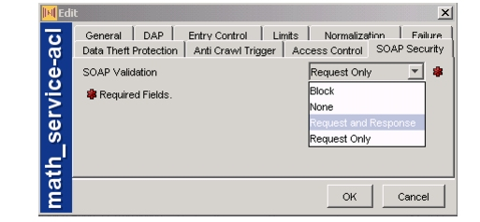
Configuring Other Security Features
The following sections describe how to configure other Web application security features for a Web service. These features are not specific to SOAP messages; they are general Web application security features that also apply to a Web service.
Configure Authentication and Access Control
The NC-Gateway supports two methods of authentication and access control for a Web service:
- SSL client certificates (see Configure Encryption"): User credentials derived from the client certificate allow access to an entire Web application with no further granularity.
- Login authentication: User credentials derived from the HTTP-based login authentication process can be applied at the URL ACL level. Access control for a Web service is configured on the Web service URL ACL (see Creating a Web Service URL ACL").
There are two options for HTTP-based login authentication:
- HTTP basic authentication. This is the usual mechanism for SOAP clients.
- HTTP form (login) authentication, that is, a POST HTTP request with parameters identifying the user ID and password. This is the usual mechanism for user authentication (not SOAP clients).
To configure login authentication and access control for a Web service, do the following (referenced sections are in the NetContinuum Application Security Gateway Application Configuration Guide (449-000018-00)):
- Associate an authentication database with the Web application that hosts the Web service as described in the "Authenticating a Database" section in Chapter 8, "User Access Control."
- Configure authentication and set basic authentication to On.
- In the Web service URL ACL, configure access control as described in the "Configuring Controlling Access" section in Chapter 6, "Web ACLs."
Configure Request Limits
The request limits set for the parent Web application also apply to SOAP messages. Note these are limits related to the HTTP message in general; SOAP-specific limits are configured through request IDP rules (see Configure Request IDP Rules").
To modify the HTTP message limits, do the following:
- From the Configuration Window, select vsite > web_app > Web Firewall and the Request Limits tab for the Web application that hosts the Web service. See the "Configuring Request Limits" section in Chapter 5, "Web Firewalls," in the NetContinuum Application Security Gateway Application Configuration Guide (449-000018-00) for instructions on how to configure HTTP request limits.
- Customize the limits (as needed) for each Web service URL ACL. See the "Configuring Limits" section in Chapter 6, "Web ACLs," in the NetContinuum Application Security Gateway Application Configuration Guide (449-000018-00) for instructions on how to configure URL ACL-specific limits
Configure URL Normalization
The URL normalization policies set for the parent Web application also apply to SOAP messages. To modify the normalization policies, do the following:
- From the Configuration Window, select vsite > web_app > Web Firewall and the URL Normalization tab for the Web application that hosts the Web service. See the "Configuring URL Normalization" section in Chapter 5, "Web Firewalls," in the NetContinuum Application Security Gateway Application Configuration Guide (449-000018-00) for instructions on how to configure URL normalization.
- Customize the normalization policy (as needed) for each Web service URL ACL. See the "Configuring Normalization" section in Chapter 6, "Web ACLs," in the NetContinuum Application Security Gateway Application Configuration Guide (449-000018-00) for instructions on how to configure URL ACL-specific normalization policy.
Configure Data Theft Protection
The data theft protections set for the parent Web application also apply to SOAP messages. SOAP responses are scanned for the specified data patterns and, upon detecting a match, are either blocked or forwarded with the matching pattern cloaked.
To configure data theft protection for SOAP messages, do the following:
- From the Configuration Window, select vsite > web_app > Web Firewall and the Data Theft Protection tab for the Web application that hosts the Web service. See "Configuring Data Theft Protection" in Chapter 5, "Web Firewalls," in the NetContinuum Application Security Gateway Application Configuration Guide (449-000018-00) for instructions on how to configure data theft protection.
- Enable data theft protection for each Web service URL ACL. See "Configuring Data Theft Protection" in Chapter 6, "Web ACLs," in the NetContinuum Application Security Gateway Application Configuration Guide (449-000018-00) for instructions on how to enable data theft protection for a URL ACL
Configure Attack Prevention
The SQL injection, cross-site scripting, and other potential attack type protections set for the parent Web application also apply to the HTTP header of SOAP messages. Headers in SOAP requests are checked for the configured attack patterns, and requests that match any of these patterns are blocked. Note these are validations related to the HTTP header; SOAP-specific header validations are configured through the SOAP validation parameters (see Configure SOAP Validations").
While parameter ACLs configured for the Web application apply to SOAP messages, parameter ACLs check HTTP parameter values (not SOAP parameter values), so they are irrelevant for SOAP messages.
To configure HTTP header attack prevention for SOAP messages, do the following:
- From the Configuration Window, select vsite > web_app > Web Firewall > Web ACLs, the Header ACLs tab, and the Add (or the target ACL and the Edit) button in the Web application that hosts the Web service.
- The Header ACL dialog appears. Enter the appropriate information for the Web service. See the "Header ACL" section in Chapter 6, "Web ACLs," in the NetContinuum Application Security Gateway Application Configuration Guide (449-000018-00) for instructions on how to create a header ACL.
Configure Encryption
Message integrity is provided through SSL encryption. The SSL encryption configured for the parent Web application also applies to SOAP messages. The NC-Gateway provides the following SSL options:
- Client-side encryption: This uses digital certificates for SSL encryption between the client and the NC-Gateway. The certificate authenticates the server to the client.
- Server-side encryption: This uses trusted certificates for SSL encryption between the NC-Gateway and back-end servers.
- Client authentication: This uses trusted certificates to authenticate clients, and it allows users to access sensitive portions of a Web site.
- Instant SSL: This redirects an HTTP connection to an established HTTPS connection.
See Chapter 4, "Encrypting Application Traffic," in the NetContinuum Application Security Gateway Application Configuration Guide (449-000018-00) for instructions on how to configure these SSL options.
Configure Cookie Security
The cookie security policies set for the parent Web application also apply to SOAP messages. A cookie is a simple text file that stores Web application state information and is susceptible to a number of potential attacks.
Cookie security is disabled by default. See the "Configuring Cookie Security" section in Chapter 5, "Web Firewalls," in the NetContinuum Application Security Gateway Application Configuration Guide (449-000018-00) for instructions on how to configure cookie security.
WSDL Files
WSDL Files
This appendix describes the standard WSDL syntax and provides sample code. This appendix covers the following topics:
- WSDL 1.2 Syntax
- Sample WSDL Code
WSDL 1.2 Syntax
The following code is the syntax defined for WSDL version 1.2 by the W3C:
<wsdl:definitions name="nmtoken"? targetNamespace="uri">
<import namespace="uri" location="uri"/> *
<wsdl:documentation .... /> ? <wsdl:types> ?
<wsdl:documentation .... /> ?
<xsd:schema .... /> *
</wsdl:types>
<wsdl:message name="ncname"> *
<wsdl:documentation .... /> ?
<part name="ncname" element="qname"? type="qname"?/> *
</wsdl:message>
<wsdl:portType name="ncname"> *
<wsdl:documentation .... /> ?
<wsdl:operation name="ncname"> *
<wsdl:documentation .... /> ?
<wsdl:input message="qname"> ?
<wsdl:documentation .... /> ?
</wsdl:input>
<wsdl:output message="qname"> ?
<wsdl:documentation .... /> ?
</wsdl:output>
<wsdl:fault name="ncname" message="qname"> *
<wsdl:documentation .... /> ?
</wsdl:fault>
</wsdl:operation>
</wsdl:portType>
<wsdl:serviceType name="ncname"> *
<wsdl:portType name="qname"/> +
</wsdl:serviceType>
<wsdl:binding name="ncname" type="qname"> *
<wsdl:documentation .... /> ?
<-- binding details --> *
<wsdl:operation name="ncname"> *
<wsdl:documentation .... /> ?
<-- binding details --> *
<wsdl:input> ?
<wsdl:documentation .... /> ?
<-- binding details -->
</wsdl:input>
<wsdl:output> ?
<wsdl:documentation .... /> ?
<-- binding details --> *
</wsdl:output>
<wsdl:fault name="ncname"> *
<wsdl:documentation .... /> ?
<-- binding details --> *
</wsdl:fault>
</wsdl:operation>
</wsdl:binding>
<wsdl:service name="ncname" serviceType="qname"> *
<wsdl:documentation .... /> ?
<wsdl:port name="ncname" binding="qname"> *
<wsdl:documentation .... /> ?
<-- address details -->
</wsdl:port>
</wsdl:service></wsdl:definitions>
Sample WSDL Code
The following code is a sample WSDL file for a simple math service that adds, subtracts, multiplies, and divides.
<?xml version="1.0" encoding="UTF-8"?>
<definitions targetNamespace="http://example.com/webservices"
xmlns:tm="http://example.com/wsdl/mime/textMatching/"
xmlns:mime="http://schemas.xmlsoap.org/wsdl/mime/"
xmlns:http="http://schemas.xmlsoap.org/wsdl/http/"
xmlns:soapenc="http://schemas.xmlsoap.org/soap/encoding/"
xmlns:s0="http://example.com/webservices"
xmlns:soap="http://schemas.xmlsoap.org/wsdl/soap/"
xmlns:s="http://www.w3.org/2001/XMLSchema"
xmlns="http://schemas.xmlsoap.org/wsdl/">
<types>
<s:schema elementFormDefault="qualified"
targetNamespace="http://example.com/webservices"
<s:element name="Divide">
<s:complexType>
<s:sequence>
<s:element maxOccurs="1" minOccurs="1"
name="a" type="s:int"/>
<s:element maxOccurs="1" minOccurs="1"
name="b" type="s:int"/>
</s:sequence>
</s:complexType>
</s:element>
<s:element name="DivideResponse">
<s:complexType>
<s:sequence>
<s:element maxOccurs="1" minOccurs="1"
name="DivideResult" type="s:int"/>
</s:sequence>
</s:complexType>
</s:element>
<s:element name="Multiply">
<s:complexType>
<s:sequence>
<s:element maxOccurs="1" minOccurs="1"
name="a" type="s:int"/>
<s:element maxOccurs="1" minOccurs="1"
name="b" type="s:int"/>
</s:sequence>
</s:complexType>
</s:element>
<s:element name="MultiplyResponse">
<s:complexType>
<s:sequence>
<s:element maxOccurs="1" minOccurs="1"
name="MultiplyResult" type="s:int"/>
</s:sequence>
</s:complexType>
</s:element>
<s:element name="Subtract">
<s:complexType>
<s:sequence>
<s:element maxOccurs="1" minOccurs="1"
name="a" type="s:int"/>
<s:element maxOccurs="1" minOccurs="1"
name="b" type="s:int"/>
</s:sequence>
</s:complexType>
</s:element>
<s:element name="SubtractResponse">
<s:complexType>
<s:sequence>
<s:element maxOccurs="1" minOccurs="1"
name="SubtractResult" type="s:int"/>
</s:sequence>
</s:complexType>
</s:element>
<s:element name="Add">
<s:complexType>
<s:sequence>
<s:element maxOccurs="1" minOccurs="1"
name="a" type="s:int"/>
<s:element maxOccurs="1" minOccurs="1"
name="b" type="s:int"/>
</s:sequence>
</s:complexType>
</s:element>
<s:element name="AddResponse">
<s:complexType>
<s:sequence>
<s:element maxOccurs="1" minOccurs="1"
name="AddResult" type="s:int"/>
</s:sequence>
</s:complexType>
</s:element>
</s:schema>
</types>
<message name="DivideSoapOut">
<part name="parameters" element="s0:DivideResponse"/>
</message>
<message name="SubtractSoapOut">
<part name="parameters" element="s0:SubtractResponse"/>
</message>
<message name="MultiplySoapOut">
<part name="parameters" element="s0:MultiplyResponse"/>
</message>
<message name="MultiplySoapIn">
<part name="parameters" element="s0:Multiply"/>
</message>
<message name="SubtractSoapIn">
<part name="parameters" element="s0:Subtract"/>
</message>
<message name="DivideSoapIn">
<part name="parameters" element="s0:Divide"/>
</message>
<message name="AddSoapOut">
<part name="parameters" element="s0:AddResponse"/>
</message>
<message name="AddSoapIn">
<part name="parameters" element="s0:Add"/>
</message>
<portType name="TestServiceSoap">
<operation name="Divide">
<input message="s0:DivideSoapIn"/>
<output message="s0:DivideSoapOut"/>
</operation>
<operation name="Multiply">
<input message="s0:MultiplySoapIn"/>
<output message="s0:MultiplySoapOut"/>
</operation>
<operation name="Subtract">
<input message="s0:SubtractSoapIn"/>
<output message="s0:SubtractSoapOut"/>
</operation>
<operation name="Add">
<input message="s0:AddSoapIn"/>
<output message="s0:AddSoapOut"/>
</operation>
</portType>
<binding name="TestServiceSoap" type="s0:TestServiceSoap">
<soap:binding style="document"
transport="http://schemas.xmlsoap.org/soap/http"/>
<operation name="Divide">
<soap:operation
soapAction="http://example.com/webservices/Divide"
style="document"/>
<input>
<soap:body use="literal"/>
</input>
<output>
<soap:body use="literal"/>
</output>
</operation>
<operation name="Multiply">
<soap:operation
soapAction="http://example.com/webservices/Multiply"
style="document"/>
<input>
<soap:body use="literal"/>
</input>
<output>
<soap:body use="literal"/>
</output>
</operation>
<operation name="Subtract">
<soap:operation
soapAction="http://example.com/webservices/Subtract"
style="document"/>
<input>
<soap:body use="literal"/>
</input>
<output>
<soap:body use="literal"/>
</output>
</operation>
<operation name="Add">
<soap:operation
soapAction="http://example.com/webservices/Add"
style="document"/>
<input>
<soap:body use="literal"/>
</input>
<output>
<soap:body use="literal"/>
</output>
</operation>
</binding>
<service name="TestService">
<port name="TestServiceSoap" binding="s0:TestServiceSoap">
<soap:address
location="http://192.168.0.229:8090/MathService.asmx"/>
</port>
</service>
</definitions>

