Calculus Terminology

Absolute Convergence  Absolute Maximum  Absolute Minimum  Absolutely Convergent  Acceleration  Alternating Series  Alternating Series Remainder  Alternating Series Test  Analytic Methods  Annulus  Antiderivative of a Function  Approximation by Differentials  Arc Length of a Curve  Area below a Curve  Area between Curves  Area of an Ellipse  Area of a Parabolic Segment  Area under a Curve  Area Using Parametric Equations  Area Using Polar Coordinates |  | Asymptote  Average Rate of Change  Average Value of a Function  Axis of Rotation  Boundary Value Problem  Bounded Function  Bounded Sequence  Bounds of Integration  Calculus  Cartesian Form  Cavalieri’s Principle  Center of Mass Formula  Centroid  Chain Rule  Comparison Test  Concave  Concave Down  Concave Up  Conditional Convergence  Constant Term | Continued Sum  Continuous Function  Continuously Differentiable Function  Converge  Converge Absolutely  Converge Conditionally  Convergence Tests  Convergent Sequence  Convergent Series  Critical Number  Critical Point  Critical Value  Curly d  Curve  Curve Sketching  Cusp  Cylindrical Shell Method  Decreasing Function  Definite Integral  Definite Integral Rules
Degenerate  Del Operator  Deleted Neighborhood  Derivative  Derivative of a Power Series  Derivative Rules  Difference Quotient  Differentiable  Differential  Differential Equation  Differentiation  Differentiation Rules  Discontinuity  Discontinuous Function  Disk  Disk Method  Distance from a Point to a Line  Diverge  Divergent Sequence | Divergent Series  e  Ellipsoid  End Behavior  Essential Discontinuity  Explicit Differentiation  Explicit Function  Exponential Decay  Exponential Growth  Exponential Model  Extreme Value Theorem  Extreme Values of a Polynomial  Extremum  Factorial  Falling Bodies  First Derivative  First Derivative Test  First Order Differential Equation  Fixed |  |  | Function Operations  Fundamental Theorem of Calculus  GLB  Global Maximum  Global Minimum  Golden Spiral  Graphic Methods  Greatest Lower Bound  Greek Alphabet  Harmonic Progression  Harmonic Sequence  Harmonic Series  Helix  Higher Derivative  Hole  Homogeneous System of Equations  Hyperbolic Trig  Hyperbolic Trigonometry  Identity Function  Implicit Differentiation

Implicit Function or Relation  Improper Integral  Increasing Function  Indefinite Integral  Indefinite Integral Rules  Indeterminate Expression  Infinite Geometric Series  Infinite Limit  Infinite Series  Infinitesimal  Infinity  Inflection Point  Initial Value Problem  Instantaneous Acceleration  Instantaneous Rate of Change  Instantaneous Velocity  Integrable Function  Integral  Integral Methods  Integral of a Function |  | Integral of a Power Series  Integral Rules  Integral Test  Integral Test Remainder  Integrand  Integration  Integration by Parts  Integration by Substitution  Integration Methods  Intermediate Value Theorem  Interval of Convergence  Iterative Process  IVP  IVT  Jump Discontinuity  L'Hôpital's Rule  Least Upper Bound  Limit  Limit Comparison Test | Limit from Above  Limit from Below  Limit from the Left  Limit from the Right  Limit Involving Infinity  Limit Test for Divergence  Limits of Integration  Local Behavior  Local Maximum  Local Minimum  Logarithmic Differentiation  Logistic Growth  LUB  Mathematical Model  Maximize  Maximum of a Function  Mean Value Theorem  Mean Value Theorem for Integrals  Mesh  Min/Max Theorem
Minimize  Minimum of a Function  Mode  Model  Moment  Multivariable  Multivariable Analysis  Multivariable Calculus  Multivariate  MVT  Neighborhood  Newton's Method  Norm of a Partition  Normal  nth Degree Taylor Polynomial  nth Derivative  nth Partial Sum  n-tuple  Oblate Spheroid  One-Sided Limit | Operations on Functions  Order of a Differential Equation  Ordinary Differential Equation  Orthogonal  p-series  Parallel Cross Sections  Parameter (algebra)  Parametric Derivative Formulas  Parametric Equations  Parametric Integral Formula  Parametrize  Partial Fractions  Partial Sum of a Series  Partition of an Interval  Piecewise Continuous Function  Pinching Theorem  Polar Derivative Formulas  Polar Integral Formula  Positive Series  Power Rule |  |  | Power Series  Power Series Convergence  Product Rule  Projectile Motion  Prolate Spheroid  Quotient Rule  Radius of Convergence  Ratio Test  Rationalizing Substitutions  Reciprocal Rule  Rectangular Form  Related Rates  Relative Maximum  Relative Minimum  Remainder of a Series  Removable Discontinuity  Riemann Sum  Rolle's Theorem  Root Test  Sandwich Theorem
Scalar  Secant Line  Second Derivative  Second Derivative Test  Second Order Critical Point  Second Order Differential Equation  Separable Differential Equation  Sequence  Sequence of Partial Sums  Series  Series Rules  Shell Method  Sigma Notation  Simple Closed Curve  Simple Harmonic Motion (SHM) |  | Simpson's Rule  Slope of a Curve  Solid  Solid of Revolution  Solve Analytically  Solve Graphically  Speed  Squeeze Theorem  Step Discontinuity  Substitution Method  Surface  Surface Area of a Surface of Revolution  Surface of Revolution  Tangent Line  Taylor Polynomial |  |  | Taylor Series  Taylor Series Remainder  Theorem of Pappus  Torus  Trapezoid Rule  Trig Substitution  u-Substitution  Uniform  Vector Calculus  Velocity  Volume  Volume by Parallel Cross Sections  Washer  Washer Method  Work
Absolute Convergence
Absolutely Convergent
Describes a series that converges when all terms are replaced by their absolute values. To see if a series converges absolutely, replace any subtraction in the series with addition. If the new series converges, then the original series converges absolutely.
Note: Any series that converges absolutely is itself convergent.
Definition: | A series 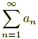is absolutely convergent if the series 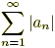converges.
Example: | Determine if 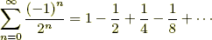 is absolutely convergent.
Solution: | To find out, consider the series 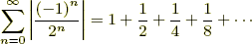 .
 | This is an infinite geometric series with ratio 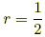, so it converges to 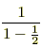or 2. As a result, we know that 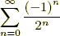converges absolutely.

Absolute Maximum, Absolute Max
Global Maximum, Global Max
The highest point over the entire domain of a function or relation.
Note: The first derivative test and the second derivative test are common methods used to find maximum values of a function.

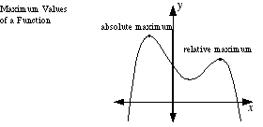

Absolute Minimum, Absolute Min
Global Minimum, Golbal Min
The lowest point over the entire domain of a function or relation.
Note: The first derivative test and the second derivative test are common methods used to find minimum values of a function.

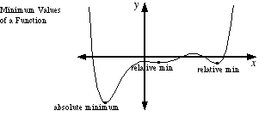

Acceleration
The rate of change of velocity over time. For motion along the number line, acceleration is a scalar. For motion on a plane or through space, acceleration is a vector.

Absolutely Convergent
See Absolute Convergence

Alternating Series
A series which alternates between positive and negative terms. For example, the series 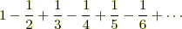is alternating.

Alternating Series Remainder
A quantity that measures how accurately the nth partial sum of an alternating series estimates the sum of the series.
Consider the following alternating series (where an > 0 for all n) and/or its equivalents.
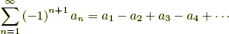
If the series converges to S by the alternating series test, then the remainder
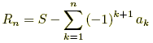
can be estimated as follows for all n ≥ N:
Here, N is the point at which the values of an become non-increasing:

Alternating Series Test
A convergence test for alternating series.
Consider the following alternating series (where a_{n} > 0 for all n) and/or its equivalents:
The series converges if the following conditions are met:

Analytic Methods
The use of algebraic and/or numeric methods as the main technique for solving a math problem. The instructions "solve using analytic methods" and "solve analytically" usually mean that no calculator is allowed.
Annulus
See Washer

Antiderivative of a Function
A function that has a given function as its derivative. For example, F(x) = x³ – 8 is an antiderivative of f(x) = 3x².

Approximation by Differentials
A method for approximating the value of a function near a known value. The method uses the tangent line at the known value of the function to approximate the function's graph. In this method Δx and Δy represent the changes in x and y for the function, and dx and dy represent the changes in x and y for the tangent line.
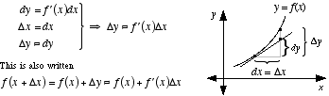
Example: | Approximate by differentials.
Solution: | is near , so we will use with x = 9 and Δx = 1.  Note that 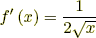.  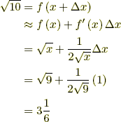  Thus we see that 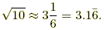  This is very close to the correct value of

Arc Length of a Curve
The length of a curve or line.
The length of an arc can be found by one of the formulas below for any differentiable curve defined by rectangular, polar, or parametric equations.
For the length of a circular arc, see arc of a circle.
Formula: | 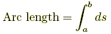  where a and b represent x, y, t, or θ-values as appropriate, and ds can be found as follows.  1. In rectangular form, use whichever of the following is easier:  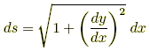 or 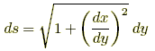  Example) Find the length of an arc of the curve y = (1/6) x³ + (1/2) x^{–1}  from x = 1 to x = 2.  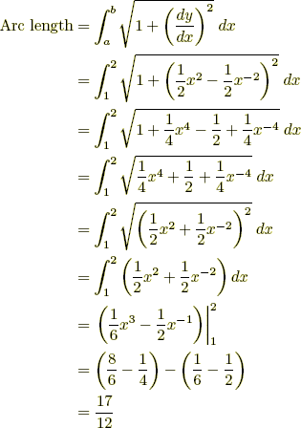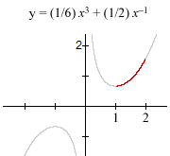  2. In parametric form, use  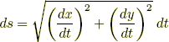  Example) Find the length of the arc in one period of the cycloid x = t – sin t, y = 1 – cos t. The values of t run from 0 to 2π.  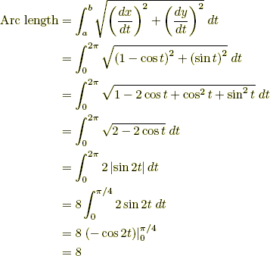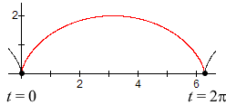  3. In polar form, use  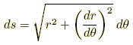  Example) Find the length of the first rotation of the logarithmic spiral r = e^{θ}. The values of θ run from 0 to 2π.  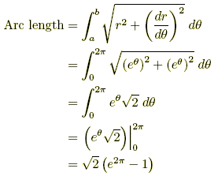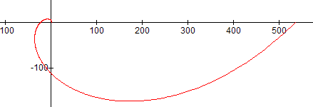

Area between Curves
The area between curves is given by the formulas below.
Formula 1: | 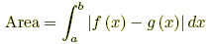
 | for a region bounded above and below by y = f(x) and y = g(x), and on the left and right by x = a and x = b.
Formula 2: | 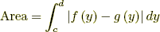
 | for a region bounded left and right by x = f(y) and x = g(y), and above and below by y = c and y = d.
Example 1:¹ | Find the area between y = x and y = x² from x = 1 to x = 2.
 | 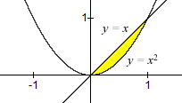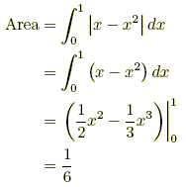
Example 2:¹ | Find the area between x = y + 3 and x = y² from y = –1 to y = 1.
 | 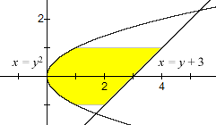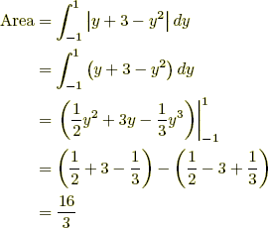

Area of an Ellipse
The formula is given below.
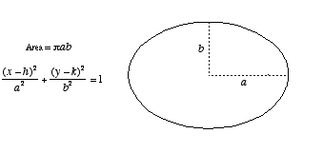

Area of a Parabolic Segment
The formula is given below.

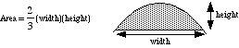

Area under a Curve
The area between the graph of y = f(x) and the x-axis is given by the definite integral below. This formula gives a positive result for a graph above the x-axis, and a negative result for a graph below the x-axis.
Note: If the graph of y = f(x) is partly above and partly below the x-axis, the formula given below generates the net area. That is, the area above the axis minus the area below the axis.
Formula: |  | 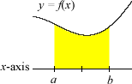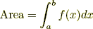
Example 1: | Find the area between y = 7 – x² and the x-axis between the values x = –1 and x = 2.  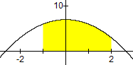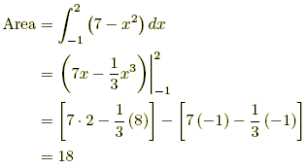
Example 2: | Find the net area between y = sin x and the x-axis between the values x = 0 and x = 2π.  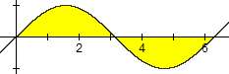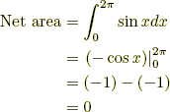

Area Using Parametric Equations
Parametric Integral Formula
The area between the x-axis and the graph of x = x(t), y = y(t) and the x-axis is given by the definite integral below. This formula gives a positive result for a graph above the x-axis, and a negative result for a graph below the x-axis.
Note: If the graph of x = x(t), y = y(t) is partly above and partly below the x-axis, the formula given below generates the net area. That is, the area above the axis minus the area below the axis.

Formula: | 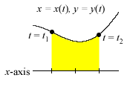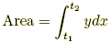
Example: | Find the area of the between the x-axis and the first period of the cycloid x = t – sin t, y = 1 – cos t. The values of t run from 0 to 2π.  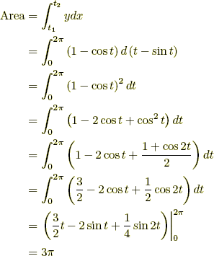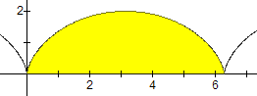

Area Using Polar Coordinates
Polar Integral Formula
The area between the graph of r = r(θ) and the origin and also between the rays θ = α and θ = β is given by the formula below (assuming α ≤ β).
Formula: | 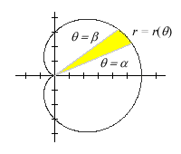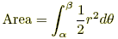
Example: | Find the area of the region bounded by the graph of the lemniscate r² = 2 cos θ,  the origin, and between the rays θ = –π/6 and θ = π/4.  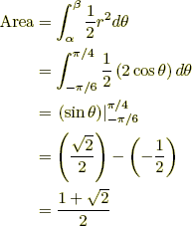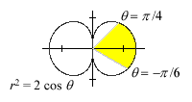

Asymptote
A line or curve that the graph of a relation approaches more and more closely the further the graph is followed.
Note: Sometimes a graph will cross a horizontal asymptote or an oblique asymptote. The graph of a function, however, will never cross a vertical asymptote.

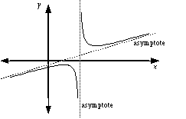
Average Rate of Change
The change in the value of a quantity divided by the elapsed time. For a function, this is the change in the y-value divided by the change in the x-value for two distinct points on the graph.
Note: This is the same thing as the slope of the secant line that passes through the two points.

Average Value of a Function
The average height of the graph of a function. For y = f(x) over the domain [a, b], the formula for average value is given below.

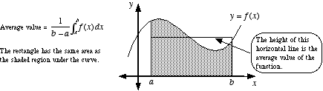

Axis of Rotation
A line about which a plane figure is rotated in three dimensional space to create a solid or surface.

Boundary Value Problem
BVP
A differential equation or partial differential equation accompanied by conditions for the value of the function but with no conditions for the value of any derivatives.
Note: Boundary value problem is often abbreviated BVP.
Differential Equation | y" + y = sin x
Initial Value Problem (IVP) | y" + y = sin x, y(0) = 1, y'(0) = – 2
Boundary Value Problem (BVP) | y" + y = sin x, y(0) = 1, y(1) = – 2

Bounded Function
A function with a range that is a bounded set. The range must have both an upper bound and a lower bound.
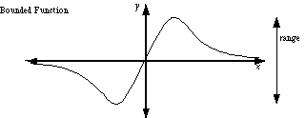
Bounded Sequence
A sequence with terms that have an upper bound and a lower bound. For example, the harmonic sequence 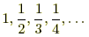is bounded since no term is greater than 1 or less than 0.

Bounds of Integration
Limits of Integration
For the definite integral 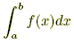, the bounds (or limits) of integration are a and b.

Calculus
The branch of mathematics dealing with limits, derivatives, definite integrals, indefinite integrals, and power series.
Common problems from calculus include finding the slope of a curve, finding extrema, finding the instantaneous rate of change of a function, finding the area under a curve, and finding volumes by parallel cross-sections.

Cartesian Form
Rectangular Form
A function (or relation) written using (x, y) or (x, y, z) coordinates.

Cavalieri’s Principle
A method, with formula given below, of finding the volume of any solid for which cross-sections by parallel planes have equal areas. This includes, but is not limited to, cylinders and prisms.
Formula: | Volume = Bh, where B is the area of a cross-section and h is the height of the solid.
Center of Mass Formula
The coordinates of the center of mass of a plane figure are given by the formulas below. The formulas only apply for figures of uniform (constant) density.
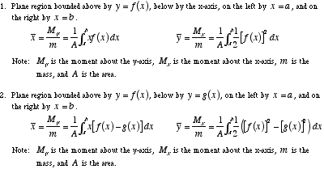

Centroid
For a triangle, this is the point at which the three medians intersect. In general, the centroid is the center of mass of a figure of uniform (constant) density.
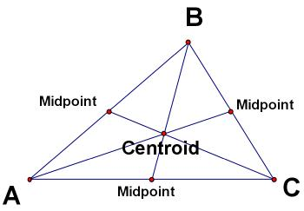
Centroid of a Triangle
Chain Rule
A method for finding the derivative of a composition of functions. The formula is . Another form of the chain rule is .
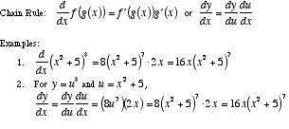

Comparison Test
A convergence test which compares the series under consideration to a known series. Essentially, the test determines whether a series is "better" than a "good" series or "worse" than a "bad" series. The "good" or "bad" series is often a p-series.
If ∑ a_{n} , ∑ c_{n} , and ∑ d_{n} are all positive series, where ∑ c_{n} converges and ∑ d_{n} diverges, then:
1. If a_{n} ≤ c_{n} for all n ≥ N for some fixed N, then ∑ a_{n} converges.
2. If a_{n} ≥ d_{n} for all n ≥ N for some fixed N, then ∑ a_{n} diverges.

Concave
Non-Convex
A shape or solid which has an indentation or "cave". Formally, a geometric figure is concave if there is at least one line segment connecting interior points which passes outside of the figure.
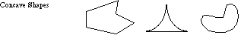

Concave Down
A graph or part of a graph which looks like an upside-down bowl or part of an upside-down bowl.
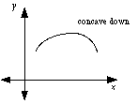

Concave Up
A graph or part of a graph which looks like a right-side up bowl or part of an right-side up bowl.
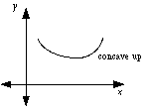

Conditional Convergence
Describes a series that converges but does not converge absolutely. That is, a convergent series that will become a divergent series if all negative terms are made positive.
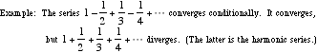

Constant Term
The term in a simplified algebraic expression or equation which contains no variable(s). If there is no such term, the constant term is 0.
Example: –5 is the constant term in p(x) = 2x³ – 4x² + 9x – 5

Continued Sum
See Sigma Notation

Continuous Function
A function with a connected graph.
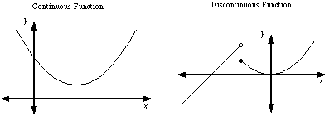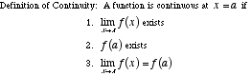

Continuously Differentiable Function
A function which has a derivative that is itself a continuous function.

Converge
To approach a finite limit. There are convergent limits, convergent series, convergent sequences, and convergent improper integrals.

Converge Absolutely
See Absolute Convergence

Converge Conditionally
See Conditional Converge

Convergent Series
An infinite series for which the sequence of partial sums converges. For example, the sequence of partial sums of the series 0.9 + 0.09 + 0.009 + 0.0009 + ··· is 0.9, 0.99, 0.999, 0.9999, .... This sequence converges to 1, so the series 0.9 + 0.09 + 0.009 + 0.0009 + ··· is convergent.

Convergent Sequence
A sequence with a limit that is a real number. For example, the sequence 2.1, 2.01, 2.001, 2.0001, . . . has limit 2, so the sequence converges to 2. On the other hand, the sequence 1, 2, 3, 4, 5, 6, . . . has a limit of infinity (∞). This is not a real number, so the sequence does not converge. It is a divergent sequence.

Convergence Tests
Limit test for divergence
Integral test
Comparison test
Limit comparison test
Alternating series test
Ratio test
Root test

Critical Number
Critical Value
The x-value of a critical point.

Critical Point
A point (x, y) on the graph of a function at which the derivative is either 0 or undefined. A critical point will often be a minimum or maximum, but it may be neither.
Note: Finding critical points is an important step in the process of curve sketching.

Critical Value
See Critical Point

Curly d
The symbol ∂ used in the notation for partial derivatives.

Curve
A word used to indicate any path, whether actually curved or straight, closed or open. A curve can be on a plane or in three-dimensional space (or n-dimensional space, for that matter). Lines, circles, arcs, parabolas, polygons, and helixes are all types of curves.
Note: Typically curves are thought of as the set of all geometric figures that can be parametrized using a single parameter. This is not in fact accurate, but it is a useful way to conceptualize curves. The exceptions to this rule require some cleverness, or at least some exposure to space-filling curves.

Curve Sketching
The process of using the first derivative and second derivative to graph a function or relation. As a result the coordinates of all discontinuities, extrema, and inflection points can be accurately plotted.

Cusp
A sharp point on a curve. Note: Cusps are points at which functions and relations are not differentiable.

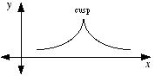
Cylindrical Shell Method
Shell Method
A technique for finding the volume of a solid of revolution.
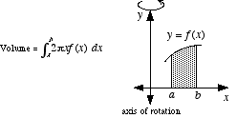
Decreasing Function
A function with a graph that moves downward as it is followed from left to right. For example, any line with a negative slope is decreasing.
Note: If a function is differentiable, then it is decreasing at all points where its derivative is negative.

Definite Integral
An integral which is evaluated over an interval. A definite integral is written . Definite integrals are used to find the area between the graph of a function and the x-axis. There are many other applications.
Formally, a definite integral is the limit of a Riemann sum as the norm of the partition approaches zero.
That is, 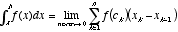.
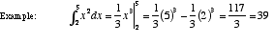
Definite Integral Rules
See Integral Rules

Degenerate
An example of a definition that stretches the definition to an absurd degree.
A degenerate triangle is the "triangle" formed by three collinear points. It doesn’t look like a triangle, it looks like a line segment.
A parabola may be thought of as a degenerate ellipse with one vertex at an infinitely distant point.
Degenerate examples can be used to test the general applicability of formulas or concepts. Many of the formulas developed for triangles (such as area formulas) apply to degenerate triangles as well.
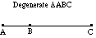
Del Operator
The symbol , which stands for the "vector" 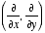or 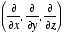.

Deleted Neighborhood
The proper name for a set such as {x: 0 < |x – a| < δ}. Deleted neighborhoods are encountered in the study of limits. It is the set of all numbers less than δ units away from a, omitting the number a itself.
Using interval notation the set {x: 0 < |x – a| < δ} would be (a – δ, a) ∪ (a, a + δ). In general, a deleted neighborhood of a is any set (c, a) ∪ (a, d) where c < a < d.
For example, one deleted neighborhood of 2 is the set {x: 0 < |x – 2| < 0.1}, which is the same as (1.9, 2) ∪ (2, 2.1).
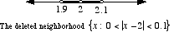

Derivative
A function which gives the slope of a curve; that is, the slope of the line tangent to a function. The derivative of a function f at a point x is commonly written f '(x). For example, if f(x) = x³ then f '(x) = 3x². The slope of the tangent line when x = 5 is f '(x) = 3·5² = 75.
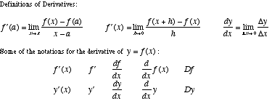

Derivative of a Power Series
The derivative of a function defined by a power series can be found by differentiating the series term-by-term.
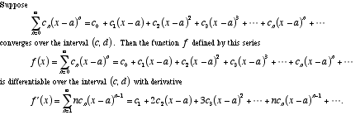

Derivative Rules
A list of common derivative rules is given below.
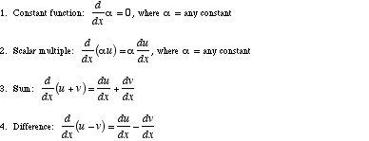
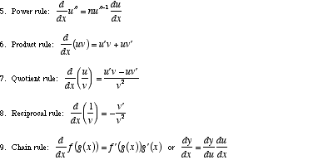
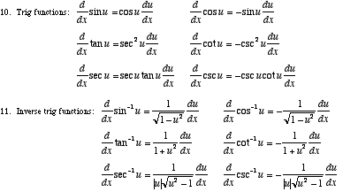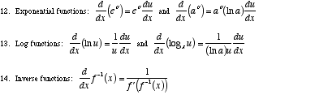

Difference Quotient
For a function f, the formula . This formula computes the slope of the secant line through two points on the graph of f. These are the points with x-coordinates x and x + h. The difference quotient is used in the definition the derivative.
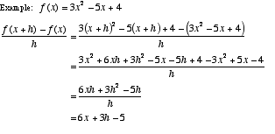

Differentiable
A curve that is smooth and contains no discontinuities or cusps. Formally, a curve is differentiable at all values of the domain variable(s) for which the derivative exists.

Differential
An tiny or infinitesimal change in the value of a variable. Differentials are commonly written in the form dx or dy.

Differential Equation
An equation showing a relationship between a function and its derivative(s). For example, is a differential equation with solutions y = Ce^{–x}.

Differentiation
The process of finding a derivative.

Differentiation Rules
See Derivative Rules

Discontinuity
A point at which the graph of a relation or function is not connected. Discontinuities can be classified as either removable or essential. There are several kinds of essential discontinuities, one of which is the step discontinuity.
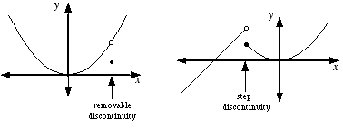

Discontinuous Function
A function with a graph that is not connected.
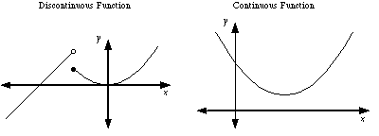

Disk
The union of a circle and its interior.
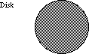
Disk Method
A technique for finding the volume of a solid of revolution. This method is a specific case of volume by parallel cross-sections.
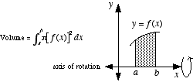
Distance from a Point to a Line
The length of the shortest segment from a given point to a given line. A formula is given below.
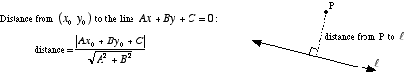

Diverge
To fail to approach a finite limit. There are divergent limits, divergent series, divergent sequences, and divergent improper integrals.

Divergent Sequence
A sequence that does not converge. For example, the sequence 1, 2, 3, 4, 5, 6, 7, ... diverges since its limit is infinity (∞). The limit of a convergent sequence must be a real number.

Divergent Series
A series that does not converge. For example, the series 1 + 2 + 3 + 4 + 5 + ··· diverges. Its sequence of partial sums 1, 1 + 2, 1 + 2 + 3 , 1 + 2 + 3 + 4 , 1 + 2 + 3 + 4 + 5, ... diverges.

e
e ≈ 2.7182818284.... is a transcendental number commonly encountered when working with exponential models (growth, decay,and logistic models, and continuously compounded interest, for example) and exponential functions. e is also the base of the natural logarithm.
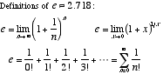

Ellipsoid
A sphere-like surface for which all cross-sections are ellipses.
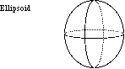
End Behavior
The appearance of a graph as it is followed farther and farther in either direction. For polynomials, the end behavior is indicated by drawing the positions of the arms of the graph, which may be pointed up or down. Other graphs may also have end behavior indicated in terms of the arms, or in terms of asymptotes or limits.
Polynomial End Behavior:
1. If the degree n of a polynomial is even, then the arms of the graph are either both up or both down.
2. If the degree n is odd, then one arm of the graph is up and one is down.
3. If the leading coefficient an is positive, the right arm of the graph is up.
4. If the leading coefficient an is negative, the right arm of the graph is down.

Essential Discontinuity
Any discontinuity that is not removable. That is, a place where a graph is not connected and cannot be made connected simply by filling in a single point. Step discontinuities and vertical asymptotes are two types of essential discontinuities.
Formally, an essential discontinuity is a discontinuity at which the limit of the function does not exist.
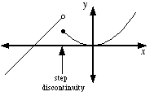

Explicit Differentiation
The process of finding the derivative of an explicit function. For example, the explicit function y = x² – 7x + 1 has derivative y' = 2x – 7.

Explicit Function
A function in which the dependent variable can be written explicitly in terms of the independent variable.
For example, the following are explicit functions: y = x² – 3, , and y = log₂ x.

Exponential Decay
A model for decay of a quantity for which the rate of decay is directly proportional to the amount present. The equation for the model is A = A₀b^{t} (where 0 < b < 1 ) or A = A₀e^{kt} (where k is a negative number representing the rate of decay). In both formulas A₀ is the original amount present at time t = 0.
This model is used for phenomena such as radioactivity or depreciation. For example, A = 50e^{–0.01t} is a model for exponential decay of 50 grams of a radioactive element that decays at a rate of 1% per year.
Exponential Growth
A model for growth of a quantity for which the rate of growth is directly proportional to the amount present. The equation for the model is A = A₀b^{t} (where b > 1 ) or A = A₀e^{kt} (where k is a positive number representing the rate of growth). In both formulas A₀ is the original amount present at time t = 0.
This model is used for such phenomena as inflation or population growth. For example, A = 7000e^{0.05t} is a model for the exponential growth of $7000 invested at 5% per year compounded continuously.

Exponential Function
Exponential Model
A function of the form y = a·b^{x} where a > 0 and either 0 < b < 1 or b > 1. The variables do not have to be x and y. For example, A = 3.2·(1.02)^{t} is an exponential function.
Note: Exponential functions are used to model exponential growth, exponential decay, compound interest, and continuously compounded interest.

Extreme Value Theorem
Min/Max Theorem
A theorem which guarantees the existence of an absolute max and an absolute min for any continuous function over a closed interval.
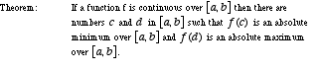

Extreme Values of a Polynomial
The graph of a polynomial of degree n has at most n – 1 extreme values (minima and/or maxima). The total number of extreme values could be n – 1 or n – 3 or n – 5 etc.
For example, a degree 9 polynomial could have 8, 6, 4, 2, or 0 extreme values. A degree 2 (quadratic) polynomial must have 1 extreme value.

Extremum
An extreme value of a function. In other words, the minima and maxima of a function. Extrema may be either relative (local) or absolute (global).
Note: The first derivative test and the second derivative test are common methods used to find extrema.
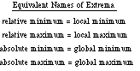
Factorial
The product of a given integer and all smaller positive integers. The factorial of n is written n! and is read aloud "n factorial".
Note: By definition, 0! = 1.
Formula: | n! = n·(n – 1)·(n – 2) · · · 3·2·1
Example: | 6! = 6·5·4·3·2·1 = 720

Falling Bodies
See Projectile Motion

First Derivative
Same as the derivative. We say first derivative instead of just derivative whenever there may be confusion between the first derivative and the second derivative (or the nth derivative).

First Derivative Test
A method for determining whether an inflection point is a minimum, maximum, or neither.
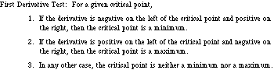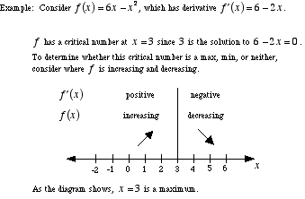

First Order Differential Equation
An ordinary differential equation of order 1. That is, a differential equation in which the highest derivative is a first derivative. For example, y' + xy = 1 is a first order differential equation.
Fixed
Constant. Not changing or moving.

Function Operations
Definitions for combining functions by adding, subtracting, multiplying, dividing, and composing them.
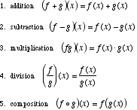

Fundamental Theorem of Calculus
The theorem that establishes the connection between derivatives, antiderivatives, and definite integrals. The fundamental theorem of calculus is typically given in two parts.
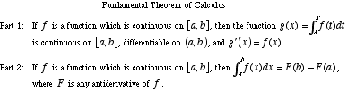

GLB
See Greatest Lower Bound of a Set

Global Maximum, Global Max
See Absolute Maximum, Absolute Max

Global Minimum, Golbal Min
See Absolute Minimum, Absolute Min

Golden Spiral
A spiral that can be drawn in a golden rectangle as shown below. The figure forming the structure for the spiral is made up entirely of squares and golden rectangles.

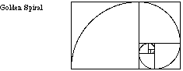

Graphic Methods
The use of graphs and/or pictures as the main technique for solving a math problem. When a problem is solved graphically, it is common to use a graphing calculator.

Greatest Lower Bound of a Set
GLB
The greatest of all lower bounds of a set of numbers. For example, the greatest lower bound of (5, 7) is 5. The greatest lower bound of the interval [5, 7] is also 5.

Greek Alphabet
The letters of ancient Greece, which are frequently used in math and science.
Α α | alpha | Ν ν | nu
Β β | beta | Ξ ξ | xi
Γ γ | gamma | Ο ο | omicron
Δ δ | delta | Π π | pi
Ε ε | epsilon | Ρ ρ | rho
Ζ ζ | zeta | Σ σ | sigma
Η η | eta | Τ τ | tau
Θ θ | theta | Υ υ | upsilon
Ι ι | iota | Φ φ | phi
Κ κ | kappa | Χ χ | chi
Λ λ | lambda | Ψ ψ | psi
Μ μ | mu | Ω ω | omega

Harmonic Sequence
Harmonic Progression
The sequence .
Note: The harmonic mean of two terms of the harmonic sequence is the term halfway between the two original terms. For example, the harmonic mean of and is .

Harmonic Series
The series . Note: The harmonic series diverges. Its sequence of partial sums is unbounded.

Helix
A curve shaped like a spring. A helix can be made by coiling a wire around the outside of a right circular cylinder.
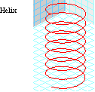

Higher Derivative
Any derivative beyond the first derivative. That is, the second, third, fourth, fifth etc. derivatives.

Hole
See Removable Discontinuity

Homogeneous System of Equations
A system, usually a linear system, in which every constant term is zero.
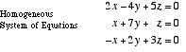
Hyperbolic Trigonometry
A variation of trigonometry. Hyperbolic trig functions are defined using e^{x} and e^{–x}. The six hyperbolic trig functions relate to each other in ways that are similar to conventional trig functions. Hyperbolic trig plays an important role when trig functions have imaginary or complex arguments.
Note: Hyperbolic trigonometry has no relation whatsoever to hyperbolic geometry.
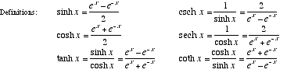

Identity Function
The function f(x) = x. More generally, an identity function is one which does not change the domain values at all.
Note: This is called the identity function since it is the identity for composition of functions. That is, if f(x) = x and g is any function, then (f ° g)(x) = g(x) and (g ° f)(x) = g(x).

Implicit Differentiation
A method for finding the derivative of an implicitly defined function or relation.
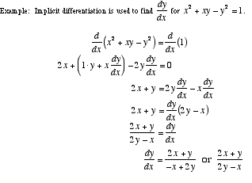

Implicit Function or Relation
A function or relation in which the dependent variable is not isolated on one side of the equation. For example, the equation x² + xy – y² = 1 represents an implicit relation

Improper Integral
A definite integral for which the integrand has a discontinuity between the bounds of integration, or which has ∞ and/or –∞ as a bound. Improper integrals are evaluated using limits as shown below. If the limit exists and is finite, we say the integral converges. If the limit does not exist or is infinite, we say the integral diverges.
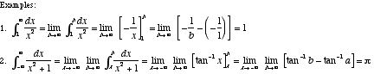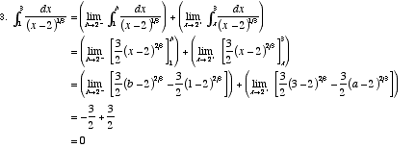

Increasing Function
A function with a graph that goes up as it is followed from left to right. For example, any line with a positive slope is increasing.
Note: If a function is differentiable, then it is increasing at all points where its derivative is positive.

Indefinite Integral
The family of functions that have a given function as a common derivative. The indefinite integral of f(x) is written
∫ f(x) dx.
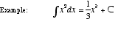

Indefinite Integral Rules
See Integral Rules

Indeterminate Expression
An undefined expression which can have a value if arrived at as a limit.
Note: Another way to think about indeterminate expressions is to see them as a disagreement between two rules for simplifying an expression. For example, one way to think about is this: The 0 in the numerator makes the fraction "equal" 0, but the 0 in the denominator makes the fraction "equal" ±∞. This conflict makes the expression indeterminate.
Common indeterminate expressions:
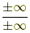 00 1∞ ∞0 ∞ – ∞
Example: | The limit 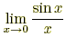 seems to evaluate to , which is indeterminate. In fact,  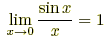  since sin x and x are approximately equal to each other for values of x near 0.  Note that this limit can also be computed using l’Hôpital’s rule.

Infinite Geometric Series
An infinite series that is geometric. An infinite geometric series converges if its common ratio r satisfies –1 < r < 1. Otherwise it diverges.
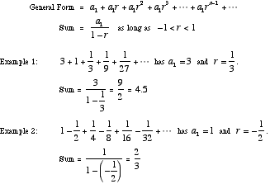
Infinite Limit
A limit that has an infinite result (either ∞ or –∞ ), or a limit taken as the variable approaches ∞ (infinity) or –∞ (minus infinity). The limit can be one-sided.
Infinite Series
A series that has no last term, such as . The sum of an infinite series is defined as the limit of the sequence of partial sums.
Note: The infinite series above happens to have a sum of π²/6.

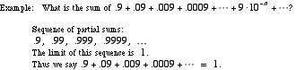
Infinitesimal
A hypothetical number that is larger than zero but smaller than any positive real number. Although the existence of such numbers makes no sense in the real number system, many worthwhile results can be obtained by overlooking this obstacle.
Note: Sometimes numbers that aren't really infinitesimals are called infinitesimals anyway. The word infinitesimal is occasionally used for tiny positive real numbers that are nearly equal to zero.

Infinity
A "number" which indicates a quantity, size, or magnitude that is larger than any real number. The number infinity is written as a sideways eight: ∞. Negative infinity is written –∞.
Note: Neither ∞ nor –∞ is a real number.

Inflection Point
A point at which a curve changes from concave up to concave down, or vice-versa.
Note: If a function has a second derivative, the value of the second derivative is either 0 or undefined at each of that function's inflection points.
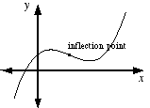

Initial Value Problem
IVP
A differential equation or partial differential equation accompanied by conditions for the value of the function and possibly its derivatives at one particular point in the domain.
Differential Equation | y" + y = sin x
Initial Value Problem (IVP) | y" + y = sin x, y(0) = 1, y'(0) = – 2
Boundary Value Problem (BVP) | y" + y = sin x, y(0) = 1, y(1) = – 2

Instantaneous Acceleration
The rate at which an object's instantaneous velocity is changing at a particular moment. This is found by taking the derivative of the velocity function.
Note: For motion on the number line, instantaneous acceleration is a scalar. For motion on a plane or in space, it is a vector.

Instantaneous Rate of Change
The rate of change at a particular moment. Same as the value of the derivative at a particular point.
For a function, the instantaneous rate of change at a point is the same as the slope of the tangent line. That is, it's the slope of a curve.
Note: Over short intervals of time, the average rate of change is approximately equal to the instantaneous rate of change

Instantaneous Velocity
The rate at which an object is moving at a particular moment. Same as the derivative of the function describing the position of the object at a particular time.
Note: For motion on the number line, instantaneous velocity is a scalar. For motion on a plane or in space, it is a vector.

Integrable Function
A function for which the definite integral exists. Piecewise continuous functions are integrable, and so are many functions that are not piecewise continuous.
Note: Non-integrable functions are seldom studied in the first two years of calculus.

Integral
As a noun, it means the integral of a function.
As an adjective, it means "in the form of an integer." For example, saying a polynomial has integral coefficients means the coefficients of the polynomial are all integers.

Integration Methods
The basic methods are listed below. Other more advanced and/or specialized methods exist as well.
u-substitution
integration by parts
partial fractions
trig substitution
rationalizing substitutions

Integral of a Function
The result of either a definite integral or an indefinite integral.
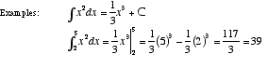
Integral Rules
For the following, a, b, c, and C are constants; for definite integrals, these represent real number constants. The rules only apply when the integrals exist.
Indefinite integrals (These rules all apply to definite integrals as well)
1. 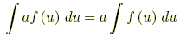
2. 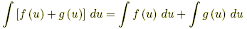
3. 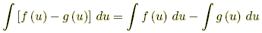
4. 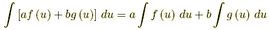
5. Integration by parts: 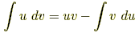

Definite integrals
1. 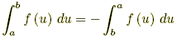
2. 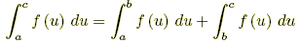
3. If f(u) ≤ g(u) for all a ≤ u ≤ b, then 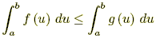
4. If f(u) ≤ M for all a ≤ u ≤ b, then 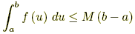
5. If m ≤ f(u) for all a ≤ u ≤ b, then 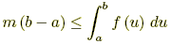
6. If a ≤ b, then 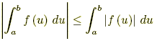

Integral Test
A convergence test used for positive series which with decreasing terms.
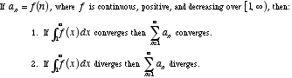

Integral Test Remainder
For a series that converges by the integral test, this is a quantity that measures how accurately the nth partial sum estimates the overall sum.
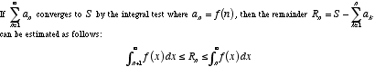
Integrand
The function being integrated in either a definite or indefinite integral.
Example: x²cos 3x is the integrand in ∫ x²cos 3x dx.

Integration
The process of finding an integral, either a definite integral or an indefinite integral.

Integration by Parts
A formula used to integrate the product of two functions.
Formula:
Example 1: | Evaluate 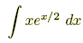.
Use u = x and dv = e^{x/2} dx. Then we get du = dx and v = 2e^{x/2}. This can be summarized:
u = x, dv = e^{x/2} dx, du = dx, v = 2e^{x/2}
It follows that
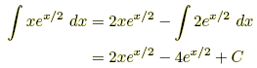
Example 2: | Evaluate 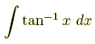.
Use the following: u = tan⁻¹ x, dv = dx, 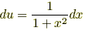, v = x
Thus
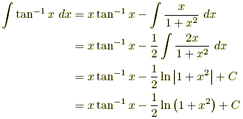

Example 3: | Evaluate 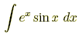.
Let I =. Proceed as follows: u = sin x, dv = e^{x} dx, du = cos x dx, v = e^{x}
Thus 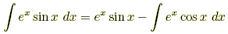
Now use integration by parts on the remaining integral. Use the following assignments:
u = cos x, dv = e^{x} dx, du = –sin x dx, v = e^{x}
Thus
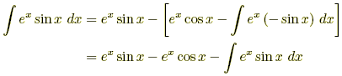
Note that appears on both sides of this equation. Replace it with I and then solve.
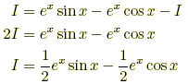
We finally obtain
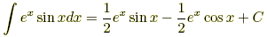

Integration by Substitution
An integration method that essentially involves using the chain rule in reverse.
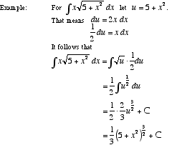

Integration Methods
See Integral Methods

Intermediate Value Theorem
IVT
A theorem verifying that the graph of a continuous function is connected.
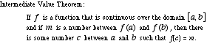

Interval of Convergence
For a power series in one variable, the set of values of the variable for which the series converges. The interval of convergence may be as small as a single point or as large as the set of all real numbers.
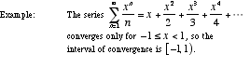

Iterative Process
An algorithm which involves repeated use of the same formula or steps. Typically, the process begins with a starting value which is plugged into the formula. The result is then taken as the new starting point which is then plugged into the formula again. The process continues to repeat.
Examples of iterative processes are factor trees, recursive formulas, and Newton’s method.

IVP
See Initial Value Problem

IVT
See Intermediate Value Theorem

Jump Discontinuity
Step Discontinuity
A discontinuity for which the graph steps or jumps from one connected piece of the graph to another. Formally, it is a discontinuity for which the limits from the left and right both exist but are not equal to each other.
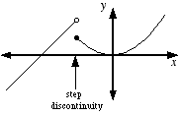

L'Hôpital's Rule
L'Hospital's Rule
A technique used to evaluate limits of fractions that evaluate to the indeterminate expressions and . This is done by finding the limit of the derivatives of the numerator and denominator.
Note: Most limits involving other indeterminate expressions can be manipulated into fraction form so that l'Hôpital's rule can be used.
L'Hôpital's Rule: | If f and g are differentiable on an open interval containing a such that g(x) ≠ 0 for all x ≠ a in the interval, and if either  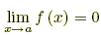and 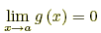  Or 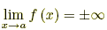and 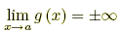  Then 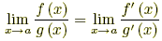
Example: | 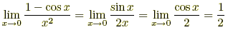

Least Upper Bound of a Set
LUB
The smallest of all upper bounds of a set of numbers. For example, the least upper bound of the interval (5, 7) is 7. The least upper bound of [5, 7] is also 7.

Limit
The value that a function or expression approaches as the domain variable(s) approach a specific value. Limits are written in the form . For example, the limit of as x approaches 3 is . This is written .
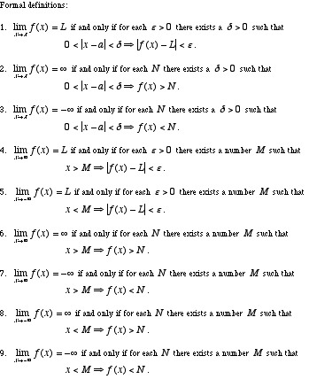

Limit Comparison Test
A convergence test often used when the terms of a series are rational functions. Essentially, the test determines whether a series is "about as good" as a "good" series or "about as bad" as a "bad" series. The "good" or "bad" series is often a p-series.
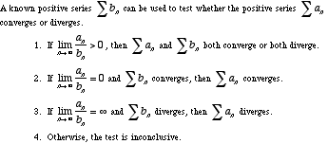

Limit from the Left
Limit from Below
A one-sided limit which, in the example , restricts x such that x < 0.
In general, a limit from the left restricts the domain variable to values less than the number the domain variable approaches. When a limit is taken from the left it is written or .
For example, since tends toward –∞ as x gets closer and closer to 0 from the left.
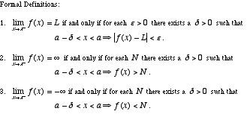

Limit from the Right
Limit from Above
A one-sided limit which, in the example , restricts x such that x > 0.
In general, a limit from the right restricts domain variable to values greater than the number the domain variable approaches. When a limit is taken from the right it is written or .
For example, since tends toward ∞ as x gets closer and closer to 0 from the right.
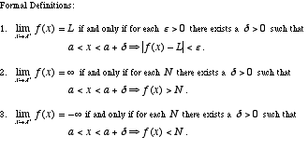

Limit Test for Divergence
A convergence test that uses the fact that the terms of a convergent series must have a limit of zero.
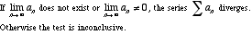
Bounds of Integration
Limits of Integration
For the definite integral , the bounds (or limits) of integration are a and b.

Local Behavior
The appearance or properties of a function, graph, or geometric figure in the immediate neighborhood of a particular point. Usually this refers to any appearance or property that becomes more apparent as you zoom in on the point.
For example, as you zoom in to the graph of y = x² at any point, the graph looks more and more like a line. Thus we say that y = x² is locally linear. We say this even though the graph is not actually a straight line.

Relative Maximum, Relative Max
Local Maximum, Local Max
The highest point in a particular section of a graph.
Note: The first derivative test and the second derivative test are common methods used to find maximum values of a function.
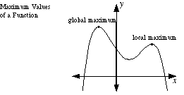
Relative Minimum, Relative Min
Local Minimum, Local Min
The lowest point in a particular section of a graph.
Note: The first derivative test and the second derivative test are common methods used to find minimum values of a function.
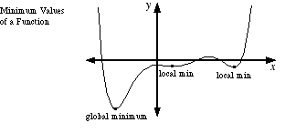

Logarithmic Differentiation
A method for finding the derivative of functions such as y = x^{sin x} and 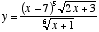.
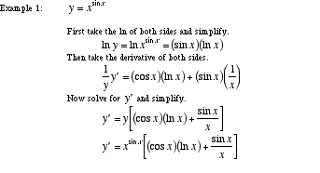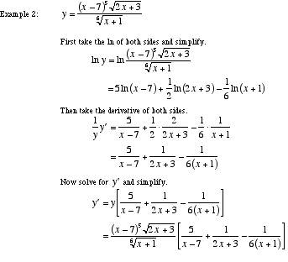

Logistic Growth
A model for a quantity that increases quickly at first and then more slowly as the quantity approaches an upper limit. This model is used for such phenomena as the increasing use of a new technology, spread of a disease, or saturation of a market (sales).
The equation for the logistic model is 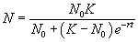. Here, t is time, N stands for the amount at time t, N₀ is the initial amount (at time 0), K is the maximum amount that can be sustained, and r is the rate of growth when N is very small compared to K.
Note: The logistic growth model can be obtained by solving the differential equation 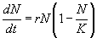

LUB
See Least Upper Bound of a Set

Model
Mathematical Model
An equation or a system of equations representing real-world phenomena. Models also represent patterns found in graphs and/or data. Usually models are not exact matches the objects or behavior they represent. A good model should capture the essential character of whatever is being modeled.

Maximize
To find the largest possible value.
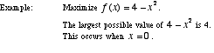

Maximum of a Function:
Either a relative (local) maximum or an absolute (global) maximum.

Mean Value Theorem
A major theorem of calculus that relates values of a function to a value of its derivative. Essentially the theorem states that for a "nice" function, there is a tangent line parallel to any secant line.
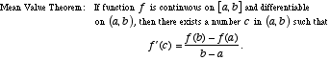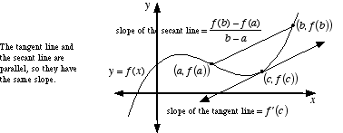

Mean Value Theorem for Integrals
A variation of the mean value theorem which guarantees that a continuous function has at least one point where the function equals the average value of the function.
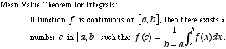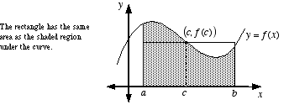

Mesh of a Partition
Norm of a Partition
The width of the largest sub-interval in a partition.
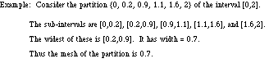

Min/Max Theorem
See Extreme Value Theorem

Minimize
To find the smallest possible value.
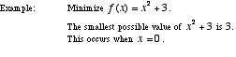

Minimum of a Function
Either a relative (local) minimum or an absolute (global) minimum.

Mode
The number that occurs the most often in a list.
Example: 5 is the mode of 2, 3, 3, 4, 5, 5, 5

Model
See Mathematical Model

Moment
A number indicating the degree to which a figure tends to balance on a given line (axis). A moment of zero indicates perfect balance, and a large moment indicates a strong tendency to tip over.
Formally, the moment of a point P about a fixed axis is the mass of P times the distance from P to the axis. For a figure, the moment is the cumulative sum of the moments of all the figure's points. This cumulative sum is the same as the mass of the figure times the distance from the figure's center of mass to the fixed axis.
Note: This is similar to, but not the same as, the physics quantity known as moment of inertia.
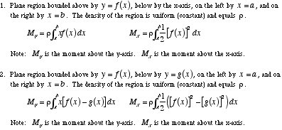

Multivariable
Multivariate
An adjective describing any problem that uses more than one variable.

Multivariable Calculus
Multivariable Analysis
Vector Calculus
The use of calculus (limits, derivatives, and integrals) with two or more independent variables, or two or more dependent variables. This can be thought of as the calculus of three dimensional figures.
Common elements of multivariable calculus include parametric equations, vectors, partial derivatives, multiple integrals, line integrals, and surface integrals. Most of multivariable calculus is beyond the scope of this website.
MVT
See Mean Value Theorem

Neighborhood
A neighborhood of a number a is any open interval containing a. One common notation for a neighborhood of a is {x: |x – a| < δ}. Using interval notation this would be (a – δ, a + δ).

Newton's Method
An iterative process using derivatives that can often (but not always) be used to find zeros of a differentiable function. The basic idea is to start with an approximate guess for the zero, then use the formula below to turn that guess into a better approximation. This process is repeated until, after only a few steps, the approximation is extremely close to the actual value of the zero.
Note: In some circumstances, Newton's method backfires and gives successively worse and worse approximations.
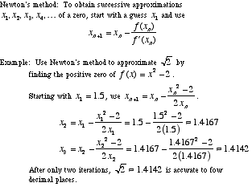

Norm of a Partition
See Mesh of a Partition

Normal
Perpendicular
Orthogonal
At a 90° angle. Note: Perpendicular lines have slopes that are negative reciprocals.
Example: Perpendicular Lines
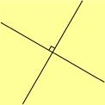
nth Degree Taylor Polynomial
See Taylor Polynomial

nth Derivative
The result of taking the derivative of the derivative of the derivative etc. of a function a total of n times. Written
f ^{(n)}(x) or .
Note: f ⁽⁰⁾(x) is the same thing as f(x).

nth Partial Sum
The sum of the first n terms of an infinite series.
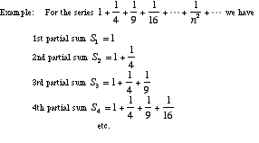
n-tuple
Coordinates / Ordered Pair / Ordered Triple
On the coordinate plane, the pair of numbers giving the location of a point (ordered pair). In three-dimensional coordinates, the triple of numbers giving the location of a point (ordered triple). In n-dimensional space, a sequence of n numbers written in parentheses.
Ordered pair: | Two numbers written in the form (x, y).
Ordered triple: | Three numbers written in the form (x, y, z).
n-tuple: | n numbers written in the form (x₁, x₂, x₃, . . . , x_{n}).

Oblate Spheroid
A flattened sphere. More formally, an oblate spheroid is a surface of revolution obtained by revolving an ellipse about its minor axis.
Note: The earth is shaped like an oblate spheroid.
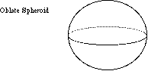

One-Sided Limit
Either a limit from the left or a limit from the right.

Operations on Functions
See Function Operations

Order of a Differential Equation
The number of the highest derivative in a differential equation. A differential equation of order 1 is called first order, order 2 second order, etc.
Example: The differential equation y" + xy' – x³y = sin x is second order since the highest derivative is y" or the second derivative.

Ordinary Differential Equation
A differential equation which does not include any partial derivatives.

Orthogonal
See Normal

p-series
A series of the form or , where p > 0. Often employed when using the comparison test and the limit comparison test.
Note: The harmonic series is a p-series with p =1.
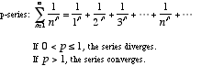

Parallel Cross Sections
The formula below gives the volume of a solid. A(x) is the formula for the area of parallel cross-sections over the entire length of the solid.
Note: The disk method and the washer method are both derived from this formula.
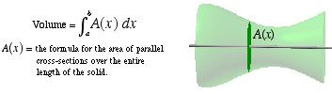

Parameter (algebra)
The independent variable or variables in a set of parametric equations.
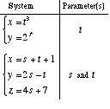
Parametric Derivative Formulas
The formulas for the first derivative and second derivative of a parametrically defined curve are given below.
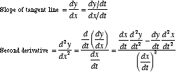

Parametric Equations
A system of equations with more than one dependent variable. Often parametric equations are used to represent the position of a moving point.
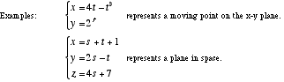

Parametric Integral Formula
See Area Using Parametric Equations

Parametrize
To write in terms of parametric equations.
Example: The line x + y = 2 can be parametrized as x = 1 + t, y = 1 – t.

Partial Fractions
The process of writing any proper rational expression as a sum of proper rational expressions. This method is use in integration as shown below.
Note: Improper rational expressions can also be rewritten using partial fractions. You must, however, use polynomial long division first before finding a partial fractions representation.
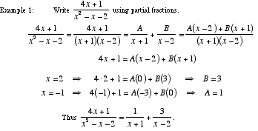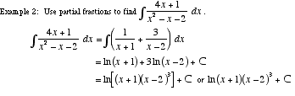

Partial Sum of a Series
The sum of a finite number of terms of a series.

Partition of an Interval
A division of an interval into a finite number of sub-intervals. Specifically, the partition itself is the set of endpoints of each of the sub-intervals.
Piecewise Continuous Function
A function made up of a finite number of continuous pieces. Piecewise continuous functions may not have vertical asymptotes. In fact, the only possible types of discontinuities for a piecewise continuous function are removable and step discontinuities.
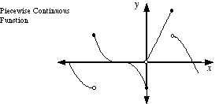
Pinching Theorem
See Sandwich Theorem
Squeeze Theorem

Polar Derivative Formulas
The formula for the first derivative of a polar curve is given below.
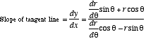

Polar Integral Formula
See Area Using Polar Coordinates
Positive Series
A series with terms that are all positive.

Power Rule
The formula for finding the derivative of a power of a variable.
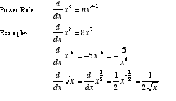
Power Series
A series which represents a function as a polynomial that goes on forever and has no highest power of x.
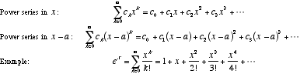

Power Series Convergence
A theorem that states the three alternatives for the way a power series may converge.
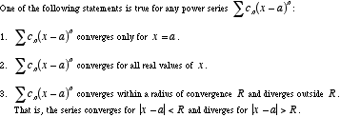

Product Rule
A formula for the derivative of the product of two functions.
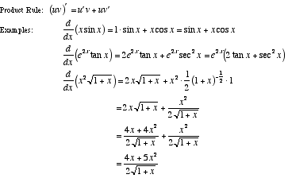

Projectile Motion
Falling Bodies
A formula used to model the vertical motion of an object that is dropped, thrown straight up, or thrown straight down.
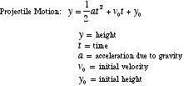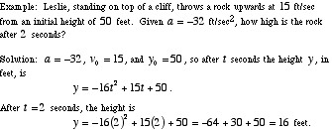

Prolate Spheroid
A stretched sphere shaped like a watermelon. Formally, a prolate spheroid is a surface of revolution obtained by revolving an ellipse about its major axis.
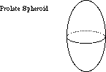

Quotient Rule
A formula for the derivative of the quotient of two functions.
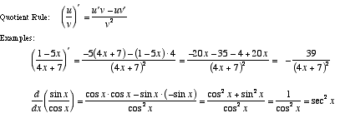
Radius of Convergence
The distance between the center of a power series' interval of convergence and its endpoints. If the series only converges at a single point, the radius of convergence is 0. If the series converges over all real numbers, the radius of convergence is ∞.
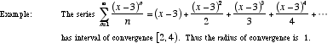

Ratio Test
A convergence test used when terms of a series contain factorials and/or nth powers.
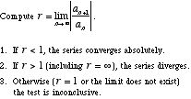

Rationalizing Substitutions
An integration method which is often useful when the integrand is a fraction including more than one kind of root, such as 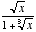. A different type of rationalizing substitution can be used to work with integrands such as .
Note: This method transforms the integrand into a rational function, hence the name rationalizing.
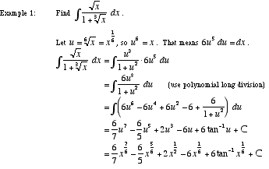

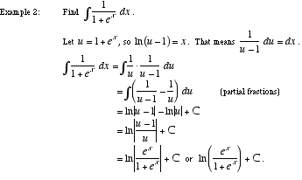
Reciprocal Rule
A formula for the derivative of the reciprocal of a function.
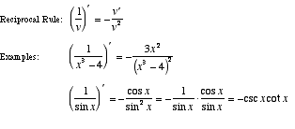
Rectangular Form
See Cartesian Form

Related Rates
A class of problems in which rates of change are related by means of differentiation. Standard examples include water dripping from a cone-shaped tank and a man’s shadow lengthening as he walks away from a street lamp.
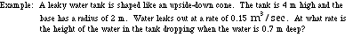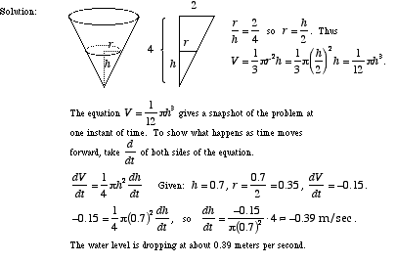

Local Maximum, Local Max
See Relative Maximum, Relative Max

Local Minimum, Local Min
See Relative Minimum, Relative Min

Remainder of a Series
The difference between the nth partial sum and the sum of a series.
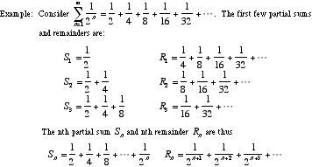

Removable Discontinuity
Hole
A hole in a graph. That is, a discontinuity that can be "repaired" by filling in a single point. In other words, a removable discontinuity is a point at which a graph is not connected but can be made connected by filling in a single point.
Formally, a removable discontinuity is one at which the limit of the function exists but does not equal the value of the function at that point; this may be because the function does not exist at that point.
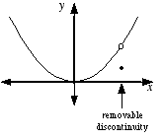

Riemann Sum
An approximation of the definite integral . This is accomplished in a three-step procedure.
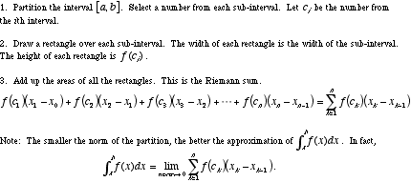
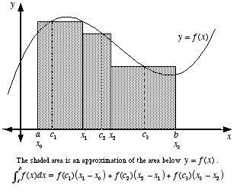

Rolle's Theorem
A theorem of calculus that ensures the existence of a critical point between any two points on a "nice" function that have the same y-value.
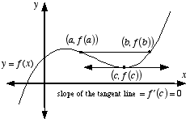

Root Test
A convergence test used when series terms contain nth powers.
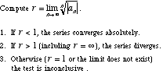

Sandwich Theorem
Squeeze Theorem
Pinching Theorem
A theorem which allows the computation of the limit of an expression by trapping the expression between two other expressions which have limits that are easier to compute.
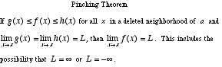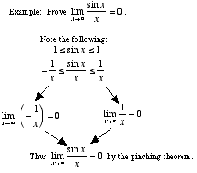

Scalar
Any real number, or any quantity that can be measured using a single real number. Temperature, length, and mass are all scalars. A scalar is said to have magnitude but no direction. A quantity with both direction and magnitude, such as force or velocity, is called a vector.

Secant Line
A line which passes through at least two points of a curve. Note: If the two points are close together, the secant line is nearly the same as a tangent line.
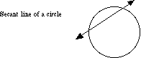

Second Derivative
The derivative of a derivative. Usually written f"(x), , or y".
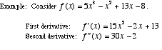

Second Derivative Test
A method for determining whether a critical point is a relative minimum or maximum.
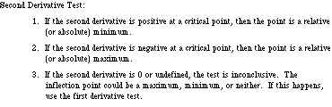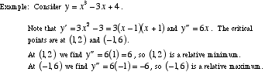

Second Order Critical Point
A point on the graph of a function at which the second derivative is either 0 or undefined. A second order critical point may or may not be an inflection point.
Note: The phrase second order critical point is NOT in common usage among mathematicians or in textbooks. Nevertheless, it is a useful name for a type of point which otherwise has no name.

Second Order Differential Equation
An ordinary differential equation of order 2. That is, a differential equation in which the highest derivative is a second derivative.
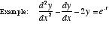
Separable Differential Equation
A first order ordinary differential equation which can be solved by separating all occurrences of the two variables on either side of the equal sign and then integrating.
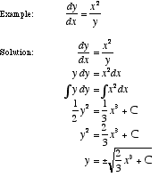

Sequence
A list of numbers set apart by commas, such as 1, 3, 5, 7, . . .

Sequence of Partial Sums
The sequence of nth partial sums of a series.
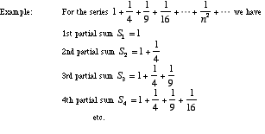
Series
The sum of the terms of a sequence. For example, the series for the sequence 1, 3, 5, 7, 9, . . . , 131, 133 is the sum 1 + 3 + 5 + 7 + 9 + . . . + 131 + 133.

Series Rules
Algebra rules for convergent series are given below.
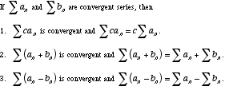

Shell Method
See Cylindrical Shell Method

Sigma Notation
Continued Sum
A notation using the Greek letter sigma (Σ) that allows a long sum to be written compactly.
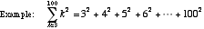

Simple Closed Curve
A connected curve that does not cross itself and ends at the same point where it begins. Examples are circles, ellipses, and polygons.
Note: Despite the name "curve", a simple closed curve does not actually have to curve.

Simple Harmonic Motion
SHM
Any kind of periodic motion that can be modeled using a sinusoid. That is, motion that can be approximately or exactly described using a sine or cosine function. Examples include the swinging back and forth of a pendulum and the bobbing up and down of a mass hanging from a spring.
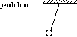
Simpson's Rule
A method for approximating a definite integral using parabolic approximations of f. The parabolas are drawn as shown below.
To use Simpson's rule follow these two steps:
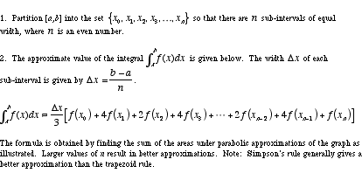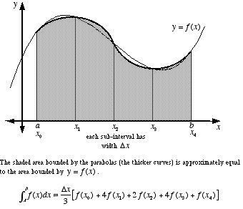

Slope of a Curve
A number which is used to indicate the steepness of a curve at a particular point. The slope of a curve at a point is defined to be the slope of the tangent line. Thus the slope of a curve at a point is found using the derivative.
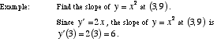

Solid
Geometric Solid
Solid Geometric Figure
The collective term for all bounded three-dimensional geometric figures. This includes polyhedra, pyramids, prisms, cylinders, cones, spheres, ellipsoids, etc.

Solid of Revolution
A solid that is obtained by rotating a plane figure in space about an axis coplanar to the figure. The axis may not intersect the figure.
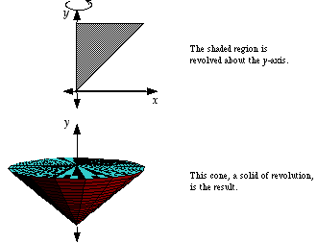

Solve Analytically
Use algebraic and/or numeric methods as the main technique for solving a math problem. Usually when a problem is solved analytically, no graphing calculator is used.

Solve Graphically
Use graphs and/or pictures as the main technique for solving a math problem. When a problem is solved graphically, graphing calculators are commonly used.

Speed
Distance covered per unit of time. Speed is a nonnegative scalar. For motion in one dimension, such as on a number line, speed is the absolute value of velocity. For motion in two or three dimensions, speed is the magnitude of the velocity vector.

Squeeze Theorem
See Sandwich Theorem

Step Discontinuity
See Jump Discontinuity

Substitution Method
See Integration by Substitution

Surface
A geometric figure in three dimensions excluding interior points, if any.

Surface Area of a Surface of Revolution
The formulas below give the surface area of a surface of revolution. The axis of rotation must be either the x-axis or the y-axis. The curve being rotated can be defined using rectangular, polar, or parametric equations.
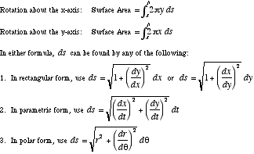

Surface of Revolution
A surface that is obtained by rotating a plane curve in space about an axis coplanar to the curve.
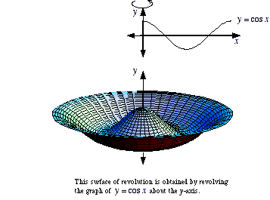

Tangent Line
A line that touches a curve at a point without crossing over. Formally, it is a line which intersects a differentiable curve at a point where the slope of the curve equals the slope of the line.
Note: A line tangent to a circle is perpendicular to the radius to the point of tangency.
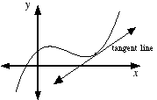

Taylor Polynomial
nth Degree Taylor Polynomial
An approximation of a function using terms from the function's Taylor series. An nth degree Taylor polynomial uses all the Taylor series terms up to and including the term using the nth derivative.
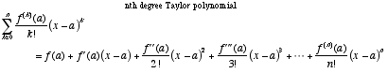

Taylor Series
The power series in x – a for a function f . Note: If a = 0 the series is called a Maclaurin series.
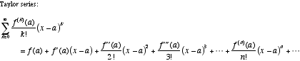

Taylor Series Remainder
A quantity that measures how accurately a Taylor polynomial estimates the sum of a Taylor series.
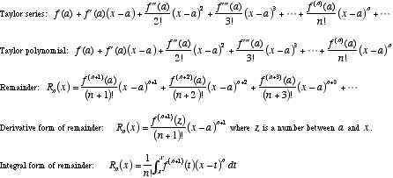

Pappus’s Theorem
Theorem of Pappus
A method for finding the volume of a solid of revolution. The volume equals the product of the area of the region being rotated times the distance traveled by the centroid of the region in one rotation.

Torus
A doughnut shape. Formally, a torus is a surface of revolution obtained by revolving (in three dimensional space) a circle about a line which does not intersect the circle.

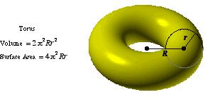
Trapezoid Rule
A method for approximating a definite integral using linear approximations of f. The trapezoids are drawn as shown below. The bases are vertical lines.
To use the trapezoid rule follow these two steps:
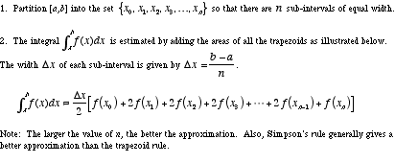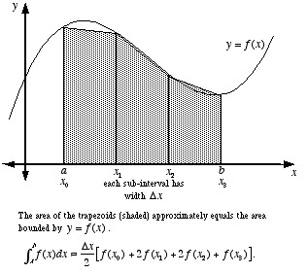

Trig Substitution
A method for computing integrals often used when the integrand contains expressions of the form a² – x², a² + x², or x² – a².
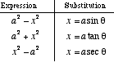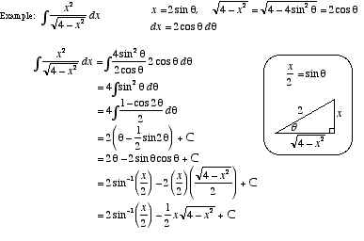

u-Substitution
See Integration by Substitution

Uniform
All the same or all in the same manner; constant.

Vector Calculus
See Multivariable Calculus

Velocity
The rate of change of the position of an object. For motion in one dimension, such as along the number line, velocity is a scalar. For motion in two dimensions or through three-dimensional space, velocity is a vector.

Volume
The total amount of space enclosed in a solid.
For the following tables,
h = height of solid | s = slant height | P = perimeter or circumference of the base
l = length of solid | B = area of the base | r = radius of sphere
w = width of solid | R = radius of the base | a = length of an edge

Figure | Volume | Lateral Surface Area | Area of the Base(s) | Total Surface Area
Box (also called rectangular parallelepiped, right rectangular prism) | lwh | 2lh + 2wh | 2lw | 2lw + 2lh + 2wh
Prism | Bh | Ph | 2B | Ph + 2B
Pyramid | 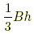 | - | B | -
Right Pyramid |  | 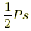 | B | 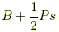
Cylinder | Bh | - | 2B | -
Right Cylinder | Bh | Ph | 2B | Ph + 2B
Right Circular Cylinder | πR²h | 2πRh | 2πR² | 2πRh + 2πR²
Cone |  | - | B | -
Right Circular Cone | 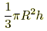 | πRs or | πR² | πRs + πR² or

Figure | Volume | Total Surface Area
Sphere | 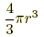
Regular Tetrahedron | 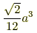
Cube (regular hexahedron) | a³ | 6a²
Regular Octahedron | 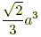
Regular Dodecahedron | 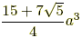 | 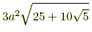
Regular Icosahedron | 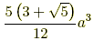

Volume by Parallel Cross Sections
See Parallel Cross Sections

Washer
Annulus
The region between two concentric circles which have different radii.
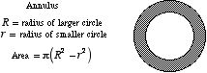

Washer Method
A technique for finding the volume of a solid of revolution. The washer method is a generalized version of the disk method. Both the washer and disk methods are specific cases of volume by parallel cross-sections.
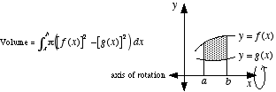

Work
The physics term for the amount of energy required to move an object over a given path subject to a given force.
