**Calculus Terminology**

|  |  |  |  |  |
| --- | --- | --- | --- | --- |
| [Absolute Convergence](http://www.mathwords.com/a/absolute_convergence.htm)  [Absolute Maximum](http://www.mathwords.com/a/absolute_maximum.htm)  [Absolute Minimum](http://www.mathwords.com/a/absolute_minimum.htm)  [Absolutely Convergent](http://www.mathwords.com/a/absolute_convergence.htm)  [Acceleration](http://www.mathwords.com/a/acceleration.htm)  [Alternating Series](http://www.mathwords.com/a/alternating_series.htm)  [Alternating Series Remainder](http://www.mathwords.com/a/alternating_series_remainder.htm)  [Alternating Series Test](http://www.mathwords.com/a/alternating_series_test.htm)  [Analytic Methods](http://www.mathwords.com/a/analytic_methods.htm)  [Annulus](http://www.mathwords.com/a/annulus.htm)  [Antiderivative of a Function](http://www.mathwords.com/a/antiderivative_function.htm)  [Approximation by Differentials](http://www.mathwords.com/a/approximation_by_differentials.htm)  [Arc Length of a Curve](http://www.mathwords.com/a/arc_length_of_a_curve.htm)  [Area below a Curve](http://www.mathwords.com/a/area_under_a_curve.htm)  [Area between Curves](http://www.mathwords.com/a/area_between_curves.htm)  [Area of an Ellipse](http://www.mathwords.com/a/area_ellipse.htm)  [Area of a Parabolic Segment](http://www.mathwords.com/a/area_parabolic_segment.htm)  [Area under a Curve](http://www.mathwords.com/a/area_under_a_curve.htm)  [Area Using Parametric Equations](http://www.mathwords.com/a/area_parametric.htm)  [Area Using Polar Coordinates](http://www.mathwords.com/a/area_polar.htm) | | [Asymptote](http://www.mathwords.com/a/asymptote.htm)  [Average Rate of Change](http://www.mathwords.com/a/average_rate_change.htm)  [Average Value of a Function](http://www.mathwords.com/a/average_value_function.htm)  [Axis of Rotation](http://www.mathwords.com/a/axis_rotation.htm)  [Boundary Value Problem](http://www.mathwords.com/b/boundary_value_problem.htm)  [Bounded Function](http://www.mathwords.com/b/bounded_function.htm)  [Bounded Sequence](http://www.mathwords.com/b/bounded_sequence.htm)  [Bounds of Integration](http://www.mathwords.com/b/bounds_of_integration.htm)  [Calculus](http://www.mathwords.com/c/calculus.htm)  [Cartesian Form](http://www.mathwords.com/c/cartesian_form.htm)  [Cavalieri’s Principle](http://www.mathwords.com/c/cavalieris_principle.htm)  [Center of Mass Formula](http://www.mathwords.com/c/center_of_mass_formula.htm)  [Centroid](http://www.mathwords.com/c/centroid.htm)  [Chain Rule](http://www.mathwords.com/c/chain_rule.htm)  [Comparison Test](http://www.mathwords.com/c/comparison_test.htm)  [Concave](http://www.mathwords.com/c/concave.htm)  [Concave Down](http://www.mathwords.com/c/concave_down.htm)  [Concave Up](http://www.mathwords.com/c/concave_up.htm)  [Conditional Convergence](http://www.mathwords.com/c/conditional_convergence.htm)  [Constant Term](http://www.mathwords.com/c/constant_term.htm) | [Continued Sum](http://www.mathwords.com/s/sigma_notation.htm)  [Continuous Function](http://www.mathwords.com/c/continuous_fn.htm)  [Continuously Differentiable Function](http://www.mathwords.com/c/continuously_differentiable_fn.htm)  [Converge](http://www.mathwords.com/c/converge.htm)  [Converge Absolutely](http://www.mathwords.com/a/absolute_convergence.htm)  [Converge Conditionally](http://www.mathwords.com/c/conditional_convergence.htm)  [Convergence Tests](http://www.mathwords.com/c/convergence_tests.htm)  [Convergent Sequence](http://www.mathwords.com/c/convergent_sequence.htm)  [Convergent Series](http://www.mathwords.com/c/convergent_series.htm)  [Critical Number](http://www.mathwords.com/c/critical_number.htm)  [Critical Point](http://www.mathwords.com/c/critical_point.htm)  [Critical Value](http://www.mathwords.com/c/critical_number.htm)  [Curly d](http://www.mathwords.com/c/curly_d.htm)  [Curve](http://www.mathwords.com/c/curve.htm)  [Curve Sketching](http://www.mathwords.com/c/curve_sketching.htm)  [Cusp](http://www.mathwords.com/c/cusp.htm)  [Cylindrical Shell Method](http://www.mathwords.com/c/cylindrical_shell_method.htm)  [Decreasing Function](http://www.mathwords.com/d/decreasing_function.htm)  [Definite Integral](http://www.mathwords.com/d/definite_integral.htm)  [Definite Integral Rules](http://www.mathwords.com/i/integral_rules.htm) | |
| [Degenerate](http://www.mathwords.com/d/degenerate.htm)  [Del Operator](http://www.mathwords.com/d/del_operator.htm)  [Deleted Neighborhood](http://www.mathwords.com/d/deleted_nbhd.htm)  [Derivative](http://www.mathwords.com/d/derivative.htm)  [Derivative of a Power Series](http://www.mathwords.com/d/derivative_of_power_series.htm)  [Derivative Rules](http://www.mathwords.com/d/derivative_rules.htm)  [Difference Quotient](http://www.mathwords.com/d/difference_quotient.htm)  [Differentiable](http://www.mathwords.com/d/differentiable.htm)  [Differential](http://www.mathwords.com/d/differential.htm)  [Differential Equation](http://www.mathwords.com/d/differential_eqn.htm)  [Differentiation](http://www.mathwords.com/d/differentiation.htm)  [Differentiation Rules](http://www.mathwords.com/d/derivative_rules.htm)  [Discontinuity](http://www.mathwords.com/d/discontinuity.htm)  [Discontinuous Function](http://www.mathwords.com/d/discontinuous_function.htm)  [Disk](http://www.mathwords.com/d/disk.htm)  [Disk Method](http://www.mathwords.com/d/disk_method.htm)  [Distance from a Point to a Line](http://www.mathwords.com/d/distance_point_to_line.htm)  [Diverge](http://www.mathwords.com/d/diverge.htm)  [Divergent Sequence](http://www.mathwords.com/d/divergent_sequence.htm) | [Divergent Series](http://www.mathwords.com/d/divergent_series.htm)  [e](http://www.mathwords.com/e/e.htm)  [Ellipsoid](http://www.mathwords.com/e/ellipsoid.htm)  [End Behavior](http://www.mathwords.com/e/end_behavior.htm)  [Essential Discontinuity](http://www.mathwords.com/e/essential_discontinuity.htm)  [Explicit Differentiation](http://www.mathwords.com/e/explicit_differentiation.htm)  [Explicit Function](http://www.mathwords.com/e/explicit_function.htm)  [Exponential Decay](http://www.mathwords.com/e/exponential_decay.htm)  [Exponential Growth](http://www.mathwords.com/e/exponential_growth.htm)  [Exponential Model](http://www.mathwords.com/e/exponential_functions.htm)  [Extreme Value Theorem](http://www.mathwords.com/e/extreme_value_theorem.htm)  [Extreme Values of a Polynomial](http://www.mathwords.com/e/extreme_values_of_a_polynomial.htm)  [Extremum](http://www.mathwords.com/e/extremum.htm)  [Factorial](http://www.mathwords.com/f/factorial.htm)  [Falling Bodies](http://www.mathwords.com/p/projectile_motion.htm)  [First Derivative](http://www.mathwords.com/f/first_derivative.htm)  [First Derivative Test](http://www.mathwords.com/f/first_derivative_test.htm)  [First Order Differential Equation](http://www.mathwords.com/f/first_order_differential_eqn.htm)  [Fixed](http://www.mathwords.com/f/fixed.htm) | | | [Function Operations](http://www.mathwords.com/f/function_operations.htm)  [Fundamental Theorem of Calculus](http://www.mathwords.com/f/fundamental_thm_calculus.htm)  [GLB](http://www.mathwords.com/g/greatest_lower_bound.htm)  [Global Maximum](http://www.mathwords.com/a/absolute_maximum.htm)  [Global Minimum](http://www.mathwords.com/a/absolute_minimum.htm)  [Golden Spiral](http://www.mathwords.com/g/golden_spiral.htm)  [Graphic Methods](http://www.mathwords.com/g/graphic_methods.htm)  [Greatest Lower Bound](http://www.mathwords.com/g/greatest_lower_bound.htm)  [Greek Alphabet](http://www.mathwords.com/g/greek_alphabet.htm)  [Harmonic Progression](http://www.mathwords.com/h/harmonic_sequence.htm)  [Harmonic Sequence](http://www.mathwords.com/h/harmonic_sequence.htm)  [Harmonic Series](http://www.mathwords.com/h/harmonic_series.htm)  [Helix](http://www.mathwords.com/h/helix.htm)  [Higher Derivative](http://www.mathwords.com/h/higher_derivative.htm)  [Hole](http://www.mathwords.com/r/removable_discontinuity.htm)  [Homogeneous System of Equations](http://www.mathwords.com/h/homogeneous_system_of_equations.htm)  [Hyperbolic Trig](http://www.mathwords.com/h/hyperbolic_trigonometry.htm)  [Hyperbolic Trigonometry](http://www.mathwords.com/h/hyperbolic_trigonometry.htm)  [Identity Function](http://www.mathwords.com/i/identity_function.htm)  [Implicit Differentiation](http://www.mathwords.com/i/implicit_differentiation.htm) |

|  |  |  |  |  |  |
| --- | --- | --- | --- | --- | --- |
| [Implicit Function or Relation](http://www.mathwords.com/i/implicit_function_or_relation.htm)  [Improper Integral](http://www.mathwords.com/i/improper_integral.htm)  [Increasing Function](http://www.mathwords.com/i/increasing_function.htm)  [Indefinite Integral](http://www.mathwords.com/i/indefinite_integral.htm)  [Indefinite Integral Rules](http://www.mathwords.com/i/integral_rules.htm)  [Indeterminate Expression](http://www.mathwords.com/i/indeterminate_expression.htm)  [Infinite Geometric Series](http://www.mathwords.com/i/infinite_geometric_series.htm)  [Infinite Limit](http://www.mathwords.com/i/infinite_limit.htm)  [Infinite Series](http://www.mathwords.com/i/infinite_series.htm)  [Infinitesimal](http://www.mathwords.com/i/infinitesimal.htm)  [Infinity](http://www.mathwords.com/i/infinity.htm)  [Inflection Point](http://www.mathwords.com/i/inflection_point.htm)  [Initial Value Problem](http://www.mathwords.com/i/initial_value_problem.htm)  [Instantaneous Acceleration](http://www.mathwords.com/i/instantaneous_acceleration.htm)  [Instantaneous Rate of Change](http://www.mathwords.com/i/instantaneous_rate_of_change.htm)  [Instantaneous Velocity](http://www.mathwords.com/i/instantaneous_velocity.htm)  [Integrable Function](http://www.mathwords.com/i/integrable_function.htm)  [Integral](http://www.mathwords.com/i/integral.htm)  [Integral Methods](http://www.mathwords.com/i/integration_methods.htm)  [Integral of a Function](http://www.mathwords.com/i/integral_of_a_function.htm) | | [Integral of a Power Series](http://www.mathwords.com/i/integral_of_a_power_series.htm)  [Integral Rules](http://www.mathwords.com/i/integral_rules.htm)  [Integral Test](http://www.mathwords.com/i/integral_test.htm)  [Integral Test Remainder](http://www.mathwords.com/i/integral_test_remainder.htm)  [Integrand](http://www.mathwords.com/i/integrand.htm)  [Integration](http://www.mathwords.com/i/integration.htm)  [Integration by Parts](http://www.mathwords.com/i/integration_by_parts.htm)  [Integration by Substitution](http://www.mathwords.com/u/u_substitution.htm)  [Integration Methods](http://www.mathwords.com/i/integration_methods.htm)  [Intermediate Value Theorem](http://www.mathwords.com/i/intermediate_value_theorem.htm)  [Interval of Convergence](http://www.mathwords.com/i/interval_of_convergence.htm)  [Iterative Process](http://www.mathwords.com/i/iterative_process.htm)  [IVP](http://www.mathwords.com/i/initial_value_problem.htm)  [IVT](http://www.mathwords.com/i/intermediate_value_theorem.htm)  [Jump Discontinuity](http://www.mathwords.com/s/step_discontinuity.htm)  [L'Hôpital's Rule](http://www.mathwords.com/l/l%27hopitals_rule.htm)  [Least Upper Bound](http://www.mathwords.com/l/least_upper_bound.htm)  [Limit](http://www.mathwords.com/l/limit.htm)  [Limit Comparison Test](http://www.mathwords.com/l/limit_comparison_test.htm) | [Limit from Above](http://www.mathwords.com/l/limit_from_right.htm)  [Limit from Below](http://www.mathwords.com/l/limit_from_left.htm)  [Limit from the Left](http://www.mathwords.com/l/limit_from_left.htm)  [Limit from the Right](http://www.mathwords.com/l/limit_from_right.htm)  [Limit Involving Infinity](http://www.mathwords.com/i/infinite_limit.htm)  [Limit Test for Divergence](http://www.mathwords.com/l/limit_test_for_divergence.htm)  [Limits of Integration](http://www.mathwords.com/b/bounds_of_integration.htm)  [Local Behavior](http://www.mathwords.com/l/local_behavior.htm)  [Local Maximum](http://www.mathwords.com/l/local_maximum.htm)  [Local Minimum](http://www.mathwords.com/l/local_minimum.htm)  [Logarithmic Differentiation](http://www.mathwords.com/l/logarithmic_differentiation.htm)  [Logistic Growth](http://www.mathwords.com/l/logistic_growth.htm)  [LUB](http://www.mathwords.com/l/least_upper_bound.htm)  [Mathematical Model](http://www.mathwords.com/m/model.htm)  [Maximize](http://www.mathwords.com/m/maximize.htm)  [Maximum of a Function](http://www.mathwords.com/m/maximum_of_a_function.htm)  [Mean Value Theorem](http://www.mathwords.com/m/mean_value_theorem.htm)  [Mean Value Theorem for Integrals](http://www.mathwords.com/m/mean_value_theorem_integrals.htm)  [Mesh](http://www.mathwords.com/m/mesh.htm)  [Min/Max Theorem](http://www.mathwords.com/e/extreme_value_theorem.htm) | | |
| [Minimize](http://www.mathwords.com/m/minimize.htm)  [Minimum of a Function](http://www.mathwords.com/m/minimum_of_a_function.htm)  [Mode](http://www.mathwords.com/m/mode.htm)  [Model](http://www.mathwords.com/m/model.htm)  [Moment](http://www.mathwords.com/m/moment.htm)  [Multivariable](http://www.mathwords.com/m/multivariable.htm)  [Multivariable Analysis](http://www.mathwords.com/m/multivariable_calculus.htm)  [Multivariable Calculus](http://www.mathwords.com/m/multivariable_calculus.htm)  [Multivariate](http://www.mathwords.com/m/multivariable.htm)  [MVT](http://www.mathwords.com/m/mean_value_theorem.htm)  [Neighborhood](http://www.mathwords.com/n/neighborhood.htm)  [Newton's Method](http://www.mathwords.com/n/newton%27s_method.htm)  [Norm of a Partition](http://www.mathwords.com/m/mesh.htm)  [Normal](http://www.mathwords.com/p/perpendicular.htm)  [nth Degree Taylor Polynomial](http://www.mathwords.com/t/taylor_polynomial.htm)  [nth Derivative](http://www.mathwords.com/n/nth_derivative.htm)  [nth Partial Sum](http://www.mathwords.com/n/nth_partial_sum.htm)  [n-tuple](http://www.mathwords.com/c/coordinates.htm)  [Oblate Spheroid](http://www.mathwords.com/o/oblate_spheroid.htm)  [One-Sided Limit](http://www.mathwords.com/o/one_sided_limit.htm) | [Operations on Functions](http://www.mathwords.com/f/function_operations.htm)  [Order of a Differential Equation](http://www.mathwords.com/o/order_of_a_differential_equation.htm)  [Ordinary Differential Equation](http://www.mathwords.com/o/ordinary_differential_equation.htm)  [Orthogonal](http://www.mathwords.com/p/perpendicular.htm)  [p-series](http://www.mathwords.com/p/p_series.htm)  [Parallel Cross Sections](http://www.mathwords.com/v/volume_by_parallel_cross_sections.htm)  [Parameter (algebra)](http://www.mathwords.com/p/parameter.htm)  [Parametric Derivative Formulas](http://www.mathwords.com/p/parametric_derivative_formulas.htm)  [Parametric Equations](http://www.mathwords.com/p/parametric_equations.htm)  [Parametric Integral Formula](http://www.mathwords.com/a/area_parametric.htm)  [Parametrize](http://www.mathwords.com/p/parametrize.htm)  [Partial Fractions](http://www.mathwords.com/p/partial_fractions.htm)  [Partial Sum of a Series](http://www.mathwords.com/p/partial_sum_of_a_series.htm)  [Partition of an Interval](http://www.mathwords.com/p/partition_of_an_interval.htm)  [Piecewise Continuous Function](http://www.mathwords.com/p/piecewise_continuous_function.htm)  [Pinching Theorem](http://www.mathwords.com/p/pinching_theorem.htm)  [Polar Derivative Formulas](http://www.mathwords.com/p/polar_derivative_formulas.htm)  [Polar Integral Formula](http://www.mathwords.com/a/area_polar.htm)  [Positive Series](http://www.mathwords.com/p/positive_series.htm)  [Power Rule](http://www.mathwords.com/p/power_rule.htm) | | | [Power Series](http://www.mathwords.com/p/power_series.htm)  [Power Series Convergence](http://www.mathwords.com/p/power_series_convergence.htm)  [Product Rule](http://www.mathwords.com/p/product_rule.htm)  [Projectile Motion](http://www.mathwords.com/p/projectile_motion.htm)  [Prolate Spheroid](http://www.mathwords.com/p/prolate_spheroid.htm)  [Quotient Rule](http://www.mathwords.com/q/quotient_rule.htm)  [Radius of Convergence](http://www.mathwords.com/r/radius_of_convergence.htm)  [Ratio Test](http://www.mathwords.com/r/ratio_test.htm)  [Rationalizing Substitutions](http://www.mathwords.com/r/rationalizing_substitution.htm)  [Reciprocal Rule](http://www.mathwords.com/r/reciprocal_rule.htm)  [Rectangular Form](http://www.mathwords.com/c/cartesian_form.htm)  [Related Rates](http://www.mathwords.com/r/related_rates.htm)  [Relative Maximum](http://www.mathwords.com/l/local_maximum.htm)  [Relative Minimum](http://www.mathwords.com/l/local_minimum.htm)  [Remainder of a Series](http://www.mathwords.com/r/remainder_of_a_series.htm)  [Removable Discontinuity](http://www.mathwords.com/r/removable_discontinuity.htm)  [Riemann Sum](http://www.mathwords.com/r/riemann_sum.htm)  [Rolle's Theorem](http://www.mathwords.com/r/rolle%27s_theorem.htm)  [Root Test](http://www.mathwords.com/r/root_test.htm)  [Sandwich Theorem](http://www.mathwords.com/p/pinching_theorem.htm) | |
|  |  | | |  | |
| [Scalar](http://www.mathwords.com/s/scalar.htm)  [Secant Line](http://www.mathwords.com/s/secant_line.htm)  [Second Derivative](http://www.mathwords.com/s/second_derivative.htm)  [Second Derivative Test](http://www.mathwords.com/s/second_derivative_test.htm)  [Second Order Critical Point](http://www.mathwords.com/s/second_order_critical_point.htm)  [Second Order Differential Equation](http://www.mathwords.com/s/second_order_differential_equation.htm)  [Separable Differential Equation](http://www.mathwords.com/s/separable_differentiable_equation.htm)  [Sequence](http://www.mathwords.com/s/sequence.htm)  [Sequence of Partial Sums](http://www.mathwords.com/s/sequence_of_partial_sums.htm)  [Series](http://www.mathwords.com/s/series.htm)  [Series Rules](http://www.mathwords.com/s/series_rules.htm)  [Shell Method](http://www.mathwords.com/c/cylindrical_shell_method.htm)  [Sigma Notation](http://www.mathwords.com/s/sigma_notation.htm)  [Simple Closed Curve](http://www.mathwords.com/s/simple_closed_curve.htm)  [Simple Harmonic Motion (SHM)](http://www.mathwords.com/s/simple_harmonic_motion.htm) | | [Simpson's Rule](http://www.mathwords.com/s/simpsons_rule.htm)  [Slope of a Curve](http://www.mathwords.com/s/slope_of_a_curve.htm)  [Solid](http://www.mathwords.com/s/solid.htm)  [Solid of Revolution](http://www.mathwords.com/s/solid_of_revolution.htm)  [Solve Analytically](http://www.mathwords.com/s/solve_analytically.htm)  [Solve Graphically](http://www.mathwords.com/s/solve_graphically.htm)  [Speed](http://www.mathwords.com/s/speed.htm)  [Squeeze Theorem](http://www.mathwords.com/p/pinching_theorem.htm)  [Step Discontinuity](http://www.mathwords.com/s/step_discontinuity.htm)  [Substitution Method](http://www.mathwords.com/u/u_substitution.htm)  [Surface](http://www.mathwords.com/s/surface.htm)  [Surface Area of a Surface of Revolution](http://www.mathwords.com/s/surface_area_of_a_surface_of_revolution.htm)  [Surface of Revolution](http://www.mathwords.com/s/surface_of_revolution.htm)  [Tangent Line](http://www.mathwords.com/t/tangent_line.htm)  [Taylor Polynomial](http://www.mathwords.com/t/taylor_polynomial.htm) | | | [Taylor Series](http://www.mathwords.com/t/taylor_series.htm)  [Taylor Series Remainder](http://www.mathwords.com/t/taylor_series_remainder.htm)  [Theorem of Pappus](http://www.mathwords.com/p/pappus%27s_theorem.htm)  [Torus](http://www.mathwords.com/t/torus.htm)  [Trapezoid Rule](http://www.mathwords.com/t/trapezoid_rule.htm)  [Trig Substitution](http://www.mathwords.com/t/trig_substitution.htm)  [u-Substitution](http://www.mathwords.com/u/u_substitution.htm)  [Uniform](http://www.mathwords.com/u/uniform.htm)  [Vector Calculus](http://www.mathwords.com/m/multivariable_calculus.htm)  [Velocity](http://www.mathwords.com/v/velocity.htm)  [Volume](http://www.mathwords.com/v/volume.htm)  [Volume by Parallel Cross Sections](http://www.mathwords.com/v/volume_by_parallel_cross_sections.htm)  [Washer](http://www.mathwords.com/a/annulus.htm)  [Washer Method](http://www.mathwords.com/w/washer_method.htm)  [Work](http://www.mathwords.com/w/work.htm) |

**Absolute Convergence  
Absolutely Convergent**

Describes a [series](http://www.mathwords.com/s/series.htm) that [converges](http://www.mathwords.com/c/converge.htm) when all [terms](http://www.mathwords.com/t/term.htm) are replaced by their [absolute values](http://www.mathwords.com/a/absolute_value.htm). To see if a series converges absolutely, replace any subtraction in the series with addition. If the new series converges, then the original series converges absolutely.

Note: Any series that converges absolutely is itself [convergent](http://www.mathwords.com/c/convergent_series.htm).

|  |  |
| --- | --- |
| Definition: | A series http://www.mathwords.com/a/a_assets/abs%20conv%20series1.gifis *absolutely convergent* if the series http://www.mathwords.com/a/a_assets/abs%20conv%20series2.gifconverges. |
|  |  |
| Example: | Determine if  http://www.mathwords.com/a/a_assets/abs%20conv%20ex1.gif  is absolutely convergent. |
|  |  |
| Solution: | To find out, consider the series  http://www.mathwords.com/a/a_assets/abs%20conv%20ex2.gif . |
|  | This is an infinite geometric series with ratio http://www.mathwords.com/a/a_assets/abs%20conv%20ex3.gif, so it converges to http://www.mathwords.com/a/a_assets/abs%20conv%20ex4.gifor 2. As a result, we know that http://www.mathwords.com/a/a_assets/abs%20conv%20ex5.gifconverges absolutely. |

**Absolute Maximum, Absolute Max  
Global Maximum, Global Max**

The highest [point](http://www.mathwords.com/p/point.htm) over the entire [domain](http://www.mathwords.com/d/domain.htm) of a [function](http://www.mathwords.com/f/function.htm) or [relation](http://www.mathwords.com/r/relation.htm).

Note: The [first derivative test](http://www.mathwords.com/f/first_derivative_test.htm) and the [second derivative test](http://www.mathwords.com/s/second_derivative_test.htm) are common methods used to find [maximum values of a function](http://www.mathwords.com/m/maximum_of_a_function.htm).

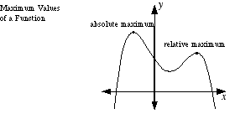

**Absolute Minimum, Absolute Min  
Global Minimum, Golbal Min**

The lowest [point](http://www.mathwords.com/p/point.htm) over the entire [domain](http://www.mathwords.com/d/domain.htm) of a [function](http://www.mathwords.com/f/function.htm) or [relation](http://www.mathwords.com/r/relation.htm).

Note: The [first derivative test](http://www.mathwords.com/f/first_derivative_test.htm) and the [second derivative test](http://www.mathwords.com/s/second_derivative_test.htm) are common methods used to find [minimum values of a function](http://www.mathwords.com/m/minimum_of_a_function.htm).

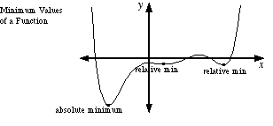

**Acceleration**

The rate of change of [velocity](http://www.mathwords.com/v/velocity.htm) over time. For motion along the number line, acceleration is a [scalar](http://www.mathwords.com/s/scalar.htm). For motion on a [plane](http://www.mathwords.com/p/plane.htm) or through [space](http://www.mathwords.com/t/three_dimensions.htm), acceleration is a [vector](http://www.mathwords.com/v/vector.htm).

**Absolutely Convergent**

**See Absolute Convergence**

**Alternating Series**

A [series](http://www.mathwords.com/s/series.htm) which alternates between [positive](http://www.mathwords.com/p/positive_number.htm) and [negative](http://www.mathwords.com/n/negative_number.htm) [terms](http://www.mathwords.com/t/term.htm). For example, the series http://www.mathwords.com/a/a_assets/alternating%20series.gifis alternating.

**Alternating Series Remainder**

A quantity that measures how [accurately](http://www.mathwords.com/a/accuracy.htm) the [nth partial sum](http://www.mathwords.com/n/nth_partial_sum.htm) of an [alternating series](http://www.mathwords.com/a/alternating_series.htm) estimates the [sum](http://www.mathwords.com/s/sum.htm) of the [series](http://www.mathwords.com/s/series.htm).

|  |
| --- |
| Consider the following alternating series (where an > 0 for all n) and/or its equivalents.  http://www.mathwords.com/a/a_assets/alternating%20series1.gif  If the series [converges](http://www.mathwords.com/c/convergent_series.htm) to S by the [alternating series test](http://www.mathwords.com/a/alternating_series_test.htm), then the remainder  http://www.mathwords.com/a/a_assets/alternating%20series%20remainder.gif  can be estimated as follows for all n ≥ N:  http://www.mathwords.com/a/a_assets/alternating%20series%20remainder2.gif  Here, N is the point at which the values of an become non-increasing:  http://www.mathwords.com/a/a_assets/alternating%20series%20test1a.gif |

**Alternating Series Test**

A [convergence test](http://www.mathwords.com/c/convergence_tests.htm) for [alternating series](http://www.mathwords.com/a/alternating_series.htm).

|  |
| --- |
| Consider the following alternating series (where *an* > 0 for all n) and/or its equivalents:  http://www.mathwords.com/a/a_assets/alternating%20series1.gif  The series [converges](http://www.mathwords.com/c/converge.htm) if the following conditions are met:  http://www.mathwords.com/a/a_assets/alternating%20series%20test1.gif  http://www.mathwords.com/a/a_assets/alternating%20series%20test2.gif |

**Analytic Methods**

The use of [algebraic](http://www.mathwords.com/a/algebra.htm) and/or numeric methods as the main technique for solving a math problem. The instructions "solve using analytic methods" and "solve analytically" usually mean that no calculator is allowed.

**Annulus**

**See Washer**

**Antiderivative of a Function**

A [function](http://www.mathwords.com/f/function.htm) that has a given function as its [derivative](http://www.mathwords.com/d/derivative.htm). For example, F(x) = x3 – 8 is an antiderivative of f(x) = 3x2.

**Approximation by Differentials**

A method for approximating the value of a [function](http://www.mathwords.com/f/function.htm) near a known value. The method uses the [tangent line](http://www.mathwords.com/t/tangent_line.htm) at the known value of the function to approximate the function's [graph](http://www.mathwords.com/g/graph_of_an_equation_or_inequality.htm). In this method Δx and Δy represent the changes in x and y for the function, and dx and dy represent the changes in x and y for the tangent line.

|  |  |
| --- | --- |
| http://www.mathwords.com/a/a_assets/a59a.gif | |
| Example: | Approximate http://www.mathwords.com/a/a_assets/approximation%20by%20differentials1.gifby differentials. |
| Solution: | http://www.mathwords.com/a/a_assets/approximation%20by%20differentials1.gifis near http://www.mathwords.com/a/a_assets/approximation%20by%20differentials2.gif, so we will use http://www.mathwords.com/a/a_assets/approximation%20by%20differentials3.gifwith x = 9 and Δx = 1.  Note that http://www.mathwords.com/a/a_assets/approximation%20by%20differentials4.gif.  http://www.mathwords.com/a/a_assets/approximation%20by%20differentials8.gif  Thus we see that http://www.mathwords.com/a/a_assets/approximation%20by%20differentials6.gif This is very close to the correct value ofhttp://www.mathwords.com/a/a_assets/approximation%20by%20differentials7.gif |

**Arc Length of a Curve**

The length of a [curve](http://www.mathwords.com/c/curve.htm) or [line](http://www.mathwords.com/l/line.htm).

The length of an arc can be found by one of the [formulas](http://www.mathwords.com/f/formula.htm) below for any [differentiable](http://www.mathwords.com/d/differentiable.htm) curve defined by [rectangular](http://www.mathwords.com/c/cartesian_form.htm), [polar](http://www.mathwords.com/p/polar_coordinates.htm), or [parametric](http://www.mathwords.com/p/parametric_equations.htm) [equations](http://www.mathwords.com/e/equation.htm).

For the length of a circular arc, see [arc of a circle](http://www.mathwords.com/a/area_circle.htm).

|  |  |
| --- | --- |
| Formula: | http://www.mathwords.com/a/a_assets/arc%20length%20formula1.gif  where *a* and *b* represent *x*, *y*, *t*, or θ-values as appropriate, and *ds* can be found as follows.  1. In [rectangular form](http://www.mathwords.com/c/cartesian_form.htm), use whichever of the following is easier:  http://www.mathwords.com/a/a_assets/arc%20length%20formula2.gif or http://www.mathwords.com/a/a_assets/arc%20length%20formula3.gif  Example) Find the length of an arc of the [curve](http://www.mathwords.com/c/curve.htm) y = (1/6) x3 + (1/2) x–1  from x = 1 to x = 2.  http://www.mathwords.com/a/a_assets/arc%20length%20ex1work.gif http://www.mathwords.com/a/a_assets/arc%20length%20example%201Graph.gif  2. In [parametric form](http://www.mathwords.com/p/parametric_equations.htm), use  http://www.mathwords.com/a/a_assets/arc%20length%20formula4.gif  Example) Find the length of the arc in one [period](http://www.mathwords.com/p/period_of_a_periodic_function.htm) of the [cycloid](http://www.mathwords.com/c/cycloid.htm) x = t – sin t, y = 1 – cos t. The values of t run from 0 to 2π.  http://www.mathwords.com/a/a_assets/arc%20length%20ex2work.gifhttp://www.mathwords.com/a/a_assets/arc%20length%20example%202Graph.gif  3. In [polar form](http://www.mathwords.com/p/polar_equation.htm), use  http://www.mathwords.com/a/a_assets/arc%20length%20formula5.gif  Example) Find the length of the first rotation of the [logarithmic spiral](http://www.mathwords.com/s/spiral.htm) *r* = eθ. The values of θ run from 0 to 2π.  http://www.mathwords.com/a/a_assets/arc%20length%20ex3work.gif http://www.mathwords.com/a/a_assets/arc%20length%20example%203Graph.gif |

**Area between Curves**

The area between curves is given by the [formulas](http://www.mathwords.com/f/formula.htm) below.

|  |  |
| --- | --- |
| Formula 1: | http://www.mathwords.com/a/a_assets/area%20between%20curves%20formula1.gif |
|  | for a region bounded above and below by y = f(x) and y = g(x), and on the left and right by x = a and x = b. |
| Formula 2: | http://www.mathwords.com/a/a_assets/area%20between%20curves%20formula2.gif |
|  | for a region bounded left and right by x = f(y) and x = g(y), and above and below by y = c and y = d. |
| Example 1:1 | Find the area between *y = x* and *y = x*2 from *x =* 1 to *x =* 2. |
|  | http://www.mathwords.com/a/a_assets/area%20between%20curves%20example1graph.gif http://www.mathwords.com/a/a_assets/area%20between%20curves%20example1work.gif |
| Example 2:1 | Find the area between *x = y +* 3 and *x = y*2 from *y =* –1 to *y =* 1. |
|  | http://www.mathwords.com/a/a_assets/area%20between%20curves%20example2graph.gif http://www.mathwords.com/a/a_assets/area%20between%20curves%20example2work.gif |

**Area of an Ellipse**

The [formula](http://www.mathwords.com/f/formula.htm) is given below.

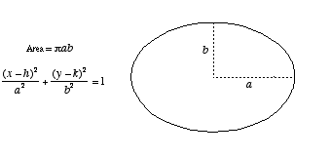

**Area of a Parabolic Segment**

The [formula](http://www.mathwords.com/f/formula.htm) is given below.

http://www.mathwords.com/a/a_assets/a72.gif

**Area under a Curve**

The area between the [graph](http://www.mathwords.com/g/graph_of_an_equation_or_inequality.htm) of y = f(x) and the x-axis is given by the [definite integral](http://www.mathwords.com/d/definite_integral.htm) below. This [formula](http://www.mathwords.com/f/formula.htm) gives a [positive](http://www.mathwords.com/p/positive_number.htm) result for a graph above the x-axis, and a [negative](http://www.mathwords.com/n/negative_number.htm) result for a graph below the x-axis.

Note: If the graph of y = f(x) is partly above and partly below the x-axis, the formula given below generates the net area. That is, the area above the axis minus the area below the axis.

|  |  |  |
| --- | --- | --- |
| Formula: | | http://www.mathwords.com/a/a_assets/area%20under%20curve%20formulaGraph.gif   http://www.mathwords.com/a/a_assets/area%20under%20curve%20formula.gif |
| Example 1: | Find the area between *y* = 7 – *x*2 and the x-axis between the values *x* = –1 and *x* = 2.  http://www.mathwords.com/a/a_assets/area%20under%20curve%20ex1graph.gif http://www.mathwords.com/a/a_assets/area%20under%20curve%20ex1work.gif |
| Example 2: | Find the net area between y = sin x and the x-axis between the values x = 0 and x = 2π.  http://www.mathwords.com/a/a_assets/area%20under%20curve%20ex2graph.gif http://www.mathwords.com/a/a_assets/area%20under%20curve%20ex2work.gif |

**Area Using Parametric Equations  
Parametric Integral Formula**

The area between the x-axis and the [graph](http://www.mathwords.com/g/graph_of_an_equation_or_inequality.htm) of x = x(t), y = y(t) and the x-axis is given by the [definite integral](http://www.mathwords.com/d/definite_integral.htm) below. This [formula](http://www.mathwords.com/f/formula.htm) gives a [positive](http://www.mathwords.com/p/positive_number.htm) result for a graph above the x-axis, and a [negative](http://www.mathwords.com/n/negative_number.htm) result for a graph below the x-axis.

Note: If the graph of x = x(t), y = y(t) is partly above and partly below the x-axis, the formula given below generates the net area. That is, the area above the axis minus the area below the axis.

|  |  |
| --- | --- |
| Formula: | http://www.mathwords.com/a/a_assets/area%20parametric%20formulaGraph.gif        http://www.mathwords.com/a/a_assets/area%20parametric%20formula.gif |
| Example: | Find the area of the between the x-axis and the first [period](http://www.mathwords.com/p/period_of_a_periodic_function.htm) of the [cycloid](http://www.mathwords.com/c/cycloid.htm) x = t – sin t, y = 1 – cos t. The values of t run from 0 to 2π.  http://www.mathwords.com/a/a_assets/area%20parametric%20exampleWork.gif http://www.mathwords.com/a/a_assets/area%20parametric%20exampleGraph.gif |

**Area Using Polar Coordinates  
Polar Integral Formula**

The area between the [graph](http://www.mathwords.com/g/graph_of_an_equation_or_inequality.htm) of r = r(θ) and the [origin](http://www.mathwords.com/o/origin.htm) and also between the [rays](http://www.mathwords.com/r/ray.htm) θ = α and θ = β is given by the [formula](http://www.mathwords.com/f/formula.htm) below (assuming α ≤ β).

|  |  |
| --- | --- |
| Formula: | http://www.mathwords.com/a/a_assets/area%20polar%20formulaGraph.gif http://www.mathwords.com/a/a_assets/area%20polar%20formula.gif |
| Example: | Find the area of the region bounded by the [graph](http://www.mathwords.com/g/graph_of_an_equation_or_inequality.htm) of the [lemniscate](http://www.mathwords.com/l/lemniscate.htm) r2 = 2 cos θ,  the [origin](http://www.mathwords.com/o/origin.htm), and between the [rays](http://www.mathwords.com/r/ray.htm) θ = –π/6 and θ = π/4.  http://www.mathwords.com/a/a_assets/area%20polar%20exampleWork.gif http://www.mathwords.com/a/a_assets/area%20polar%20exampleGraph.gif |

**Asymptote**

A [line](http://www.mathwords.com/l/line.htm) or [curve](http://www.mathwords.com/c/curve.htm) that the [graph](http://www.mathwords.com/g/graph_of_an_equation_or_inequality.htm) of a [relation](http://www.mathwords.com/r/relation.htm) approaches more and more closely the further the graph is followed.

Note: Sometimes a graph will cross a [horizontal](http://www.mathwords.com/h/horizontal.htm) asymptote or an [oblique](http://www.mathwords.com/o/oblique.htm) asymptote. The graph of a [function](http://www.mathwords.com/f/function.htm), however, will never cross a [vertical](http://www.mathwords.com/v/vertical.htm) asymptote.

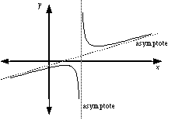

**Average Rate of Change**

The change in the value of a quantity divided by the elapsed time. For a [function](http://www.mathwords.com/f/function.htm), this is the change in the y-value divided by the change in the x-value for two [distinct](http://www.mathwords.com/d/distinct.htm) [points](http://www.mathwords.com/p/point.htm) on the [graph](http://www.mathwords.com/g/graph_of_an_equation_or_inequality.htm).

Note: This is the same thing as the [slope](http://www.mathwords.com/s/slope_of_a_line.htm) of the [secant line](http://www.mathwords.com/s/secant_line.htm) that passes through the two points.

**Average Value of a Function**

The [average](http://www.mathwords.com/a/average.htm) height of the [graph](http://www.mathwords.com/g/graph_of_an_equation_or_inequality.htm) of a [function](http://www.mathwords.com/f/function.htm). For *y* = *f*(*x*) over the [domain](http://www.mathwords.com/d/domain.htm) [*a*, *b*], the [formula](http://www.mathwords.com/f/formula.htm) for average value is given below.

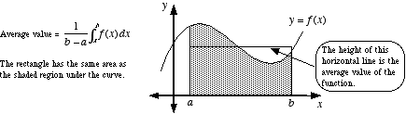

**Axis of Rotation**

A [line](http://www.mathwords.com/l/line.htm) about which a [plane figure](http://www.mathwords.com/p/plane_figure.htm) is [rotated](http://www.mathwords.com/r/rotation.htm) in [three dimensional space](http://www.mathwords.com/t/three_dimensions.htm) to create a [solid](http://www.mathwords.com/s/solid.htm) or [surface](http://www.mathwords.com/s/surface.htm).

**Boundary Value Problem  
BVP**

A [differential equation](http://www.mathwords.com/d/differential_eqn.htm) or [partial differential equation](http://www.mathwords.com/p/partial_differential_equations.htm) accompanied by conditions for the value of the function but with no conditions for the value of any [derivatives](http://www.mathwords.com/d/derivative.htm).

Note: Boundary value problem is often abbreviated BVP.

|  |  |
| --- | --- |
| [Differential Equation](http://www.mathwords.com/d/differential_eqn.htm) | y" + y = sin x |
| [Initial Value Problem](http://www.mathwords.com/i/initial_value_problem.htm) (IVP) | y" + y = sin x, y(0) = 1, y'(0) = – 2 |
| Boundary Value Problem (BVP) | y" + y = sin x, y(0) = 1, y(1) = – 2 |

**Bounded Function**

A [function](http://www.mathwords.com/f/function.htm) with a [range](http://www.mathwords.com/r/range.htm) that is a [bounded set](http://www.mathwords.com/b/bounded_set_numbers.htm). The range must have both an [upper bound](http://www.mathwords.com/u/upper_bound.htm) and a [lower bound](http://www.mathwords.com/l/lower_bound.htm).

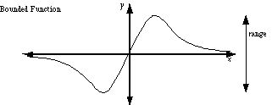

**Bounded Sequence**

A [sequence](http://www.mathwords.com/s/sequence.htm) with [terms](http://www.mathwords.com/t/term.htm) that have an [upper bound](http://www.mathwords.com/u/upper_bound.htm) and a [lower bound](http://www.mathwords.com/l/lower_bound.htm). For example, the [harmonic sequence](http://www.mathwords.com/h/harmonic_sequence.htm) http://www.mathwords.com/b/b_assets/bounded%20sequence%20harmonic.gifis bounded since no term is greater than 1 or less than 0.

**Bounds of Integration  
Limits of Integration**

For the [definite integral](http://www.mathwords.com/d/definite_integral.htm) http://www.mathwords.com/d/d_assets/definite%20integral%20notation.gif, the bounds (or limits) of [integration](http://www.mathwords.com/d/definite_integral.htm) are a and b.

**Calculus**

The branch of mathematics dealing with [limits](http://www.mathwords.com/l/limit.htm), [derivatives](http://www.mathwords.com/d/derivative.htm), [definite integrals](http://www.mathwords.com/d/definite_integral.htm), [indefinite integrals](http://www.mathwords.com/i/indefinite_integral.htm), and [power series](http://www.mathwords.com/p/power_series.htm).

Common problems from calculus include finding the [slope of a curve](http://www.mathwords.com/s/slope_of_a_curve.htm), finding [extrema](http://www.mathwords.com/e/extremum.htm), finding the [instantaneous rate of change](http://www.mathwords.com/i/instantaneous_rate_of_change.htm) of a [function](http://www.mathwords.com/f/function.htm), finding the [area under a curve](http://www.mathwords.com/a/area_under_a_curve.htm), and finding [volumes by parallel cross-sections](http://www.mathwords.com/v/volume_by_parallel_cross_sections.htm).

**Cartesian Form  
Rectangular Form**

A [function](http://www.mathwords.com/f/function.htm) (or [relation](http://www.mathwords.com/r/relation.htm)) written using (*x*, *y*) or (*x*, *y*, *z*) [coordinates](http://www.mathwords.com/c/coordinates.htm).

**Cavalieri’s Principle**

A method, with [formula](http://www.mathwords.com/f/formula.htm) given below, of finding the [volume](http://www.mathwords.com/v/volume.htm) of any [solid](http://www.mathwords.com/s/solid_geometry.htm) for which cross-sections by [parallel planes](http://www.mathwords.com/p/parallel_planes.htm) have equal areas. This includes, but is not limited to, [cylinders](http://www.mathwords.com/c/cylinder.htm) and [prisms](http://www.mathwords.com/p/prism.htm).

|  |  |
| --- | --- |
| Formula: | Volume = Bh, where B is the area of a cross-section and h is the height of the solid. |

**Center of Mass Formula**

The [coordinates](http://www.mathwords.com/c/coordinates.htm) http://www.mathwords.com/c/c_assets/c14.gifof the center of mass of a [plane figure](http://www.mathwords.com/p/plane_figure.htm) are given by the [formulas](http://www.mathwords.com/f/formula.htm) below. The formulas only apply for figures of [uniform](http://www.mathwords.com/u/uniform.htm) (constant) density.

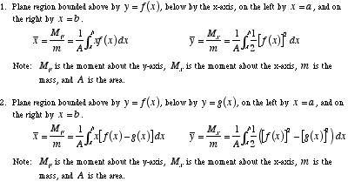

**Centroid**

For a [triangle](http://www.mathwords.com/t/triangle.htm), this is the point at which the three [medians](http://www.mathwords.com/m/median_of_a_triangle.htm) intersect. In general, the centroid is the [center of mass](http://www.mathwords.com/c/center_of_mass_formula.htm) of a [figure](http://www.mathwords.com/g/geometric_figure.htm) of [uniform](http://www.mathwords.com/u/uniform.htm) (constant) density.

[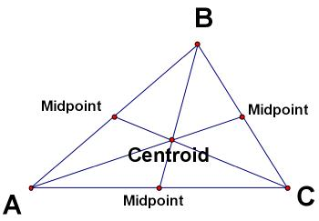](http://www.mathwords.com/multimedia/centroid.htm)  
Centroid of a Triangle

**Chain Rule**

A method for finding the [derivative](http://www.mathwords.com/d/derivative.htm) of a [composition](http://www.mathwords.com/c/composition.htm) of [functions](http://www.mathwords.com/f/function.htm). The [formula](http://www.mathwords.com/f/formula.htm) is http://www.mathwords.com/c/c_assets/c24.gif. Another form of the chain rule is http://www.mathwords.com/c/c_assets/c25.gif.

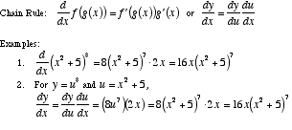

**Comparison Test**

A [convergence test](http://www.mathwords.com/c/convergence_tests.htm) which compares the [series](http://www.mathwords.com/s/series.htm) under consideration to a known series. Essentially, the test determines whether a series is "better" than a "good" series or "worse" than a "bad" series. The "good" or "bad" series is often a [p-series](http://www.mathwords.com/p/p_series.htm).

|  |
| --- |
| If ∑ *an* , ∑ *cn* , and ∑ *dn* are all [positive series](http://www.mathwords.com/p/positive_series.htm), where ∑ *cn* [converges](http://www.mathwords.com/c/convergent_series.htm) and ∑ *dn* [diverges](http://www.mathwords.com/d/divergent_series.htm), then:  1. If *an* ≤ *cn* for all *n* ≥ *N* for some [fixed](http://www.mathwords.com/f/fixed.htm) *N*, then ∑ *an* converges.  2. If *an* ≥ *dn* for all *n* ≥ *N* for some [fixed](http://www.mathwords.com/f/fixed.htm) *N*, then ∑ *an* diverges. |

**Concave  
Non-Convex**

A shape or solid which has an indentation or "cave". Formally, a [geometric figure](http://www.mathwords.com/g/geometric_figure.htm) is concave if there is at least one [line segment](http://www.mathwords.com/l/line_segment.htm) connecting [interior](http://www.mathwords.com/i/interior.htm) [points](http://www.mathwords.com/p/point.htm) which passes outside of the figure.

http://www.mathwords.com/c/c_assets/c110.gif

**Concave Down**

A [graph](http://www.mathwords.com/g/graph_of_an_equation_or_inequality.htm) or part of a graph which looks like an upside-down bowl or part of an upside-down bowl.

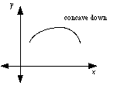

**Concave Up**

A [graph](http://www.mathwords.com/g/graph_of_an_equation_or_inequality.htm) or part of a graph which looks like a right-side up bowl or part of an right-side up bowl.

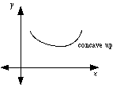

**Conditional Convergence**

Describes a [series](http://www.mathwords.com/s/series.htm) that [converges](http://www.mathwords.com/c/convergent_series.htm) but does not [converge absolutely](http://www.mathwords.com/a/absolute_convergence.htm). That is, a convergent series that will become a [divergent series](http://www.mathwords.com/d/divergent_series.htm) if all [negative](http://www.mathwords.com/n/negative_number.htm) terms are made [positive](http://www.mathwords.com/p/positive_number.htm).

http://www.mathwords.com/c/c_assets/c115.gif

**Constant Term**

The [term](http://www.mathwords.com/t/term.htm) in a [simplified](http://www.mathwords.com/s/simplify.htm) [algebraic](http://www.mathwords.com/a/algebra.htm) [expression](http://www.mathwords.com/e/expression.htm) or [equation](http://www.mathwords.com/e/equation.htm) which contains no [variable(s)](http://www.mathwords.com/v/variable.htm). If there is no such term, the [constant](http://www.mathwords.com/c/constant.htm) term is 0.

Example:   –5 is the constant term in p(x) = 2x3 – 4x2 + 9x – 5

**Continued Sum**

**See Sigma Notation**

**Continuous Function**

A [function](http://www.mathwords.com/f/function.htm) with a connected [graph](http://www.mathwords.com/g/graph_of_an_equation_or_inequality.htm).

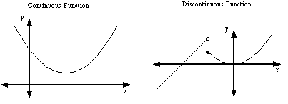  
  
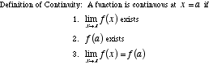

**Continuously Differentiable Function**

A [function](http://www.mathwords.com/f/function.htm) which has a [derivative](http://www.mathwords.com/d/derivative.htm) that is itself a [continuous function](http://www.mathwords.com/c/continuous_fn.htm).

**Converge**

To approach a [finite](http://www.mathwords.com/f/finite.htm) [limit](http://www.mathwords.com/l/limit.htm). There are convergent limits, [convergent series](http://www.mathwords.com/c/convergent_series.htm), [convergent sequences](http://www.mathwords.com/c/convergent_sequence.htm), and convergent [improper integrals](http://www.mathwords.com/i/improper_integral.htm).

**Converge Absolutely**

**See Absolute Convergence**

**Converge Conditionally**

**See Conditional Converge**

**Convergent Series**

An [infinite series](http://www.mathwords.com/i/infinite_series.htm) for which the [sequence of partial sums](http://www.mathwords.com/s/sequence_of_partial_sums.htm) [converges](http://www.mathwords.com/c/converge.htm). For example, the sequence of partial sums of the [series](http://www.mathwords.com/s/series.htm) 0.9 + 0.09 + 0.009 + 0.0009 + ··· is 0.9, 0.99, 0.999, 0.9999, .... This [sequence converges](http://www.mathwords.com/c/convergent_sequence.htm) to 1, so the series 0.9 + 0.09 + 0.009 + 0.0009 + ··· is convergent.

**Convergent Sequence**

A [sequence](http://www.mathwords.com/s/sequence.htm) with a [limit](http://www.mathwords.com/l/limit.htm) that is a [real number](http://www.mathwords.com/r/real_numbers.htm). For example, the sequence 2.1, 2.01, 2.001, 2.0001, . . . has limit 2, so the sequence [converges](http://www.mathwords.com/c/converge.htm) to 2. On the other hand, the sequence 1, 2, 3, 4, 5, 6, . . . has a limit of [infinity (∞)](http://www.mathwords.com/i/infinity.htm). This is not a real number, so the sequence does not converge. It is a [divergent sequence](http://www.mathwords.com/d/divergent_sequence.htm).

**Convergence Tests**

[Limit test for divergence](http://www.mathwords.com/l/limit_test_for_divergence.htm)  
[Integral test](http://www.mathwords.com/i/integral_test.htm)  
[Comparison test](http://www.mathwords.com/c/comparison_test.htm)  
[Limit comparison test](http://www.mathwords.com/l/limit_comparison_test.htm)  
[Alternating series test](http://www.mathwords.com/a/alternating_series_test.htm)  
[Ratio test](http://www.mathwords.com/r/ratio_test.htm)  
[Root test](http://www.mathwords.com/r/root_test.htm)

**Critical Number  
Critical Value**

The *x*-value of a [critical point](http://www.mathwords.com/c/critical_point.htm).

**Critical Point**

A [point](http://www.mathwords.com/p/point.htm) (*x*, *y*) on the [graph](http://www.mathwords.com/g/graph_of_an_equation_or_inequality.htm) of a [function](http://www.mathwords.com/f/function.htm) at which the [derivative](http://www.mathwords.com/d/derivative.htm) is either 0 or undefined. A critical point will often be a [minimum](http://www.mathwords.com/m/minimum_of_a_function.htm) or [maximum](http://www.mathwords.com/m/maximum_of_a_function.htm), but it may be neither.

Note: Finding critical points is an important step in the process of [curve sketching](http://www.mathwords.com/c/curve_sketching.htm).

**Critical Value  
 See Critical Point**

**Curly d**

The symbol ∂ used in the notation for [partial derivatives](http://www.mathwords.com/p/partial_derivative.htm).

**Curve**

A word used to indicate any path, whether actually curved or straight, closed or open. A curve can be on a [plane](http://www.mathwords.com/p/plane.htm) or in [three-dimensional space](http://www.mathwords.com/t/three_dimensions.htm) (or [n-dimensional space](http://www.mathwords.com/n/n_dimensions.htm), for that matter). [Lines](http://www.mathwords.com/l/line.htm), [circles](http://www.mathwords.com/c/circle.htm), [arcs](http://www.mathwords.com/a/arc_circle.htm), [parabolas](http://www.mathwords.com/p/parabola.htm), [polygons](http://www.mathwords.com/p/polygon.htm), and [helixes](http://www.mathwords.com/h/helix.htm) are all types of curves.

Note: Typically curves are thought of as the [set](http://www.mathwords.com/s/set.htm) of all [geometric figures](http://www.mathwords.com/g/geometric_figure.htm) that can be [parametrized](http://www.mathwords.com/p/parametrize.htm) using a single [parameter](http://www.mathwords.com/p/parameter.htm). This is not in fact accurate, but it is a useful way to conceptualize curves. The exceptions to this rule require some cleverness, or at least some exposure to space-filling curves.

**Curve Sketching**

The process of using the [first derivative](http://www.mathwords.com/f/first_derivative.htm) and [second derivative](http://www.mathwords.com/s/second_derivative.htm) to [graph](http://www.mathwords.com/g/graph_of_an_equation_or_inequality.htm) a [function](http://www.mathwords.com/f/function.htm) or [relation](http://www.mathwords.com/r/relation.htm). As a result the [coordinates](http://www.mathwords.com/c/coordinates.htm) of all [discontinuities](http://www.mathwords.com/d/discontinuity.htm), [extrema](http://www.mathwords.com/e/extremum.htm), and [inflection points](http://www.mathwords.com/i/inflection_point.htm) can be accurately plotted.

**Cusp**

A sharp [point](http://www.mathwords.com/p/point.htm) on a curve. Note: Cusps are points at which [functions](http://www.mathwords.com/f/function.htm) and [relations](http://www.mathwords.com/r/relation.htm) are not [differentiable](http://www.mathwords.com/d/differentiable.htm).

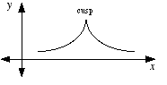

**Cylindrical Shell Method  
Shell Method**

A technique for finding the [volume](http://www.mathwords.com/v/volume.htm) of a [solid of revolution](http://www.mathwords.com/s/solid_of_revolution.htm).

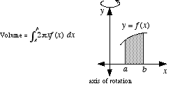

**Decreasing Function**

A [function](http://www.mathwords.com/f/function.htm) with a [graph](http://www.mathwords.com/g/graph_of_an_equation_or_inequality.htm) that moves downward as it is followed from left to right. For example, any [line](http://www.mathwords.com/l/line.htm) with a [negative](http://www.mathwords.com/n/negative_number.htm) [slope](http://www.mathwords.com/s/slope_of_a_line.htm) is decreasing.

Note: If a function is [differentiable](http://www.mathwords.com/d/differentiable.htm), then it is decreasing at all [points](http://www.mathwords.com/p/point.htm) where its [derivative](http://www.mathwords.com/d/derivative.htm) is negative.

**Definite Integral**

An [integral](http://www.mathwords.com/i/integral_of_a_function.htm) which is [evaluated](http://www.mathwords.com/e/evaluate.htm) over an [interval](http://www.mathwords.com/i/interval.htm). A definite integral is written http://www.mathwords.com/d/d_assets/definite%20integral%20notation.gif. Definite integrals are used to find the [area between the graph of a function and the x-axis](http://www.mathwords.com/a/area_under_a_curve.htm). There are many other applications.

Formally, a definite integral is the [limit](http://www.mathwords.com/l/limit.htm) of a [Riemann sum](http://www.mathwords.com/r/riemann_sum.htm) as the [norm of the partition](http://www.mathwords.com/m/mesh.htm) approaches [zero](http://www.mathwords.com/xyz/zero.htm).   
That is, http://www.mathwords.com/d/d_assets/d4.gif.

http://www.mathwords.com/d/d_assets/d5.gif

**Definite Integral Rules   
 See Integral Rules**

**Degenerate**

An example of a definition that stretches the definition to an absurd degree.

A degenerate [triangle](http://www.mathwords.com/t/triangle.htm) is the "triangle" formed by three [collinear points](http://www.mathwords.com/c/collinear.htm). It doesn’t look like a triangle, it looks like a [line segment](http://www.mathwords.com/l/line_segment.htm).

A [parabola](http://www.mathwords.com/p/parabola.htm) may be thought of as a degenerate [ellipse](http://www.mathwords.com/e/ellipse.htm) with one [vertex](http://www.mathwords.com/v/vertices_of_an_ellipse.htm) at an infinitely distant [point](http://www.mathwords.com/p/point.htm).

Degenerate examples can be used to test the general applicability of [formulas](http://www.mathwords.com/f/formula.htm) or concepts. Many of the formulas developed for triangles (such as [area formulas](http://www.mathwords.com/a/area_triangle.htm)) apply to degenerate triangles as well.

http://www.mathwords.com/d/d_assets/d6.gif

**Del Operator**

The symbol http://www.mathwords.com/d/d_assets/d12.gif, which stands for the "[vector](http://www.mathwords.com/v/vector.htm)" http://www.mathwords.com/d/d_assets/d13.gifor http://www.mathwords.com/d/d_assets/d14.gif.

**Deleted Neighborhood**

The proper name for a [set](http://www.mathwords.com/s/set.htm) such as {x: 0 < |x – a| < δ}. Deleted neighborhoods are encountered in the study of [limits](http://www.mathwords.com/l/limit.htm). It is the set of all numbers less than δ units away from a, omitting the number a itself.

Using [interval notation](http://www.mathwords.com/i/interval_notation.htm) the set {x: 0 < |x – a| < δ} would be (a – δ, a) ∪ (a, a + δ). In general, a deleted neighborhood of a is any set (c, a) ∪ (a, d) where c < a < d.

For example, one deleted neighborhood of 2 is the set {x: 0 < |x – 2| < 0.1}, which is the same as (1.9, 2) ∪ (2, 2.1).

http://www.mathwords.com/d/d_assets/d24.gif

**Derivative**

A [function](http://www.mathwords.com/f/function.htm) which gives the [slope of a curve](http://www.mathwords.com/s/slope_of_a_curve.htm); that is, the [slope](http://www.mathwords.com/s/slope_of_a_line.htm) of the [line tangent](http://www.mathwords.com/t/tangent_line.htm) to a [function](http://www.mathwords.com/f/function.htm). The derivative of a function *f* at a [point](http://www.mathwords.com/p/point.htm) *x* is commonly written f '(x). For example, if f(x) = x3 then f '(x) = 3x2. The slope of the tangent line when x = 5 is f '(x) = 3·52 = 75.

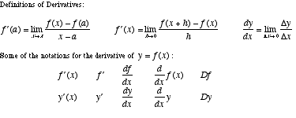

**Derivative of a Power Series**

The [derivative](http://www.mathwords.com/d/derivative.htm) of a [function](http://www.mathwords.com/f/function.htm) defined by a [power series](http://www.mathwords.com/p/power_series.htm) can be found by [differentiating](http://www.mathwords.com/d/differentiation.htm) the [series](http://www.mathwords.com/s/series.htm) term-by-term.

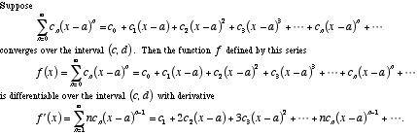

**Derivative Rules**

A list of common [derivative](http://www.mathwords.com/d/derivative.htm) rules is given below.

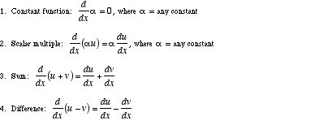

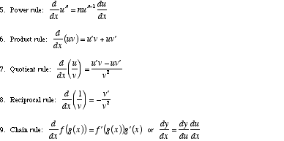

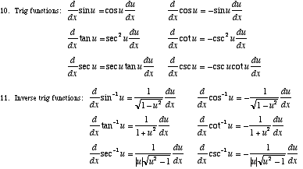  
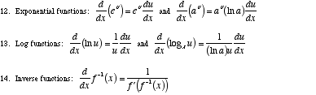

**Difference Quotient**

For a [function](http://www.mathwords.com/f/function.htm) f, the [formula](http://www.mathwords.com/f/formula.htm) http://www.mathwords.com/d/d_assets/d55.gif. This formula [computes](http://www.mathwords.com/c/compute.htm) the [slope](http://www.mathwords.com/s/slope_of_a_line.htm) of the [secant line](http://www.mathwords.com/s/secant_line.htm) through two [points](http://www.mathwords.com/p/point.htm) on the [graph](http://www.mathwords.com/g/graph_of_an_equation_or_inequality.htm) of f. These are the points with x-coordinates x and x + h. The difference quotient is used in the definition the [derivative](http://www.mathwords.com/d/derivative.htm).

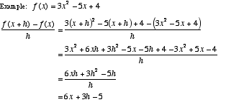

**Differentiable**

A [curve](http://www.mathwords.com/c/curve.htm) that is smooth and contains no [discontinuities](http://www.mathwords.com/d/discontinuity.htm) or [cusps](http://www.mathwords.com/c/cusp.htm). Formally, a curve is differentiable at all values of the [domain](http://www.mathwords.com/d/domain.htm) [variable(s)](http://www.mathwords.com/v/variable.htm) for which the [derivative](http://www.mathwords.com/d/derivative.htm) exists.

**Differential**

An tiny or [infinitesimal](http://www.mathwords.com/i/infinitesimal.htm) change in the value of a [variable](http://www.mathwords.com/v/variable.htm). Differentials are commonly written in the form *dx* or *dy*.

**Differential Equation**

An [equation](http://www.mathwords.com/e/equation.htm) showing a relationship between a [function](http://www.mathwords.com/f/function.htm) and its [derivative(s)](http://www.mathwords.com/d/derivative.htm). For example, http://www.mathwords.com/d/d_assets/d62.gifis a differential equation with [solutions](http://www.mathwords.com/s/solution.htm) y = Ce–x.

**Differentiation**

The process of finding a [derivative](http://www.mathwords.com/d/derivative.htm).

**Differentiation Rules**

**See Derivative Rules**

**Discontinuity**

A [point](http://www.mathwords.com/p/point.htm) at which the [graph](http://www.mathwords.com/g/graph_of_an_equation_or_inequality.htm) of a [relation](http://www.mathwords.com/r/relation.htm) or [function](http://www.mathwords.com/f/function.htm) is not connected. Discontinuities can be classified as either [removable](http://www.mathwords.com/r/removable_discontinuity.htm) or [essential](http://www.mathwords.com/e/essential_discontinuity.htm). There are several kinds of essential discontinuities, one of which is the [step discontinuity](http://www.mathwords.com/s/step_discontinuity.htm).

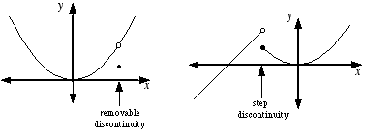

**Discontinuous Function**

A [function](http://www.mathwords.com/f/function.htm) with a [graph](http://www.mathwords.com/g/graph_of_an_equation_or_inequality.htm) that is not connected.

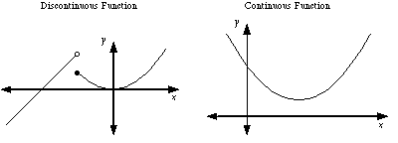

**Disk**

The [union](http://www.mathwords.com/u/union.htm) of a [circle](http://www.mathwords.com/c/circle.htm) and its [interior](http://www.mathwords.com/i/interior.htm).

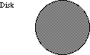

**Disk Method**

A technique for finding the [volume](http://www.mathwords.com/v/volume.htm) of a [solid of revolution](http://www.mathwords.com/s/solid_of_revolution.htm). This method is a specific case of [volume by parallel cross-sections](http://www.mathwords.com/v/volume_by_parallel_cross_sections.htm).

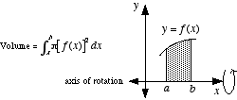

**Distance from a Point to a Line**

The length of the shortest [segment](http://www.mathwords.com/l/line_segment.htm) from a given [point](http://www.mathwords.com/p/point.htm) to a given [line](http://www.mathwords.com/l/line.htm). A [formula](http://www.mathwords.com/f/formula.htm) is given below.

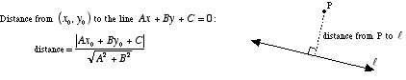

**Diverge**

To fail to approach a [finite](http://www.mathwords.com/f/finite.htm) [limit](http://www.mathwords.com/l/limit.htm). There are divergent [limits](http://www.mathwords.com/l/limit.htm), [divergent series](http://www.mathwords.com/d/divergent_series.htm), [divergent sequences](http://www.mathwords.com/d/divergent_sequence.htm), and divergent [improper integrals](http://www.mathwords.com/i/improper_integral.htm).

**Divergent Sequence**

A [sequence](http://www.mathwords.com/s/sequence.htm) that does not [converge](http://www.mathwords.com/c/convergent_sequence.htm). For example, the sequence 1, 2, 3, 4, 5, 6, 7, ... diverges since its [limit](http://www.mathwords.com/l/limit.htm) is [infinity (∞)](http://www.mathwords.com/i/infinity.htm). The limit of a convergent sequence must be a [real number](http://www.mathwords.com/r/real_numbers.htm).

**Divergent Series**

A [series](http://www.mathwords.com/s/series.htm) that does not [converge](http://www.mathwords.com/c/convergent_series.htm). For example, the series 1 + 2 + 3 + 4 + 5 + ··· diverges. Its [sequence of partial sums](http://www.mathwords.com/s/sequence_of_partial_sums.htm) 1, 1 + 2, 1 + 2 + 3 , 1 + 2 + 3 + 4 , 1 + 2 + 3 + 4 + 5, ... [diverges](http://www.mathwords.com/d/diverge.htm).

***e***

e ≈ 2.7182818284.... is a [transcendental number](http://www.mathwords.com/t/transcendental_numbers.htm) commonly encountered when working with exponential models ([growth](http://www.mathwords.com/e/exponential_growth.htm), [decay](http://www.mathwords.com/e/exponential_decay.htm),and [logistic](http://www.mathwords.com/l/logistic_growth.htm) models, and [continuously compounded interest](http://www.mathwords.com/c/continuously_compounded_interest.htm), for example) and [exponential functions](http://www.mathwords.com/e/exponential_functions.htm). e is also the base of the [natural logarithm](http://www.mathwords.com/n/natural_logarithm.htm).

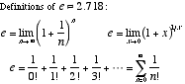

**Ellipsoid**

A [sphere](http://www.mathwords.com/s/sphere.htm)-like [surface](http://www.mathwords.com/s/surface.htm) for which all cross-sections are [ellipses](http://www.mathwords.com/e/ellipse.htm).

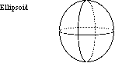

**End Behavior**

The appearance of a [graph](http://www.mathwords.com/g/graph_of_an_equation_or_inequality.htm) as it is followed farther and farther in either direction. For [polynomials](http://www.mathwords.com/p/polynomial.htm), the end behavior is indicated by drawing the positions of the arms of the graph, which may be pointed up or down. Other graphs may also have end behavior indicated in terms of the arms, or in terms of [asymptotes](http://www.mathwords.com/a/asymptote.htm) or [limits](http://www.mathwords.com/l/limit.htm).

Polynomial End Behavior:  
1. If the [degree](http://www.mathwords.com/d/degree_polynomial.htm) *n* of a polynomial is [even](http://www.mathwords.com/e/even_number.htm), then the arms of the graph are either both up or both down.  
2. If the degree *n* is [odd](http://www.mathwords.com/o/odd_number.htm), then one arm of the graph is up and one is down.  
3. If the [leading coefficient](http://www.mathwords.com/l/leading_coefficient.htm) *an* is [positive](http://www.mathwords.com/p/positive_number.htm), the right arm of the graph is up.  
4. If the leading coefficient *an* is [negative](http://www.mathwords.com/n/negative_number.htm), the right arm of the graph is down.

**Essential Discontinuity**

Any [discontinuity](http://www.mathwords.com/d/discontinuity.htm) that is not [removable](http://www.mathwords.com/r/removable_discontinuity.htm). That is, a place where a [graph](http://www.mathwords.com/g/graph_of_an_equation_or_inequality.htm) is not connected and cannot be made connected simply by filling in a single [point](http://www.mathwords.com/p/point.htm). [Step discontinuities](http://www.mathwords.com/s/step_discontinuity.htm) and [vertical](http://www.mathwords.com/v/vertical.htm) [asymptotes](http://www.mathwords.com/a/asymptote.htm) are two types of essential discontinuities.

Formally, an essential discontinuity is a discontinuity at which the [limit](http://www.mathwords.com/l/limit.htm) of the [function](http://www.mathwords.com/f/function.htm) does not exist.

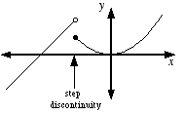

**Explicit Differentiation**

The process of finding the derivative of an explicit function. For example, the explicit function y = x2 – 7x + 1 has derivative y' = 2x – 7.

**Explicit Function**

A [function](http://www.mathwords.com/f/function.htm) in which the [dependent variable](http://www.mathwords.com/d/dependent_variable.htm) can be written explicitly in terms of the [independent variable](http://www.mathwords.com/i/independent_variable.htm).

For example, the following are explicit functions: y = x2 – 3, http://www.mathwords.com/e/e_assets/e47.gif, and y = log2 x.

**Exponential Decay**

A [model](http://www.mathwords.com/m/model.htm) for decay of a quantity for which the rate of decay is [directly proportional](http://www.mathwords.com/d/direct_variation.htm) to the amount present. The [equation](http://www.mathwords.com/e/equation.htm) for the model is A = A0bt (where 0 < b < 1 ) or A = A0ekt (where k is a negative number representing the rate of decay). In both formulas A0 is the original amount present at time t = 0.

This model is used for phenomena such as radioactivity or depreciation. For example, A = 50e–0.01t is a model for exponential decay of 50 grams of a radioactive element that decays at a rate of 1% per year.

**Exponential Growth**

A [model](http://www.mathwords.com/m/model.htm) for growth of a quantity for which the rate of growth is [directly proportional](http://www.mathwords.com/d/direct_variation.htm) to the amount present. The [equation](http://www.mathwords.com/e/equation.htm) for the model is A = A0bt (where b > 1 ) or A = A0ekt (where k is a positive number representing the rate of growth). In both formulas A0 is the original amount present at time t = 0.

This model is used for such phenomena as inflation or population growth. For example, A = 7000e0.05t is a model for the exponential growth of $7000 invested at 5% per year [compounded continuously](http://www.mathwords.com/c/continuously_compounded_interest.htm).

**Exponential Function  
Exponential Model**

A [function](http://www.mathwords.com/f/function.htm) of the form y = a·bx where a > 0 and either 0 < b < 1 or b > 1. The [variables](http://www.mathwords.com/v/variable.htm) do not have to be x and y. For example, A = 3.2·(1.02)t  is an exponential function.

Note: Exponential functions are used to [model](http://www.mathwords.com/m/model.htm) [exponential growth](http://www.mathwords.com/e/exponential_growth.htm), [exponential decay](http://www.mathwords.com/e/exponential_decay.htm), [compound interest](http://www.mathwords.com/c/compound_interest.htm), and [continuously compounded interest](http://www.mathwords.com/c/continuously_compounded_interest.htm).

**Extreme Value Theorem  
Min/Max Theorem**

A [theorem](http://www.mathwords.com/t/theorem.htm) which guarantees the existence of an [absolute max](http://www.mathwords.com/a/absolute_maximum.htm) and an [absolute min](http://www.mathwords.com/a/absolute_minimum.htm) for any [continuous function](http://www.mathwords.com/c/continuous_fn.htm) over a [closed interval](http://www.mathwords.com/c/closed_interval.htm).

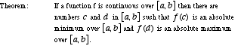

**Extreme Values of a Polynomial**

The [graph](http://www.mathwords.com/g/graph_of_an_equation_or_inequality.htm) of a [polynomial](http://www.mathwords.com/p/polynomial.htm) of [degree](http://www.mathwords.com/d/degree_polynomial.htm) *n* has at most *n* – 1 [extreme values](http://www.mathwords.com/e/extreme_values_of_a_polynomial.htm) ([minima](http://www.mathwords.com/m/minimum_of_a_function.htm) and/or [maxima](http://www.mathwords.com/m/maximum_of_a_function.htm)). The total number of extreme values could be *n* – 1 or *n* – 3 or *n* – 5 etc.

For example, a degree 9 polynomial could have 8, 6, 4, 2, or 0 extreme values. A degree 2 ([quadratic](http://www.mathwords.com/q/quadratic.htm)) polynomial must have 1 extreme value.

**Extremum**

An extreme value of a [function](http://www.mathwords.com/f/function.htm). In other words, the [minima](http://www.mathwords.com/m/minimum_of_a_function.htm) and [maxima](http://www.mathwords.com/m/maximum_of_a_function.htm) of a function. Extrema may be either relative (local) or absolute (global).

Note: The [first derivative test](http://www.mathwords.com/f/first_derivative_test.htm) and the [second derivative test](http://www.mathwords.com/s/second_derivative_test.htm) are common methods used to find extrema.

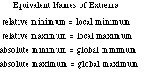

**Factorial**

The [product](http://www.mathwords.com/p/product.htm) of a given [integer](http://www.mathwords.com/i/integers.htm) and all smaller [positive](http://www.mathwords.com/p/positive_number.htm) integers. The factorial of n is written n! and is read aloud "n factorial".

Note: By definition, 0! = 1.

|  |  |
| --- | --- |
| [Formula](http://www.mathwords.com/f/formula.htm): | n! = n·(n – 1)·(n – 2) · · · 3·2·1 |
| Example: | 6! = 6·5·4·3·2·1 = 720 |

**Falling Bodies**

**See Projectile Motion**

**First Derivative**

Same as the [derivative](http://www.mathwords.com/d/derivative.htm). We say *first derivative* instead of just *derivative* whenever there may be confusion between the first derivative and the [second derivative](http://www.mathwords.com/s/second_derivative.htm) (or the [nth derivative](http://www.mathwords.com/n/nth_derivative.htm)).

**First Derivative Test**

A method for determining whether an [inflection point](http://www.mathwords.com/i/inflection_point.htm) is a [minimum](http://www.mathwords.com/m/minimum_of_a_function.htm), [maximum](http://www.mathwords.com/m/maximum_of_a_function.htm), or neither.

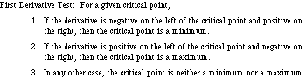  
  
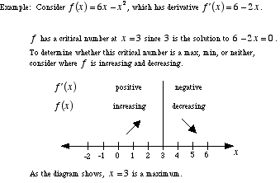

**First Order Differential Equation**

An [ordinary differential equation](http://www.mathwords.com/o/ordinary_differential_equation.htm) of [order](http://www.mathwords.com/o/order_of_a_differential_equation.htm) 1. That is, a [differential equation](http://www.mathwords.com/d/differential_eqn.htm) in which the highest [derivative](http://www.mathwords.com/d/derivative.htm) is a [first derivative](http://www.mathwords.com/f/first_derivative.htm). For example, y' + xy = 1 is a first order differential equation.

**Fixed**

[Constant](http://www.mathwords.com/c/constant.htm). Not changing or moving.

**Function Operations**

Definitions for combining functions by adding, subtracting, multiplying, dividing, and [composing](http://www.mathwords.com/c/composition.htm) them.

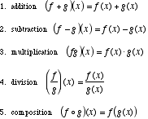

**Fundamental Theorem of Calculus**

The [theorem](http://www.mathwords.com/t/theorem.htm) that establishes the connection between [derivatives](http://www.mathwords.com/d/derivative.htm), [antiderivatives](http://www.mathwords.com/a/antiderivative_function.htm), and [definite integrals](http://www.mathwords.com/d/definite_integral.htm). The fundamental theorem of calculus is typically given in two parts.

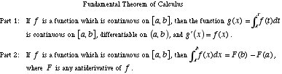

**GLB   
 See Greatest Lower Bound of a Set**

**Global Maximum, Global Max  
 See Absolute Maximum, Absolute Max**

**Global Minimum, Golbal Min  
 See Absolute Minimum, Absolute Min**

**Golden Spiral**

A [spiral](http://www.mathwords.com/s/spiral.htm) that can be drawn in a [golden rectangle](http://www.mathwords.com/g/golden_rectangle.htm) as shown below. The figure forming the structure for the spiral is made up entirely of [squares](http://www.mathwords.com/s/square.htm) and golden rectangles.

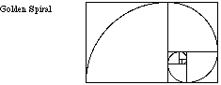

**Graphic Methods**

The use of [graphs](http://www.mathwords.com/g/graph_of_an_equation_or_inequality.htm) and/or pictures as the main technique for solving a math problem. When a problem is solved graphically, it is common to use a graphing calculator.

**Greatest Lower Bound of a Set  
GLB**

The greatest of all [lower bounds](http://www.mathwords.com/l/lower_bound.htm) of a [set](http://www.mathwords.com/s/set.htm) of numbers. For example, the greatest lower bound of (5, 7) is 5. The greatest lower bound of the interval [5, 7] is also 5.

**Greek Alphabet**

The letters of ancient Greece, which are frequently used in math and science.

|  |  |  |  |
| --- | --- | --- | --- |
| Α α | alpha | Ν ν | nu |
| Β β | beta | Ξ ξ | xi |
| Γ γ | gamma | Ο ο | omicron |
| Δ δ | delta | [Π π](http://www.mathwords.com/p/pi.htm) | [pi](http://www.mathwords.com/p/pi.htm) |
| Ε ε | epsilon | Ρ ρ | rho |
| Ζ ζ | zeta | Σ σ | sigma |
| Η η | eta | Τ τ | tau |
| Θ θ | theta | Υ υ | upsilon |
| Ι ι | iota | Φ φ | phi |
| Κ κ | kappa | Χ χ | chi |
| Λ λ | lambda | Ψ ψ | psi |
| Μ μ | mu | Ω ω | omega |

**Harmonic Sequence  
Harmonic Progression**

The [sequence](http://www.mathwords.com/s/sequence.htm) http://www.mathwords.com/b/b_assets/bounded%20sequence%20harmonic.gif.

Note: The [harmonic mean](http://www.mathwords.com/h/harmonic_mean.htm) of two [terms](http://www.mathwords.com/t/term.htm) of the harmonic sequence is the term halfway between the two original terms. For example, the harmonic mean of http://www.mathwords.com/h/h_assets/h10.gifand http://www.mathwords.com/h/h_assets/h11.gifis http://www.mathwords.com/h/h_assets/h12.gif.

**Harmonic Series**

The [series](http://www.mathwords.com/s/series.htm) http://www.mathwords.com/h/h_assets/h13.gif. Note: The harmonic series [diverges](http://www.mathwords.com/d/divergent_series.htm). Its [sequence of partial sums](http://www.mathwords.com/s/sequence_of_partial_sums.htm) is [unbounded](http://www.mathwords.com/u/unbounded.htm).

**Helix**

A [curve](http://www.mathwords.com/c/curve.htm) shaped like a spring. A helix can be made by coiling a wire around the outside of a [right circular cylinder](http://www.mathwords.com/r/right_circular_cylinder.htm).

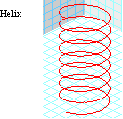

**Higher Derivative**

Any [derivative](http://www.mathwords.com/d/derivative.htm) beyond the [first derivative](http://www.mathwords.com/f/first_derivative.htm). That is, the [second](http://www.mathwords.com/s/second_derivative.htm), third, fourth, fifth etc. derivatives.

**Hole  
 See Removable Discontinuity**

**Homogeneous System of Equations**

A [system](http://www.mathwords.com/s/simultaneous_equations.htm), usually a [linear system](http://www.mathwords.com/l/linear_system_of_equations.htm), in which every [constant term](http://www.mathwords.com/c/constant_term.htm) is [zero](http://www.mathwords.com/xyz/zero.htm).

http://www.mathwords.com/h/h_assets/h27.gif

**Hyperbolic Trigonometry**

A variation of [trigonometry](http://www.mathwords.com/t/trigonometry.htm). Hyperbolic trig functions are defined using ex and e–x. The six hyperbolic trig functions relate to each other in ways that are similar to conventional [trig functions](http://www.mathwords.com/t/trig_functions.htm). Hyperbolic trig plays an important role when trig functions have [imaginary](http://www.mathwords.com/i/imaginary_numbers.htm) or [complex arguments](http://www.mathwords.com/c/complex_numbers.htm).

Note: Hyperbolic trigonometry has no relation whatsoever to [hyperbolic geometry](http://www.mathwords.com/h/hyperbolic_geometry.htm).

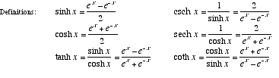

**Identity Function**

The [function](http://www.mathwords.com/f/function.htm) *f*(*x*) = *x*. More generally, an identity function is one which does not change the [domain](http://www.mathwords.com/d/domain.htm) values at all.

Note: This is called the identity function since it is the [identity](http://www.mathwords.com/i/identity.htm) for [composition](http://www.mathwords.com/c/composition.htm) of functions. That is, if *f*(*x*) = *x* and *g* is any function, then (*f* ° *g*)(*x*) = *g*(*x*) and (*g* ° *f*)(*x*) = *g*(*x*).

**Implicit Differentiation**

A method for finding the [derivative](http://www.mathwords.com/d/derivative.htm) of an [implicitly defined function or relation](http://www.mathwords.com/i/implicit_function_or_relation.htm).

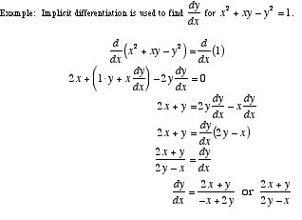

**Implicit Function or Relation**

A [function](http://www.mathwords.com/f/function.htm) or [relation](http://www.mathwords.com/r/relation.htm) in which the [dependent variable](http://www.mathwords.com/d/dependent_variable.htm) is not isolated on one side of the [equation](http://www.mathwords.com/e/equation.htm). For example, the equation x2 + xy – y2 = 1 represents an implicit relation

**Improper Integral**

A [definite integral](http://www.mathwords.com/d/definite_integral.htm) for which the [integrand](http://www.mathwords.com/i/integrand.htm) has a [discontinuity](http://www.mathwords.com/d/discontinuity.htm) between the [bounds of integration](http://www.mathwords.com/b/bounds_of_integration.htm), or which has ∞ and/or –∞ as a bound. Improper [integrals](http://www.mathwords.com/i/integral_of_a_function.htm) are evaluated using [limits](http://www.mathwords.com/l/limit.htm) as shown below. If the limit [exists](http://www.mathwords.com/c/converge.htm) and is [finite](http://www.mathwords.com/f/finite.htm), we say the integral [converges](http://www.mathwords.com/c/converge.htm). If the limit does not exist or is [infinite](http://www.mathwords.com/i/infinite.htm), we say the integral [diverges](http://www.mathwords.com/d/diverge.htm).

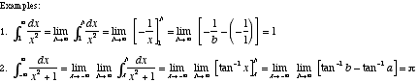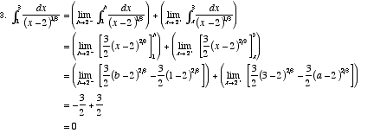

**Increasing Function**

A [function](http://www.mathwords.com/f/function.htm) with a [graph](http://www.mathwords.com/g/graph_of_an_equation_or_inequality.htm) that goes up as it is followed from left to right. For example, any line with a [positive](http://www.mathwords.com/p/positive_number.htm) [slope](http://www.mathwords.com/s/slope_of_a_line.htm) is increasing.

Note: If a function is [differentiable](http://www.mathwords.com/d/differentiable.htm), then it is increasing at all [points](http://www.mathwords.com/p/point.htm) where its [derivative](http://www.mathwords.com/d/derivative.htm) is positive.

**Indefinite Integral**

The family of [functions](http://www.mathwords.com/f/function.htm) that have a given function as a common [derivative](http://www.mathwords.com/d/derivative.htm). The indefinite [integral](http://www.mathwords.com/i/integral_of_a_function.htm) of *f*(*x*) is written  
∫ *f*(*x*) *dx*.

http://www.mathwords.com/i/i_assets/i39.gif

**Indefinite Integral Rules  
 See Integral Rules**

**Indeterminate Expression**

An undefined [expression](http://www.mathwords.com/e/expression.htm) which can have a value if arrived at as a [limit](http://www.mathwords.com/l/limit.htm).

Note: Another way to think about indeterminate expressions is to see them as a disagreement between two rules for simplifying an expression. For example, one way to think about http://www.mathwords.com/i/i_assets/zero%20over%20zero.gifis this: The 0 in the [numerator](http://www.mathwords.com/n/numerator.htm) makes the [fraction](http://www.mathwords.com/f/fraction.htm) "equal" 0, but the 0 in the [denominator](http://www.mathwords.com/d/denominator.htm) makes the fraction http://www.mathwords.com/i/i_assets/zero%20over%20zero.gif"equal" ±∞. This conflict makes the expression indeterminate.

|  |  |
| --- | --- |
| Common indeterminate expressions:  http://www.mathwords.com/i/i_assets/zero%20over%20zero.gif        http://www.mathwords.com/i/i_assets/infinity%20over%20infinity.gif        00        1∞        ∞0        ∞ – ∞ | |
|  |  |
| Example: | The limit http://www.mathwords.com/i/i_assets/indeterminate%20lim%20sin%20x%20over%20x.gif seems to evaluate to http://www.mathwords.com/i/i_assets/zero%20over%20zero.gif, which is indeterminate. In fact,  http://www.mathwords.com/i/i_assets/indeterminate%20lim%20sin%20x%20over%20x%20equals%201.gif  since sin x and x are approximately equal to each other for values of x near 0.  Note that this limit can also be [computed](http://www.mathwords.com/c/compute.htm) using [l’Hôpital’s rule](http://www.mathwords.com/l/l%27hopitals_rule.htm). | |

**Infinite Geometric Series**

An [infinite series](http://www.mathwords.com/i/infinite_series.htm) that is [geometric](http://www.mathwords.com/g/geometric_series.htm). An infinite geometric series [converges](http://www.mathwords.com/c/convergent_series.htm) if its [common ratio](http://www.mathwords.com/c/common_ratio.htm) *r* [satisfies](http://www.mathwords.com/s/satisfy.htm) –1 < *r* < 1. Otherwise it [diverges](http://www.mathwords.com/d/diverge.htm).

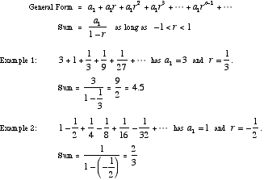

**Infinite Limit**

A [limit](http://www.mathwords.com/l/limit.htm) that has an [infinite](http://www.mathwords.com/i/infinite.htm) result (either ∞ or –∞ ), or a limit taken as the [variable](http://www.mathwords.com/v/variable.htm) approaches ∞ ([infinity](http://www.mathwords.com/i/infinity.htm)) or –∞ (minus infinity). The limit can be [one-sided](http://www.mathwords.com/o/one_sided_limit.htm).

**Infinite Series**

A [series](http://www.mathwords.com/s/series.htm) that has no last [term,](http://www.mathwords.com/t/term.htm) such as http://www.mathwords.com/i/i_assets/i70.gif. The [sum](http://www.mathwords.com/s/sum.htm) of an [infinite](http://www.mathwords.com/i/infinite.htm) series is defined as the [limit](http://www.mathwords.com/l/limit.htm) of the [sequence of partial sums](http://www.mathwords.com/s/sequence_of_partial_sums.htm).

Note: The infinite series above happens to have a sum of π2/6.

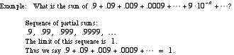

**Infinitesimal**

A hypothetical number that is larger than [zero](http://www.mathwords.com/xyz/zero.htm) but smaller than any [positive](http://www.mathwords.com/p/positive_number.htm) [real number](http://www.mathwords.com/r/real_numbers.htm). Although the existence of such numbers makes no sense in the real number system, many worthwhile results can be obtained by overlooking this obstacle.

Note: Sometimes numbers that aren't really infinitesimals are called infinitesimals anyway. The word infinitesimal is occasionally used for tiny positive real numbers that are nearly equal to zero.

**Infinity**

A "number" which indicates a quantity, size, or magnitude that is larger than any [real number](http://www.mathwords.com/r/real_numbers.htm). The number infinity is written as a sideways eight: ∞. Negative infinity is written –∞.

Note: Neither ∞ nor –∞ is a real number.

**Inflection Point**

A [point](http://www.mathwords.com/p/point.htm) at which a [curve](http://www.mathwords.com/c/curve.htm) changes from [concave up](http://www.mathwords.com/c/concave_up.htm) to [concave down](http://www.mathwords.com/c/concave_down.htm), or vice-versa.

Note: If a [function](http://www.mathwords.com/f/function.htm) has a [second derivative](http://www.mathwords.com/s/second_derivative.htm), the value of the second derivative is either 0 or undefined at each of that function's inflection points.

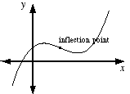

**Initial Value Problem  
IVP**

A [differential equation](http://www.mathwords.com/d/differential_eqn.htm) or [partial differential equation](http://www.mathwords.com/p/partial_differential_equations.htm) accompanied by conditions for the value of the [function](http://www.mathwords.com/f/function.htm) and possibly its [derivatives](http://www.mathwords.com/d/derivative.htm) at one particular point in the [domain](http://www.mathwords.com/d/domain.htm).

|  |  |
| --- | --- |
| [Differential Equation](http://www.mathwords.com/d/differential_eqn.htm) | *y" + y =* sin *x* |
| Initial Value Problem (IVP) | *y" + y =* sin *x*, *y*(0) = 1, *y'*(0) = – 2 |
| [Boundary Value Problem (BVP)](http://www.mathwords.com/b/boundary_value_problem.htm) | *y" + y =* sin *x*, *y*(0) = 1, *y*(1) = – 2 |

**Instantaneous Acceleration**

The rate at which an object's [instantaneous velocity](http://www.mathwords.com/i/instantaneous_velocity.htm) is changing at a particular moment. This is found by taking the [derivative](http://www.mathwords.com/d/derivative.htm) of the [velocity](http://www.mathwords.com/v/velocity.htm) [function](http://www.mathwords.com/f/function.htm).

Note: For motion on the [number line](http://www.mathwords.com/n/number_line.htm), instantaneous acceleration is a [scalar](http://www.mathwords.com/s/scalar.htm). For motion on a [plane](http://www.mathwords.com/p/plane.htm) or in [space](http://www.mathwords.com/t/three_dimensions.htm), it is a [vector](http://www.mathwords.com/v/vector.htm).

**Instantaneous Rate of Change**

The rate of change at a particular moment. Same as the value of the [derivative](http://www.mathwords.com/d/derivative.htm) at a particular [point](http://www.mathwords.com/p/point.htm).

For a [function](http://www.mathwords.com/f/function.htm), the instantaneous rate of change at a point is the same as the [slope](http://www.mathwords.com/s/slope_of_a_line.htm) of the [tangent line](http://www.mathwords.com/t/tangent_line.htm). That is, it's the [slope of a curve](http://www.mathwords.com/s/slope_of_a_curve.htm).

Note: Over short intervals of time, the [average rate of change](http://www.mathwords.com/a/average_rate_change.htm) is approximately equal to the instantaneous rate of change

**Instantaneous Velocity**

The rate at which an object is moving at a particular moment. Same as the [derivative](http://www.mathwords.com/d/derivative.htm) of the [function](http://www.mathwords.com/f/function.htm) describing the position of the object at a particular time.

Note: For motion on the [number line](http://www.mathwords.com/n/number_line.htm), instantaneous [velocity](http://www.mathwords.com/v/velocity.htm) is a [scalar](http://www.mathwords.com/s/scalar.htm). For motion on a [plane](http://www.mathwords.com/p/plane.htm) or in [space](http://www.mathwords.com/t/three_dimensions.htm), it is a [vector](http://www.mathwords.com/v/vector.htm).

**Integrable Function**

A [function](http://www.mathwords.com/f/function.htm) for which the [definite integral](http://www.mathwords.com/d/definite_integral.htm) exists. [Piecewise continuous functions](http://www.mathwords.com/p/piecewise_continuous_function.htm) are integrable, and so are many functions that are not piecewise continuous.

Note: Non-integrable functions are seldom studied in the first two years of [calculus](http://www.mathwords.com/c/calculus.htm).

**Integral**

As a noun, it means the [integral of a function](http://www.mathwords.com/i/integral_of_a_function.htm).

As an adjective, it means "in the form of an [integer](http://www.mathwords.com/i/integers.htm)." For example, saying a [polynomial](http://www.mathwords.com/p/polynomial.htm) has integral [coefficients](http://www.mathwords.com/c/coefficient.htm) means the coefficients of the polynomial are all integers.

**Integration Methods**

The basic methods are listed below. Other more advanced and/or specialized methods exist as well.

[u-substitution](http://www.mathwords.com/u/u_substitution.htm)  
[integration by parts](http://www.mathwords.com/i/integration_by_parts.htm)  
[partial fractions](http://www.mathwords.com/p/partial_fractions.htm)  
[trig substitution](http://www.mathwords.com/t/trig_substitution.htm)  
[rationalizing substitutions](http://www.mathwords.com/r/rationalizing_substitution.htm)

**Integral of a Function**

The result of either a [definite integral](http://www.mathwords.com/d/definite_integral.htm) or an [indefinite integral](http://www.mathwords.com/i/indefinite_integral.htm).

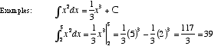

**Integral Rules**

For the following, *a*, *b*, *c*, and *C* are [constants](http://www.mathwords.com/c/constant.htm); for definite integrals, these represent [real number](http://www.mathwords.com/r/real_numbers.htm) constants. The rules only apply when the integrals exist.

[Indefinite integrals](http://www.mathwords.com/i/indefinite_integral.htm) (These rules all apply to [definite integrals](http://www.mathwords.com/d/definite_integral.htm) as well)

1. http://www.mathwords.com/i/i_assets/indefinite%20integral%20rule%201.gif

2. http://www.mathwords.com/i/i_assets/indefinite%20integral%20rule%202.gif

3. http://www.mathwords.com/i/i_assets/indefinite%20integral%20rule%203.gif

4. http://www.mathwords.com/i/i_assets/indefinite%20integral%20rule%204.gif

5. [Integration by parts](http://www.mathwords.com/i/integration_by_parts.htm): http://www.mathwords.com/i/i_assets/indefinite%20integral%20rule%205.gif

[Definite integrals](http://www.mathwords.com/d/definite_integral.htm)

1. http://www.mathwords.com/i/i_assets/definite%20integral%20rule%201.gif

2. http://www.mathwords.com/i/i_assets/definite%20integral%20rule%202.gif

3. If *f*(*u*) ≤ *g*(*u*) for all *a* ≤ *u* ≤ *b*, then http://www.mathwords.com/i/i_assets/definite%20integral%20rule%203.gif

4. If *f*(*u*) ≤ *M* for all *a* ≤ *u* ≤ *b*, then http://www.mathwords.com/i/i_assets/definite%20integral%20rule%204.gif

5. If *m* ≤ *f*(*u*) for all *a* ≤ *u* ≤ *b*, then http://www.mathwords.com/i/i_assets/definite%20integral%20rule%205.gif

6. If *a* ≤ *b*, then http://www.mathwords.com/i/i_assets/definite%20integral%20rule%206.gif

**Integral Test**

A [convergence test](http://www.mathwords.com/c/convergence_tests.htm) used for [positive series](http://www.mathwords.com/p/positive_series.htm) which with decreasing [terms](http://www.mathwords.com/t/term.htm).

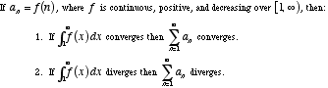

**Integral Test Remainder**

For a [series](http://www.mathwords.com/s/series.htm) that [converges](http://www.mathwords.com/c/convergent_series.htm) by the [integral test](http://www.mathwords.com/i/integral_test.htm), this is a quantity that measures how accurately the [nth partial sum](http://www.mathwords.com/n/nth_partial_sum.htm) estimates the overall [sum](http://www.mathwords.com/s/sum.htm).

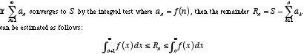

**Integrand**

The [function](http://www.mathwords.com/f/function.htm) being [integrated](http://www.mathwords.com/i/integration.htm) in either a [definite](http://www.mathwords.com/d/definite_integral.htm) or [indefinite integral](http://www.mathwords.com/i/indefinite_integral.htm).

Example: x2cos 3x is the integrand in ∫ x2cos 3x dx.

**Integration**

The process of finding an [integral](http://www.mathwords.com/i/integral_of_a_function.htm), either a [definite integral](http://www.mathwords.com/d/definite_integral.htm) or an [indefinite integral](http://www.mathwords.com/i/indefinite_integral.htm).

**Integration by Parts**

A [formula](http://www.mathwords.com/f/formula.htm) used to [integrate](http://www.mathwords.com/i/integration.htm) the [product](http://www.mathwords.com/p/product.htm) of two [functions](http://www.mathwords.com/f/function.htm).

|  |  |
| --- | --- |
| Formula: | http://www.mathwords.com/i/i_assets/indefinite%20integral%20rule%205.gif |
|  |  |
| Example 1: | Evaluate http://www.mathwords.com/i/i_assets/integration%20by%20parts%20example%201.gif. |
|  | Use *u* = *x* and *dv* = *ex*/2 *dx*. Then we get *du* = *dx* and *v* = 2*ex*/2. This can be summarized:  *u* = *x, dv* = *ex*/2 *dx, du* = *dx, v* = 2*ex*/2  It follows that  http://www.mathwords.com/i/i_assets/integration%20by%20parts%20example%201%20work.gif |
| Example 2: | Evaluate http://www.mathwords.com/i/i_assets/integration%20by%20parts%20example%202.gif. |
|  | Use the following: *u* = tan-1 *x, dv* = *dx, http://www.mathwords.com/i/i_assets/integration%20by%20parts%20example%202%20du%20formula.gif, v* = *x*  Thus  http://www.mathwords.com/i/i_assets/integration%20by%20parts%20example%202%20work.gif |
| Example 3: | Evaluate http://www.mathwords.com/i/i_assets/integration%20by%20parts%20example%203.gif. |
|  | Let I =http://www.mathwords.com/i/i_assets/integration%20by%20parts%20example%203.gif. Proceed as follows: *u* = sin *x, dv* = *ex* *dx, du* = cos *x dx, v* = *ex*  Thus http://www.mathwords.com/i/i_assets/integration%20by%20parts%20example%203%20work%20phase%201.gif  Now use integration by parts on the remaining integral. Use the following assignments:  *u* = cos *x, dv* = *ex* *dx, du* = –sin *x dx, v* = *ex*  Thus  http://www.mathwords.com/i/i_assets/integration%20by%20parts%20example%203%20work%20phase%202.gif  Note that http://www.mathwords.com/i/i_assets/integration%20by%20parts%20example%203.gifappears on both sides of this equation. Replace it with *I* and then solve.  http://www.mathwords.com/i/i_assets/integration%20by%20parts%20example%203%20work%20phase%203.gif  We finally obtain  http://www.mathwords.com/i/i_assets/integration%20by%20parts%20example%203%20answer.gif |

**Integration by Substitution**

An [integration method](http://www.mathwords.com/i/integration_methods.htm) that essentially involves using the [chain rule](http://www.mathwords.com/c/chain_rule.htm) in reverse.

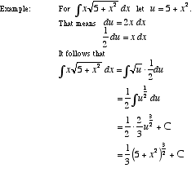

**Integration Methods**

**See Integral Methods**

**Intermediate Value Theorem  
IVT**

A [theorem](http://www.mathwords.com/t/theorem.htm) verifying that the [graph](http://www.mathwords.com/g/graph_of_an_equation_or_inequality.htm) of a [continuous function](http://www.mathwords.com/c/continuous_fn.htm) is connected.

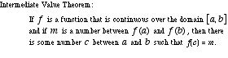

**Interval of Convergence**

For a [power series](http://www.mathwords.com/p/power_series.htm) in one [variable](http://www.mathwords.com/v/variable.htm), the [set](http://www.mathwords.com/s/set.htm) of values of the variable for which the [series](http://www.mathwords.com/s/series.htm) converges. The interval of convergence may be as small as a single [point](http://www.mathwords.com/p/point.htm) or as large as the set of all [real numbers](http://www.mathwords.com/r/real_numbers.htm).

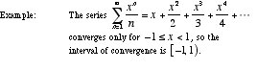

**Iterative Process**

An [algorithm](http://www.mathwords.com/a/algorithm.htm) which involves repeated use of the same [formula](http://www.mathwords.com/f/formula.htm) or steps. Typically, the process begins with a starting value which is plugged into the formula. The result is then taken as the new starting point which is then plugged into the formula again. The process continues to repeat.

Examples of iterative processes are [factor trees](http://www.mathwords.com/f/factor_tree.htm), [recursive formulas](http://www.mathwords.com/r/recursive_formula.htm), and [Newton’s method](http://www.mathwords.com/n/newton%27s_method.htm).

**IVP   
 See Initial Value Problem**

**IVT  
 See Intermediate Value Theorem**

**Jump Discontinuity  
Step Discontinuity**

A [discontinuity](http://www.mathwords.com/d/discontinuity.htm) for which the [graph](http://www.mathwords.com/g/graph_of_an_equation_or_inequality.htm) steps or jumps from one connected piece of the graph to another. Formally, it is a discontinuity for which the [limits from the left](http://www.mathwords.com/l/limit_from_left.htm) and [right](http://www.mathwords.com/l/limit_from_right.htm) both exist but are not equal to each other.

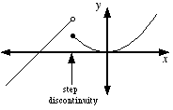

**L'Hôpital's Rule  
L'Hospital's Rule**

A technique used to [evaluate](http://www.mathwords.com/e/evaluate.htm) [limits](http://www.mathwords.com/l/limit.htm) of [fractions](http://www.mathwords.com/f/fraction.htm) that evaluate to the [indeterminate expressions](http://www.mathwords.com/i/indeterminate_expression.htm) http://www.mathwords.com/i/i_assets/zero%20over%20zero.gifand http://www.mathwords.com/i/i_assets/infinity%20over%20infinity.gif. This is done by finding the limit of the [derivatives](http://www.mathwords.com/d/derivative.htm) of the [numerator](http://www.mathwords.com/n/numerator.htm) and [denominator](http://www.mathwords.com/d/denominator.htm).

Note: Most limits involving other indeterminate expressions can be manipulated into fraction form so that l'Hôpital's rule can be used.

|  |  |
| --- | --- |
| L'Hôpital's Rule: | If f and g are differentiable on an open interval containing a such that g(x) ≠ 0 for all x ≠ a in the interval, and if either  http://www.mathwords.com/l/l_assets/lim%20f%20of%20x.gifand http://www.mathwords.com/l/l_assets/lim%20g%20of%20x.gif  Or http://www.mathwords.com/l/l_assets/lim%20f%20of%20x%20infinity.gifand http://www.mathwords.com/l/l_assets/lim%20g%20of%20x%20infinity.gif  Then http://www.mathwords.com/l/l_assets/lhopital%20statement.gif |
| Example: | http://www.mathwords.com/l/l_assets/lhopital%20example.gif |

**Least Upper Bound of a Set  
LUB**

The smallest of all [upper bounds](http://www.mathwords.com/u/upper_bound.htm) of a [set](http://www.mathwords.com/s/set.htm) of numbers. For example, the least upper bound of the [interval](http://www.mathwords.com/i/interval.htm) (5, 7) is 7. The least upper bound of [5, 7] is also 7.

**Limit**

The value that a [function](http://www.mathwords.com/f/function.htm) or [expression](http://www.mathwords.com/e/expression.htm) approaches as the [domain](http://www.mathwords.com/d/domain.htm) [variable(s)](http://www.mathwords.com/v/variable.htm) approach a specific value. Limits are written in the form http://www.mathwords.com/l/l_assets/l28.gif. For example, the limit of http://www.mathwords.com/l/l_assets/l29.gifas *x* approaches 3 is http://www.mathwords.com/l/l_assets/l32.gif. This is written http://www.mathwords.com/l/l_assets/l33.gif.

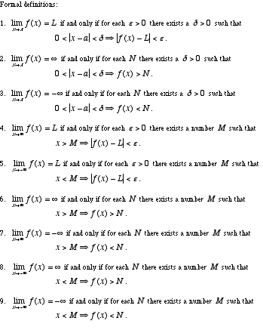

**Limit Comparison Test**

A [convergence test](http://www.mathwords.com/c/convergence_tests.htm) often used when the [terms](http://www.mathwords.com/t/term.htm) of a [series](http://www.mathwords.com/s/series.htm) are [rational functions](http://www.mathwords.com/r/rational_function.htm). Essentially, the test determines whether a series is "about as good" as a "good" series or "about as bad" as a "bad" series. The "good" or "bad" series is often a [p-series](http://www.mathwords.com/p/p_series.htm).

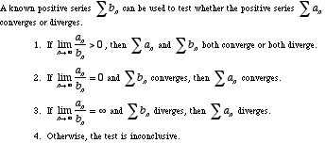

**Limit from the Left  
Limit from Below**

A [one-sided limit](http://www.mathwords.com/o/one_sided_limit.htm) which, in the example http://www.mathwords.com/l/l_assets/l36.gif, restricts *x* such that *x* < 0.

In general, a limit from the left restricts the [domain](http://www.mathwords.com/d/domain.htm) [variable](http://www.mathwords.com/v/variable.htm) to values less than the number the domain variable approaches. When a limit is taken from the left it is written http://www.mathwords.com/l/l_assets/l39.gifor http://www.mathwords.com/l/l_assets/l40.gif.

For example, http://www.mathwords.com/l/l_assets/l41.gifsince http://www.mathwords.com/l/l_assets/l42.giftends toward –∞ as *x* gets closer and closer to 0 from the left.

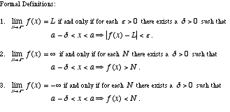

**Limit from the Right  
Limit from Above**

A [one-sided limit](http://www.mathwords.com/o/one_sided_limit.htm) which, in the example http://www.mathwords.com/l/l_assets/l47.gif, restricts *x* such that *x* > 0.

In general, a limit from the right restricts [domain](http://www.mathwords.com/d/domain.htm) [variable](http://www.mathwords.com/v/variable.htm) to values greater than the number the domain variable approaches. When a limit is taken from the right it is written http://www.mathwords.com/l/l_assets/l50.gifor http://www.mathwords.com/l/l_assets/l51.gif.

For example, http://www.mathwords.com/l/l_assets/l52.gifsince http://www.mathwords.com/l/l_assets/l53.giftends toward ∞ as *x* gets closer and closer to 0 from the right.

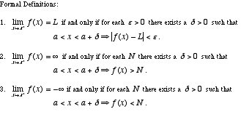

**Limit Test for Divergence**

A [convergence test](http://www.mathwords.com/c/convergence_tests.htm) that uses the fact that the [terms](http://www.mathwords.com/t/term.htm) of a [convergent series](http://www.mathwords.com/c/convergent_series.htm) must have a [limit](http://www.mathwords.com/l/limit.htm) of [zero](http://www.mathwords.com/xyz/zero.htm).

http://www.mathwords.com/l/l_assets/l58.gif

**Bounds of Integration  
Limits of Integration**

For the [definite integral](http://www.mathwords.com/d/definite_integral.htm) http://www.mathwords.com/d/d_assets/definite%20integral%20notation.gif, the bounds (or limits) of [integration](http://www.mathwords.com/d/definite_integral.htm) are *a* and *b*.

**Local Behavior**

The appearance or properties of a [function](http://www.mathwords.com/f/function.htm), [graph](http://www.mathwords.com/g/graph_of_an_equation_or_inequality.htm), or [geometric figure](http://www.mathwords.com/g/geometric_figure.htm) in the immediate neighborhood of a particular [point](http://www.mathwords.com/p/point.htm). Usually this refers to any appearance or property that becomes more apparent as you zoom in on the point.

For example, as you zoom in to the graph of y = x2 at any point, the graph looks more and more like a [line](http://www.mathwords.com/l/line.htm). Thus we say that y = x2 is locally [linear](http://www.mathwords.com/l/linear.htm). We say this even though the graph is not actually a straight line.

**Relative Maximum, Relative Max  
Local Maximum, Local Max**

The highest [point](http://www.mathwords.com/p/point.htm) in a particular section of a [graph](http://www.mathwords.com/g/graph_of_an_equation_or_inequality.htm).

Note: The [first derivative test](http://www.mathwords.com/f/first_derivative_test.htm) and the [second derivative test](http://www.mathwords.com/s/second_derivative_test.htm) are common methods used to find maximum values of a [function](http://www.mathwords.com/f/function.htm).

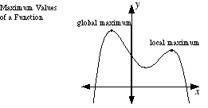

**Relative Minimum, Relative Min  
Local Minimum, Local Min**

The lowest [point](http://www.mathwords.com/p/point.htm) in a particular section of a [graph](http://www.mathwords.com/g/graph_of_an_equation_or_inequality.htm).

Note: The [first derivative test](http://www.mathwords.com/f/first_derivative_test.htm) and the [second derivative test](http://www.mathwords.com/s/second_derivative_test.htm) are common methods used to find minimum values of a [function](http://www.mathwords.com/f/function.htm).

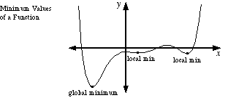

**Logarithmic Differentiation**

A method for finding the [derivative](http://www.mathwords.com/d/derivative.htm) of functions such as y = xsin x and http://www.mathwords.com/l/l_assets/l99.gif.

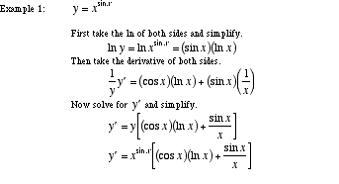  
  
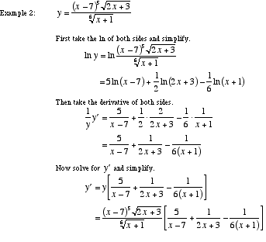

**Logistic Growth**

A [model](http://www.mathwords.com/m/model.htm) for a quantity that increases quickly at first and then more slowly as the quantity approaches an upper limit. This model is used for such phenomena as the increasing use of a new technology, spread of a disease, or saturation of a market (sales).

The equation for the logistic model is http://www.mathwords.com/l/l_assets/logistic_eqn.gif. Here, t is time, N stands for the amount at time t, N0 is the initial amount (at time 0), K is the maximum amount that can be sustained, and r is the rate of growth when N is very small compared to K.

Note: The logistic growth model can be obtained by solving the [differential equation](http://www.mathwords.com/d/differential_eqn.htm) http://www.mathwords.com/l/l_assets/logistic_diffeq.gif

**LUB  
 See Least Upper Bound of a Set**

**Model  
Mathematical Model**

An [equation](http://www.mathwords.com/e/equation.htm) or a [system of equations](http://www.mathwords.com/s/simultaneous_equations.htm) representing real-world phenomena. Models also represent patterns found in [graphs](http://www.mathwords.com/g/graph_of_an_equation_or_inequality.htm) and/or data. Usually models are not exact matches the objects or behavior they represent. A good model should capture the essential character of whatever is being modeled.

**Maximize**

To find the largest possible value.

http://www.mathwords.com/m/m_assets/m18.gif

**Maximum of a Function:**

Either a [relative (local) maximum](http://www.mathwords.com/l/local_maximum.htm) or an [absolute (global) maximum](http://www.mathwords.com/a/absolute_maximum.htm).

**Mean Value Theorem**

A major [theorem](http://www.mathwords.com/t/theorem.htm) of [calculus](http://www.mathwords.com/c/calculus.htm) that relates values of a [function](http://www.mathwords.com/f/function.htm) to a value of its [derivative](http://www.mathwords.com/d/derivative.htm). Essentially the theorem states that for a "nice" function, there is a [tangent line](http://www.mathwords.com/t/tangent_line.htm) [parallel](http://www.mathwords.com/p/parallel_lines.htm) to any [secant line](http://www.mathwords.com/s/secant_line.htm).

http://www.mathwords.com/m/m_assets/m21.gif  
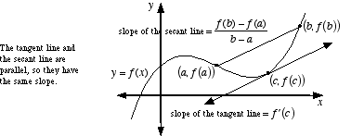

**Mean Value Theorem for Integrals**

A variation of the [mean value theorem](http://www.mathwords.com/m/mean_value_theorem.htm) which guarantees that a [continuous function](http://www.mathwords.com/c/continuous_fn.htm) has at least one [point](http://www.mathwords.com/p/point.htm) where the [function](http://www.mathwords.com/f/function.htm) equals the [average value of the function](http://www.mathwords.com/a/average_value_function.htm).

http://www.mathwords.com/m/m_assets/m23.gif  
  
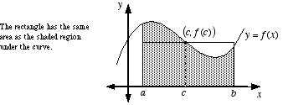

**Mesh of a Partition  
Norm of a Partition**

The width of the largest sub-[interval](http://www.mathwords.com/i/interval.htm) in a [partition](http://www.mathwords.com/p/partition_of_an_interval.htm).

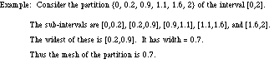

**Min/Max Theorem**

**See Extreme Value Theorem**

**Minimize**

To find the smallest possible value.

http://www.mathwords.com/m/m_assets/m34.gif

**Minimum of a Function**

Either a [relative (local) minimum](http://www.mathwords.com/l/local_minimum.htm) or an [absolute (global) minimum](http://www.mathwords.com/a/absolute_minimum.htm).

**Mode**

The number that occurs the most often in a list.

Example:          5 is the mode of 2, 3, 3, 4, 5, 5, 5

**Model**

**See Mathematical Model**

**Moment**

A number indicating the degree to which a [figure](http://www.mathwords.com/g/geometric_figure.htm) tends to balance on a given [line](http://www.mathwords.com/l/line.htm) (axis). A moment of [zero](http://www.mathwords.com/xyz/zero.htm) indicates perfect balance, and a large moment indicates a strong tendency to tip over.

Formally, the moment of a [point](http://www.mathwords.com/p/point.htm) P about a fixed axis is the mass of P times the distance from P to the axis. For a figure, the moment is the cumulative [sum](http://www.mathwords.com/s/sum.htm) of the moments of all the figure's points. This cumulative sum is the same as the mass of the figure times the distance from the figure's [center of mass](http://www.mathwords.com/c/center_of_mass_formula.htm) to the fixed axis.

Note: This is similar to, but not the same as, the physics quantity known as moment of inertia.

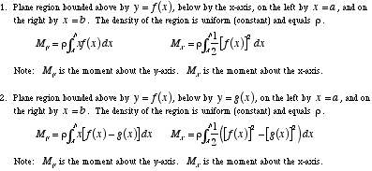

**Multivariable  
Multivariate**

An adjective describing any problem that uses more than one [variable](http://www.mathwords.com/v/variable.htm).

**Multivariable Calculus  
Multivariable Analysis  
Vector Calculus**

The use of [calculus](http://www.mathwords.com/c/calculus.htm) ([limits](http://www.mathwords.com/l/limit.htm), [derivatives](http://www.mathwords.com/d/derivative.htm), and [integrals](http://www.mathwords.com/i/integral.htm)) with two or more [independent variables](http://www.mathwords.com/i/independent_variable.htm), or two or more [dependent variables](http://www.mathwords.com/d/dependent_variable.htm). This can be thought of as the calculus of [three dimensional](http://www.mathwords.com/t/three_dimensions.htm) [figures](http://www.mathwords.com/g/geometric_figure.htm).

Common elements of multivariable calculus include [parametric equations](http://www.mathwords.com/p/parametric_equations.htm), [vectors](http://www.mathwords.com/v/vector.htm), [partial derivatives](http://www.mathwords.com/p/partial_derivative.htm), multiple integrals, line integrals, and surface integrals. Most of multivariable calculus is beyond the scope of this website.

**MVT**

**See Mean Value Theorem**

**Neighborhood**

A neighborhood of a number *a* is any [open interval](http://www.mathwords.com/o/open_interval.htm) containing *a*. One common notation for a neighborhood of *a* is {*x*: |*x* – *a*| < δ}. Using [interval notation](http://www.mathwords.com/i/interval_notation.htm) this would be (*a* – δ, *a* + δ).

**Newton's Method**

An [iterative process](http://www.mathwords.com/i/iterative_process.htm) using [derivatives](http://www.mathwords.com/d/derivative.htm) that can often (but not always) be used to find [zeros](http://www.mathwords.com/xyz/zero_of_a_function.htm) of a [differentiable](http://www.mathwords.com/d/differentiable.htm) [function](http://www.mathwords.com/f/function.htm). The basic idea is to start with an approximate guess for the zero, then use the [formula](http://www.mathwords.com/f/formula.htm) below to turn that guess into a better approximation. This process is repeated until, after only a few steps, the approximation is extremely close to the actual value of the zero.

Note: In some circumstances, Newton's method backfires and gives successively worse and worse approximations.

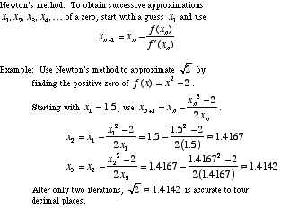

**Norm of a Partition**

**See Mesh of a Partition**

**Normal  
Perpendicular   
Orthogonal**

At a 90° [angle](http://www.mathwords.com/a/angle.htm). Note: Perpendicular [lines](http://www.mathwords.com/l/line.htm) have [slopes](http://www.mathwords.com/s/slope_of_a_line.htm) that are [negative reciprocals](http://www.mathwords.com/n/negative_reciprocal.htm).

Example: Perpendicular Lines

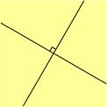

**nth Degree Taylor Polynomial**

**See Taylor Polynomial**

**nth Derivative**

The result of taking the [derivative](http://www.mathwords.com/d/derivative.htm) of the derivative of the derivative etc. of a [function](http://www.mathwords.com/f/function.htm) a total of n times. Written  
f (n)(x) or http://www.mathwords.com/n/n_assets/n28.gif.

Note: f (0)(x) is the same thing as f(x).

**nth Partial Sum**

The [sum](http://www.mathwords.com/s/sum.htm) of the first *n* [terms](http://www.mathwords.com/t/term.htm) of an [infinite series](http://www.mathwords.com/i/infinite_series.htm).

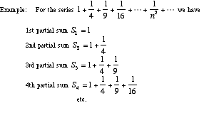

***n*-tuple   
Coordinates / Ordered Pair / Ordered Triple**

On the [coordinate plane](http://www.mathwords.com/c/coordinate_plane.htm), the pair of numbers giving the location of a [point](http://www.mathwords.com/p/point.htm) (ordered pair). In [three-dimensional coordinates](http://www.mathwords.com/t/three_dimensional_coordinates.htm), the triple of numbers giving the location of a point (ordered triple). In [n-dimensional space](http://www.mathwords.com/n/n_dimensions.htm), a sequence of n numbers written in parentheses.

|  |  |
| --- | --- |
| Ordered pair: | Two numbers written in the form (x, y). |
| Ordered triple: | Three numbers written in the form (x, y, z). |
| n-tuple: | n numbers written in the form (*x*1, *x*2, *x*3, . . . , *xn*). |

**Oblate Spheroid**

A flattened [sphere](http://www.mathwords.com/s/sphere.htm). More formally, an oblate [spheroid](http://www.mathwords.com/s/spheroid.htm) is a [surface of revolution](http://www.mathwords.com/s/surface_of_revolution.htm) obtained by revolving an [ellipse](http://www.mathwords.com/e/ellipse.htm) about its [minor axis](http://www.mathwords.com/m/minor_axis_of_an_ellipse.htm).

Note: The earth is shaped like an oblate spheroid.

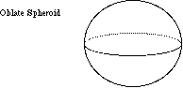

**One-Sided Limit**

Either a [limit from the left](http://www.mathwords.com/l/limit_from_left.htm) or a [limit from the right](http://www.mathwords.com/l/limit_from_right.htm).

**Operations on Functions**

**See Function Operations**

**Order of a Differential Equation**

The [number of the highest derivative](http://www.mathwords.com/n/nth_derivative.htm) in a [differential equation](http://www.mathwords.com/d/differential_eqn.htm). A differential equation of order 1 is called [first order](http://www.mathwords.com/f/first_order_differential_eqn.htm), order 2 [second order](http://www.mathwords.com/s/second_order_differential_equation.htm), etc.

Example: The differential equation y" + xy' – x3y = sin x is second order since the highest derivative is y" or the [second derivative](http://www.mathwords.com/s/second_derivative.htm).

**Ordinary Differential Equation**

A [differential equation](http://www.mathwords.com/d/differential_eqn.htm) which does not include any [partial derivatives](http://www.mathwords.com/p/partial_derivative.htm).

**Orthogonal**

**See Normal**

**p-series**

A [series](http://www.mathwords.com/s/series.htm) of the form http://www.mathwords.com/p/p_assets/p116.gifor http://www.mathwords.com/p/p_assets/p117.gif, where *p* > 0. Often employed when using the [comparison test](http://www.mathwords.com/c/comparison_test.htm) and the [limit comparison test](http://www.mathwords.com/l/limit_comparison_test.htm).

Note: The [harmonic series](http://www.mathwords.com/h/harmonic_series.htm) is a *p*-series with *p* =1.

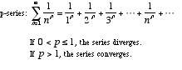

**Parallel Cross Sections**

The [formula](http://www.mathwords.com/f/formula.htm) below gives the [volume](http://www.mathwords.com/v/volume.htm) of a [solid](http://www.mathwords.com/s/solid.htm). *A*(*x*) is the formula for the area of [parallel](http://www.mathwords.com/p/parallel_planes.htm) cross-sections over the entire length of the solid.

Note: The [disk method](http://www.mathwords.com/d/disk_method.htm) and the [washer method](http://www.mathwords.com/w/washer_method.htm) are both derived from this formula.

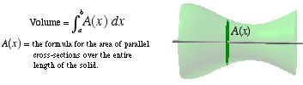

**Parameter (algebra)**

The [independent variable](http://www.mathwords.com/i/independent_variable.htm) or [variables](http://www.mathwords.com/v/variable.htm) in a set of [parametric equations](http://www.mathwords.com/p/parametric_equations.htm).

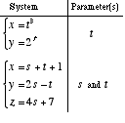

**Parametric Derivative Formulas**

The [formulas](http://www.mathwords.com/f/formula.htm) for the [first derivative](http://www.mathwords.com/f/first_derivative.htm) http://www.mathwords.com/p/p_assets/p13.gifand [second derivative](http://www.mathwords.com/s/second_derivative.htm) http://www.mathwords.com/p/p_assets/p14.gifof a [parametrically](http://www.mathwords.com/p/parametric_equations.htm) defined [curve](http://www.mathwords.com/c/curve.htm) are given below.

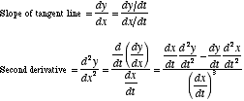

**Parametric Equations**

A [system of equations](http://www.mathwords.com/s/simultaneous_equations.htm) with more than one [dependent variable](http://www.mathwords.com/d/dependent_variable.htm). Often parametric equations are used to represent the position of a moving [point](http://www.mathwords.com/p/point.htm).

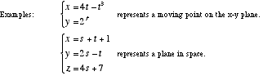

**Parametric Integral Formula**

**See Area Using Parametric Equations**

**Parametrize**

To write in terms of [parametric equations](http://www.mathwords.com/p/parametric_equations.htm).

Example: The line *x* + *y* = 2 can be parametrized as *x* = 1 + *t*, *y* = 1 – *t*.

**Partial Fractions**

The process of writing any [proper rational expression](http://www.mathwords.com/p/proper_rational_expression.htm) as a sum of proper rational expressions. This method is use in [integration](http://www.mathwords.com/i/integration.htm) as shown below.

Note: [Improper rational expressions](http://www.mathwords.com/i/improper_rational_expression.htm) can also be rewritten using partial fractions. You must, however, use [polynomial long division](http://www.mathwords.com/p/polynomial_long_division.htm) first before finding a partial fractions representation.

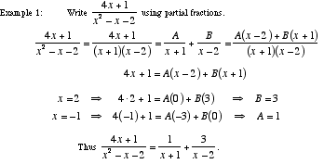  
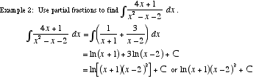

**Partial Sum of a Series**

The [sum](http://www.mathwords.com/s/sum.htm) of a [finite](http://www.mathwords.com/f/finite.htm) number of [terms](http://www.mathwords.com/t/term.htm) of a [series](http://www.mathwords.com/s/series.htm).

**Partition of an Interval**

A division of an [interval](http://www.mathwords.com/i/interval.htm) into a [finite](http://www.mathwords.com/f/finite.htm) number of sub-intervals. Specifically, the partition itself is the set of endpoints of each of the sub-intervals.

http://www.mathwords.com/p/p_assets/p23.gif

**Piecewise Continuous Function**

A [function](http://www.mathwords.com/f/function.htm) made up of a [finite](http://www.mathwords.com/f/finite.htm) number of [continuous](http://www.mathwords.com/c/continuous_fn.htm) pieces. Piecewise continuous functions may not have [vertical](http://www.mathwords.com/v/vertical.htm) [asymptotes](http://www.mathwords.com/a/asymptote.htm). In fact, the only possible types of [discontinuities](http://www.mathwords.com/d/discontinuity.htm) for a piecewise continuous function are [removable](http://www.mathwords.com/r/removable_discontinuity.htm) and [step](http://www.mathwords.com/s/step_discontinuity.htm) discontinuities.

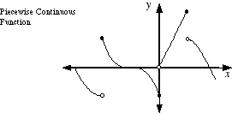

**Pinching Theorem**

**See Sandwich Theorem  
Squeeze Theorem**

**Polar Derivative Formulas**

The [formula](http://www.mathwords.com/f/formula.htm) for the [first derivative](http://www.mathwords.com/f/first_derivative.htm) http://www.mathwords.com/p/p_assets/p67.gifof a [polar curve](http://www.mathwords.com/p/polar_curves.htm) is given below.

http://www.mathwords.com/p/p_assets/p68.gif

**Polar Integral Formula**

**See Area Using Polar Coordinates**

**Positive Series**

A [series](http://www.mathwords.com/s/series.htm) with [terms](http://www.mathwords.com/t/term.htm) that are all [positive](http://www.mathwords.com/p/positive_number.htm).

**Power Rule**

The [formula](http://www.mathwords.com/f/formula.htm) for finding the [derivative](http://www.mathwords.com/d/derivative.htm) of a [power](http://www.mathwords.com/p/power.htm) of a [variable](http://www.mathwords.com/v/variable.htm).

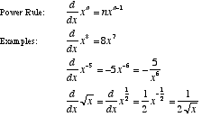

**Power Series**

A [series](http://www.mathwords.com/s/series.htm) which represents a [function](http://www.mathwords.com/f/function.htm) as a [polynomial](http://www.mathwords.com/p/polynomial.htm) that goes on forever and has no highest [power](http://www.mathwords.com/p/power.htm) of *x*.

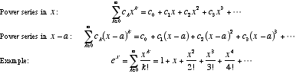

**Power Series Convergence**

A [theorem](http://www.mathwords.com/t/theorem.htm) that states the three alternatives for the way a [power series](http://www.mathwords.com/p/power_series.htm) may [converge](http://www.mathwords.com/c/convergent_series.htm).

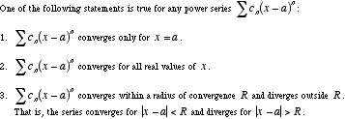

**Product Rule**

A [formula](http://www.mathwords.com/f/formula.htm) for the [derivative](http://www.mathwords.com/d/derivative.htm) of the [product](http://www.mathwords.com/p/product.htm) of two [functions](http://www.mathwords.com/f/function.htm).

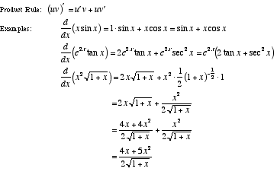

**Projectile Motion  
Falling Bodies**

A [formula](http://www.mathwords.com/f/formula.htm) used to [model](http://www.mathwords.com/m/model.htm) the [vertical](http://www.mathwords.com/v/vertical.htm) motion of an object that is dropped, thrown straight up, or thrown straight down.

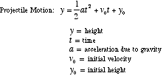  
  
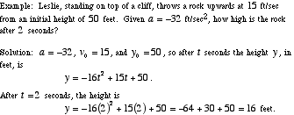

**Prolate Spheroid**

A stretched [sphere](http://www.mathwords.com/s/sphere.htm) shaped like a watermelon. Formally, a prolate spheroid is a [surface of revolution](http://www.mathwords.com/s/surface_of_revolution.htm) obtained by revolving an [ellipse](http://www.mathwords.com/e/ellipse.htm) about its [major axis](http://www.mathwords.com/m/major_axis_ellipse.htm).

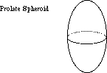

**Quotient Rule**

A [formula](http://www.mathwords.com/f/formula.htm) for the [derivative](http://www.mathwords.com/d/derivative.htm) of the [quotient](http://www.mathwords.com/q/quotient.htm) of two [functions](http://www.mathwords.com/f/function.htm).

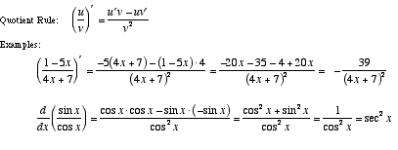

**Radius of Convergence**

The distance between the center of a [power series'](http://www.mathwords.com/p/power_series.htm) [interval of convergence](http://www.mathwords.com/i/interval_of_convergence.htm) and its endpoints. If the [series](http://www.mathwords.com/s/series.htm) only [converges](http://www.mathwords.com/c/convergent_series.htm) at a single point, the radius of convergence is 0. If the series converges over all [real numbers](http://www.mathwords.com/r/real_numbers.htm), the radius of convergence is ∞.

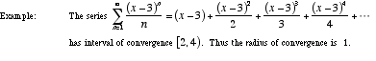

**Ratio Test**

A [convergence test](http://www.mathwords.com/c/convergence_tests.htm) used when [terms](http://www.mathwords.com/t/term.htm) of a [series](http://www.mathwords.com/s/series.htm) contain [factorials](http://www.mathwords.com/f/factorial.htm) and/or nth [powers](http://www.mathwords.com/p/power.htm).

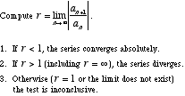

**Rationalizing Substitutions**

An [integration method](http://www.mathwords.com/i/integration_methods.htm) which is often useful when the [integrand](http://www.mathwords.com/i/integrand.htm) is a [fraction](http://www.mathwords.com/f/fraction.htm) including more than one kind of [root](http://www.mathwords.com/r/root_of_a_number.htm), such as http://www.mathwords.com/r/r_assets/r34.gif. A different type of rationalizing substitution can be used to work with integrands such as http://www.mathwords.com/r/r_assets/r35.gif.

Note: This method transforms the integrand into a [rational function](http://www.mathwords.com/r/rational_function.htm), hence the name *rationalizing*.

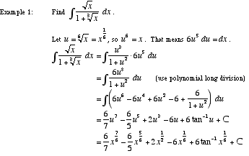

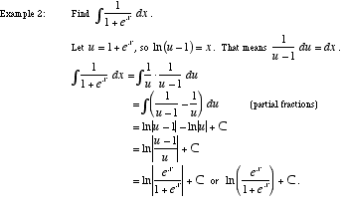

**Reciprocal Rule**

A [formula](http://www.mathwords.com/f/formula.htm) for the [derivative](http://www.mathwords.com/d/derivative.htm) of the [reciprocal](http://www.mathwords.com/m/multiplicative_inverse_of_a_number.htm) of a [function](http://www.mathwords.com/f/function.htm).

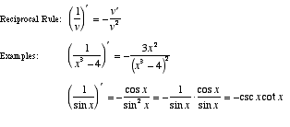

**Rectangular Form**

**See Cartesian Form**

**Related Rates**

A class of problems in which rates of change are related by means of [differentiation](http://www.mathwords.com/d/differentiation.htm). Standard examples include water dripping from a [cone](http://www.mathwords.com/c/cone.htm)-shaped tank and a man’s shadow lengthening as he walks away from a street lamp.

http://www.mathwords.com/r/r_assets/r73.gif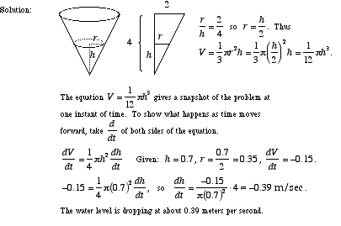

**Local Maximum, Local Max**

**See Relative Maximum, Relative Max**

**Local Minimum, Local Min**

**See Relative Minimum, Relative Min**

**Remainder of a Series**

The [difference](http://www.mathwords.com/d/difference.htm) between the [nth partial sum](http://www.mathwords.com/n/nth_partial_sum.htm) and the [sum](http://www.mathwords.com/s/sum.htm) of a [series](http://www.mathwords.com/s/series.htm).

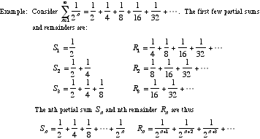

**Removable Discontinuity  
Hole**

A hole in a [graph](http://www.mathwords.com/g/graph_of_an_equation_or_inequality.htm). That is, a [discontinuity](http://www.mathwords.com/d/discontinuity.htm) that can be "repaired" by filling in a single [point](http://www.mathwords.com/p/point.htm). In other words, a removable discontinuity is a point at which a graph is not connected but can be made connected by filling in a single point.

Formally, a removable discontinuity is one at which the [limit](http://www.mathwords.com/l/limit.htm) of the [function](http://www.mathwords.com/f/function.htm) exists but does not equal the value of the function at that point; this may be because the function does not exist at that point.

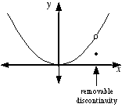

**Riemann Sum**

An approximation of the [definite integral](http://www.mathwords.com/d/definite_integral.htm) http://www.mathwords.com/r/r_assets/r93.gif. This is accomplished in a three-step procedure.

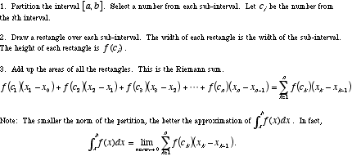

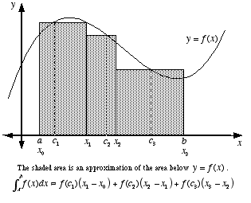

**Rolle's Theorem**

A [theorem](http://www.mathwords.com/t/theorem.htm) of [calculus](http://www.mathwords.com/c/calculus.htm) that ensures the existence of a [critical point](http://www.mathwords.com/c/critical_point.htm) between any two [points](http://www.mathwords.com/p/point.htm) on a "nice" [function](http://www.mathwords.com/f/function.htm) that have the same *y*-value.

http://www.mathwords.com/r/r_assets/r105.gif  
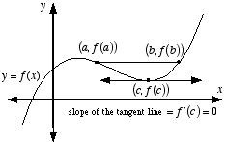

**Root Test**

A [convergence test](http://www.mathwords.com/c/convergence_tests.htm) used when [series](http://www.mathwords.com/s/series.htm) [terms](http://www.mathwords.com/t/term.htm) contain nth [powers](http://www.mathwords.com/p/power.htm).

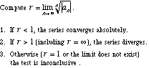

**Sandwich Theorem   
Squeeze Theorem   
Pinching Theorem**

A [theorem](http://www.mathwords.com/t/theorem.htm) which allows the [computation](http://www.mathwords.com/c/compute.htm) of the [limit](http://www.mathwords.com/l/limit.htm) of an [expression](http://www.mathwords.com/e/expression.htm) by trapping the expression between two other expressions which have limits that are easier to compute.

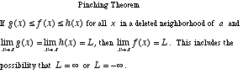  
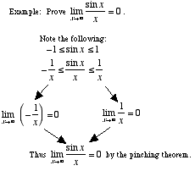

**Scalar**

Any real number, or any quantity that can be measured using a single real number. Temperature, length, and mass are all scalars. A scalar is said to have [magnitude](http://www.mathwords.com/m/magnitude.htm) but no direction. A quantity with both direction and magnitude, such as force or [velocity](http://www.mathwords.com/v/velocity.htm), is called a [vector](http://www.mathwords.com/v/vector.htm).

**Secant Line**

A [line](http://www.mathwords.com/l/line.htm) which passes through at least two [points](http://www.mathwords.com/p/point.htm) of a [curve](http://www.mathwords.com/c/curve.htm). Note: If the two points are close together, the secant line is nearly the same as a [tangent line](http://www.mathwords.com/t/tangent_line.htm).

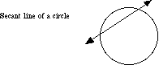

**Second Derivative**

The [derivative](http://www.mathwords.com/d/derivative.htm) of a derivative. Usually written f"(x), http://www.mathwords.com/s/s_assets/s48.gif, or y".

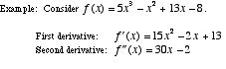

**Second Derivative Test**

A method for determining whether a [critical point](http://www.mathwords.com/c/critical_point.htm) is a [relative minimum](http://www.mathwords.com/l/local_minimum.htm) or [maximum](http://www.mathwords.com/l/local_maximum.htm).

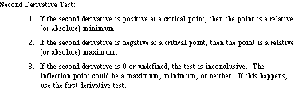  
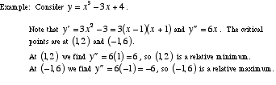

**Second Order Critical Point**

A [point](http://www.mathwords.com/p/point.htm) on the [graph](http://www.mathwords.com/g/graph_of_an_equation_or_inequality.htm) of a [function](http://www.mathwords.com/f/function.htm) at which the [second derivative](http://www.mathwords.com/s/second_derivative.htm) is either 0 or undefined. A second order critical point may or may not be an [inflection point](http://www.mathwords.com/i/inflection_point.htm).

Note: The phrase *second order critical point* is NOT in common usage among mathematicians or in textbooks. Nevertheless, it is a useful name for a type of point which otherwise has no name.

**Second Order Differential Equation**

An [ordinary differential equation](http://www.mathwords.com/o/ordinary_differential_equation.htm) of [order](http://www.mathwords.com/o/order_of_a_differential_equation.htm) 2. That is, a [differential equation](http://www.mathwords.com/d/differential_eqn.htm) in which the highest [derivative](http://www.mathwords.com/d/derivative.htm) is a [second derivative](http://www.mathwords.com/s/second_derivative.htm).

http://www.mathwords.com/s/s_assets/s53.gif

**Separable Differential Equation**

A [first order ordinary differential equation](http://www.mathwords.com/f/first_order_differential_eqn.htm) which can be solved by separating all occurrences of the two [variables](http://www.mathwords.com/v/variable.htm) on either side of the equal sign and then [integrating](http://www.mathwords.com/i/integration.htm).

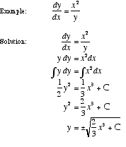

**Sequence**

A list of numbers set apart by commas, such as 1, 3, 5, 7, . . .

**Sequence of Partial Sums**

The [sequence](http://www.mathwords.com/s/sequence.htm) of [nth partial sums](http://www.mathwords.com/n/nth_partial_sum.htm) of a [series](http://www.mathwords.com/s/series.htm).

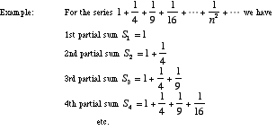

**Series**

The [sum](http://www.mathwords.com/s/sum.htm) of the [terms](http://www.mathwords.com/t/term.htm) of a [sequence](http://www.mathwords.com/s/sequence.htm). For example, the series for the sequence 1, 3, 5, 7, 9, . . . , 131, 133 is the sum 1 + 3 + 5 + 7 + 9 + . . . + 131 + 133.

**Series Rules**

[Algebra](http://www.mathwords.com/a/algebra.htm) rules for [convergent series](http://www.mathwords.com/c/convergent_series.htm) are given below.

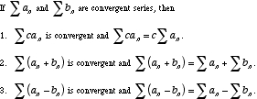

**Shell Method**

**See Cylindrical Shell Method**

**Sigma Notation  
Continued Sum**

A notation using the [Greek letter](http://www.mathwords.com/g/greek_alphabet.htm) sigma (Σ) that allows a long [sum](http://www.mathwords.com/s/sum.htm) to be written compactly.

http://www.mathwords.com/s/s_assets/s79.gif

**Simple Closed Curve**

A connected [curve](http://www.mathwords.com/c/curve.htm) that does not cross itself and ends at the same point where it begins. Examples are [circles](http://www.mathwords.com/c/circle.htm), [ellipses](http://www.mathwords.com/e/ellipse.htm), and [polygons](http://www.mathwords.com/p/polygon.htm).

Note: Despite the name "curve", a simple closed curve does not actually have to curve.

**Simple Harmonic Motion  
SHM**

Any kind of [periodic motion](http://www.mathwords.com/p/periodic_motion.htm) that can be [modeled](http://www.mathwords.com/m/model.htm) using a [sinusoid](http://www.mathwords.com/s/sinusoid.htm). That is, motion that can be approximately or exactly described using a [sine](http://www.mathwords.com/s/sine.htm) or [cosine](http://www.mathwords.com/c/cosine.htm) [function](http://www.mathwords.com/f/function.htm). Examples include the swinging back and forth of a pendulum and the bobbing up and down of a mass hanging from a spring.

http://www.mathwords.com/p/p_assets/p35.gif

**Simpson's Rule**

A method for approximating a [definite integral](http://www.mathwords.com/d/definite_integral.htm) http://www.mathwords.com/s/s_assets/s85.gifusing [parabolic](http://www.mathwords.com/p/parabola.htm) approximations of *f*. The parabolas are drawn as shown below.

To use Simpson's rule follow these two steps:

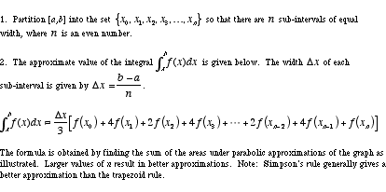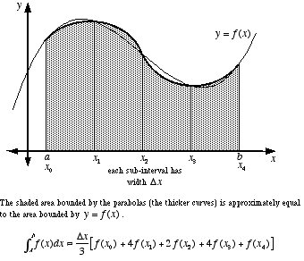

**Slope of a Curve**

A number which is used to indicate the steepness of a [curve](http://www.mathwords.com/c/curve.htm) at a particular [point](http://www.mathwords.com/p/point.htm). The [slope](http://www.mathwords.com/s/slope_of_a_line.htm) of a curve at a point is defined to be the slope of the [tangent line](http://www.mathwords.com/t/tangent_line.htm). Thus the slope of a curve at a point is found using the [derivative](http://www.mathwords.com/d/derivative.htm).

http://www.mathwords.com/s/s_assets/s123.gif

**Solid  
Geometric Solid  
Solid Geometric Figure**

The collective term for all [bounded](http://www.mathwords.com/b/bounded_set_points.htm) [three-dimensional](http://www.mathwords.com/t/three_dimensions.htm) [geometric figures](http://www.mathwords.com/g/geometric_figure.htm). This includes [polyhedra](http://www.mathwords.com/p/polyhedron.htm), [pyramids](http://www.mathwords.com/p/pyramid.htm), [prisms](http://www.mathwords.com/p/prism.htm), [cylinders](http://www.mathwords.com/c/cylinder.htm), [cones](http://www.mathwords.com/c/cone.htm), [spheres](http://www.mathwords.com/s/sphere.htm), [ellipsoids](http://www.mathwords.com/e/ellipsoid.htm), etc.

**Solid of Revolution**

A [solid](http://www.mathwords.com/s/solid.htm) that is obtained by [rotating](http://www.mathwords.com/r/rotation.htm) a [plane figure](http://www.mathwords.com/p/plane_figure.htm) in [space](http://www.mathwords.com/t/three_dimensions.htm) about an [axis](http://www.mathwords.com/a/axis_rotation.htm) [coplanar](http://www.mathwords.com/c/coplanar.htm) to the figure. The axis may not intersect the figure.

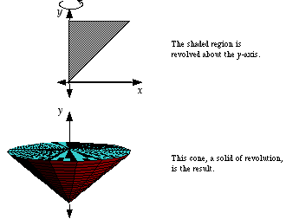

**Solve Analytically**

Use [algebraic](http://www.mathwords.com/a/algebra.htm) and/or numeric methods as the main technique for solving a math problem. Usually when a problem is solved analytically, no graphing calculator is used.

**Solve Graphically**

Use [graphs](http://www.mathwords.com/g/graph_of_an_equation_or_inequality.htm) and/or pictures as the main technique for solving a math problem. When a problem is solved graphically, graphing calculators are commonly used.

**Speed**

Distance covered per unit of time. Speed is a [nonnegative](http://www.mathwords.com/n/nonnegative.htm) [scalar](http://www.mathwords.com/s/scalar.htm). For motion in [one dimension](http://www.mathwords.com/o/one_dimension.htm), such as on a [number line](http://www.mathwords.com/n/number_line.htm), speed is the [absolute value](http://www.mathwords.com/a/absolute_value.htm) of [velocity](http://www.mathwords.com/v/velocity.htm). For motion in [two](http://www.mathwords.com/t/two_dimensions.htm) or [three dimensions](http://www.mathwords.com/t/three_dimensions.htm), speed is the [magnitude](http://www.mathwords.com/m/magnitude.htm) of the velocity [vector](http://www.mathwords.com/v/vector.htm).

**Squeeze Theorem**

**See Sandwich Theorem**

**Step Discontinuity**

**See Jump Discontinuity**

**Substitution Method**

**See Integration by Substitution**

**Surface**

A [geometric figure](http://www.mathwords.com/g/geometric_figure.htm) in [three dimensions](http://www.mathwords.com/t/three_dimensions.htm) excluding [interior](http://www.mathwords.com/i/interior.htm) [points](http://www.mathwords.com/p/point.htm), if any.

**Surface Area of a Surface of Revolution**

The [formulas](http://www.mathwords.com/f/formula.htm) below give the [surface area](http://www.mathwords.com/s/surface_area.htm) of a [surface of revolution](http://www.mathwords.com/s/surface_of_revolution.htm). The [axis of rotation](http://www.mathwords.com/a/axis_rotation.htm) must be either the x-axis or the y-axis. The [curve](http://www.mathwords.com/c/curve.htm) being rotated can be defined using [rectangular](http://www.mathwords.com/c/cartesian_coordinates.htm), [polar](http://www.mathwords.com/p/polar_equation.htm), or [parametric equations](http://www.mathwords.com/p/parametric_equations.htm).

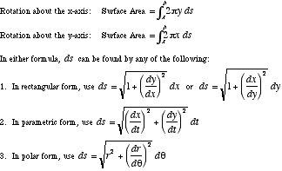

**Surface of Revolution**

A [surface](http://www.mathwords.com/s/surface.htm) that is obtained by rotating a [plane](http://www.mathwords.com/p/plane.htm) [curve](http://www.mathwords.com/c/curve.htm) in [space](http://www.mathwords.com/t/three_dimensions.htm) about an [axis](http://www.mathwords.com/a/axis_rotation.htm) [coplanar](http://www.mathwords.com/c/coplanar.htm) to the curve.

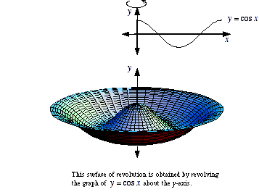

**Tangent Line**

A [line](http://www.mathwords.com/l/line.htm) that touches a [curve](http://www.mathwords.com/c/curve.htm) at a [point](http://www.mathwords.com/p/point.htm) without crossing over. Formally, it is a line which intersects a [differentiable](http://www.mathwords.com/d/differentiable.htm) curve at a point where the [slope of the curve](http://www.mathwords.com/s/slope_of_a_curve.htm) equals the [slope of the line](http://www.mathwords.com/s/slope_of_a_line.htm).

Note: A line tangent to a [circle](http://www.mathwords.com/c/circle.htm) is [perpendicular](http://www.mathwords.com/p/perpendicular.htm) to the [radius](http://www.mathwords.com/r/radius_of_a_circle_or_sphere.htm) to the point of tangency.

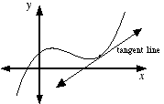

**Taylor Polynomial  
nth Degree Taylor Polynomial**

An approximation of a [function](http://www.mathwords.com/f/function.htm) using [terms](http://www.mathwords.com/t/term.htm) from the function's [Taylor series](http://www.mathwords.com/t/taylor_series.htm). An nth degree Taylor polynomial uses all the Taylor series terms up to and including the term using the [nth derivative](http://www.mathwords.com/n/nth_derivative.htm).

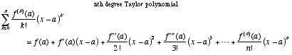

**Taylor Series**

The [power series](http://www.mathwords.com/p/power_series.htm) in *x – a* for a [function](http://www.mathwords.com/f/function.htm) *f* . Note: If *a* = 0 the series is called a [Maclaurin series](http://www.mathwords.com/m/maclaurin_series.htm).

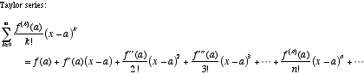

**Taylor Series Remainder**

A quantity that measures how [accurately](http://www.mathwords.com/a/accuracy.htm) a [Taylor polynomial](http://www.mathwords.com/t/taylor_polynomial.htm) estimates the sum of a [Taylor series](http://www.mathwords.com/t/taylor_series.htm).

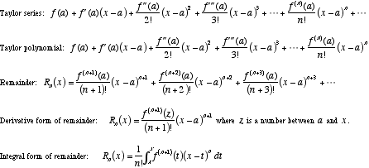

**Pappus’s Theorem  
Theorem of Pappus**

A method for finding the [volume](http://www.mathwords.com/v/volume.htm) of a [solid of revolution](http://www.mathwords.com/s/solid_of_revolution.htm). The volume equals the [product](http://www.mathwords.com/p/product.htm) of the area of the region being rotated times the distance traveled by the [centroid](http://www.mathwords.com/c/centroid.htm) of the region in one rotation.

**Torus**

A doughnut shape. Formally, a torus is a [surface of revolution](http://www.mathwords.com/s/surface_of_revolution.htm) obtained by revolving (in [three dimensional space](http://www.mathwords.com/t/three_dimensions.htm)) a [circle](http://www.mathwords.com/c/circle.htm) about a [line](http://www.mathwords.com/l/line.htm) which does not intersect the circle.

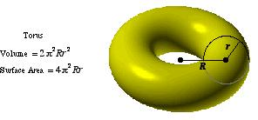

**Trapezoid Rule**

A method for approximating a [definite integral](http://www.mathwords.com/d/definite_integral.htm) http://www.mathwords.com/t/t_assets/t56.gifusing [linear](http://www.mathwords.com/l/linear.htm) approximations of *f*. The [trapezoids](http://www.mathwords.com/t/trapezoid.htm) are drawn as shown below. The [bases](http://www.mathwords.com/b/base_trapezoid.htm) are [vertical](http://www.mathwords.com/v/vertical.htm) [lines](http://www.mathwords.com/l/line.htm).

To use the trapezoid rule follow these two steps:

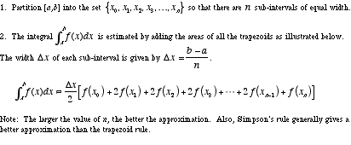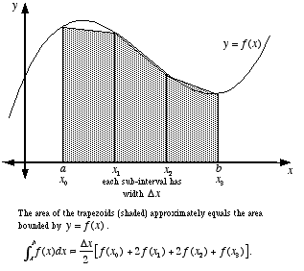

**Trig Substitution**

A [method for computing integrals](http://www.mathwords.com/i/integration_methods.htm) often used when the [integrand](http://www.mathwords.com/i/integrand.htm) contains [expressions](http://www.mathwords.com/e/expression.htm) of the form a2 – x2, a2 + x2, or x2 – a2.

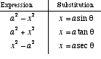  
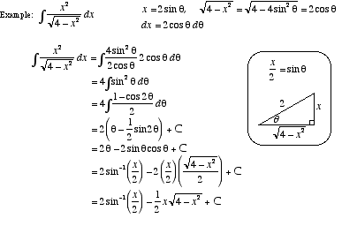

**u-Substitution**

**See Integration by Substitution**

**Uniform**

All the same or all in the same manner; [constant](http://www.mathwords.com/c/constant.htm).

**Vector Calculus**

**See Multivariable Calculus**

**Velocity**

The rate of change of the position of an object. For motion in [one dimension](http://www.mathwords.com/o/one_dimension.htm), such as along the [number line](http://www.mathwords.com/n/number_line.htm), velocity is a [scalar](http://www.mathwords.com/s/scalar.htm). For motion in [two dimensions](http://www.mathwords.com/t/two_dimensions.htm) or through [three-dimensional space](http://www.mathwords.com/t/three_dimensions.htm), velocity is a [vector](http://www.mathwords.com/v/vector.htm).

**Volume**

The total amount of space enclosed in a [solid](http://www.mathwords.com/s/solid.htm).

|  |  |  |
| --- | --- | --- |
| For the following tables, | | |
| h = [height](http://www.mathwords.com/a/altitude.htm) of [solid](http://www.mathwords.com/s/solid.htm) | s = [slant height](http://www.mathwords.com/s/slant_height.htm) | P = [perimeter](http://www.mathwords.com/p/perimeter.htm) or [circumference](http://www.mathwords.com/c/circumference.htm) of the [base](http://www.mathwords.com/b/base.htm) |
| l = length of [solid](http://www.mathwords.com/s/solid.htm) | B = area of the [base](http://www.mathwords.com/b/base.htm) | r = [radius](http://www.mathwords.com/r/radius_of_a_circle_or_sphere.htm) of [sphere](http://www.mathwords.com/s/sphere.htm) |
| w = width of [solid](http://www.mathwords.com/s/solid.htm) | R = [radius](http://www.mathwords.com/r/radius_of_a_circle_or_sphere.htm) of the [base](http://www.mathwords.com/b/base.htm) | a = length of an [edge](http://www.mathwords.com/e/edge_polyhedron.htm) |

|  |  |  |  |  |
| --- | --- | --- | --- | --- |
| Figure | Volume | [Lateral Surface Area](http://www.mathwords.com/l/lateral_surface_area.htm) | Area of the [Base(s)](http://www.mathwords.com/b/base.htm) | Total [Surface Area](http://www.mathwords.com/s/surface_area.htm) |
| [Box](http://www.mathwords.com/r/rectangular_parallelepiped.htm) (also called [rectangular parallelepiped](http://www.mathwords.com/r/rectangular_parallelepiped.htm), [right rectangular prism](http://www.mathwords.com/r/rectangular_parallelepiped.htm)) | lwh | 2lh + 2wh | 2lw | 2lw + 2lh + 2wh |
| [Prism](http://www.mathwords.com/p/prism.htm) | Bh | Ph | 2B | Ph + 2B |
| [Pyramid](http://www.mathwords.com/p/pyramid.htm) | http://www.mathwords.com/p/p_assets/pyramid%20volume.gif | - | B | - |
| [Right Pyramid](http://www.mathwords.com/r/right_pyramid.htm) | http://www.mathwords.com/p/p_assets/pyramid%20volume.gif | http://www.mathwords.com/p/p_assets/pyramid%20lateral%20surface%20area.gif | B | http://www.mathwords.com/p/p_assets/pyramid%20total%20surface%20area.gif |
| [Cylinder](http://www.mathwords.com/c/cylinder.htm) | Bh | - | 2B | - |
| [Right Cylinder](http://www.mathwords.com/r/right_cylinder.htm) | Bh | Ph | 2B | Ph + 2B |
| [Right Circular Cylinder](http://www.mathwords.com/r/right_circular_cylinder.htm) | π*R*2*h* | 2πRh | 2πR2 | 2πRh + 2πR2 |
| [Cone](http://www.mathwords.com/c/cone.htm) | http://www.mathwords.com/p/p_assets/pyramid%20volume.gif | - | B | - |
| [Right Circular Cone](http://www.mathwords.com/r/right_circular_cone.htm) | http://www.mathwords.com/c/c_assets/cone%20volume.gif | π*Rs* or http://www.mathwords.com/c/c_assets/cone%20lateral%20surface%20area.gif | πR2 | πRs + πR2 or http://www.mathwords.com/c/c_assets/cone%20surface%20area.gif |

|  |  |  |
| --- | --- | --- |
| Figure | Volume | Total [Surface Area](http://www.mathwords.com/s/surface_area.htm) |
| Sphere | http://www.mathwords.com/s/s_assets/sphere%20volume.gif | http://www.mathwords.com/s/s_assets/sphere%20surface%20area.gif |
| [Regular](http://www.mathwords.com/p/platonic_solids.htm) [Tetrahedron](http://www.mathwords.com/t/tetrahedron.htm) | http://www.mathwords.com/t/t_assets/tetrahedron%20volume.gif | http://www.mathwords.com/t/t_assets/tetrahedron%20surface%20area.gif |
| [Cube](http://www.mathwords.com/c/cube.htm) ([regular hexahedron](http://www.mathwords.com/c/cube.htm)) | a3 | 6a2 |
| [Regular](http://www.mathwords.com/p/platonic_solids.htm) [Octahedron](http://www.mathwords.com/o/octahedron.htm) | http://www.mathwords.com/o/o_assets/octahedron%20volume.gif | http://www.mathwords.com/o/o_assets/octahedron%20surface%20area.gif |
| [Regular](http://www.mathwords.com/p/platonic_solids.htm) [Dodecahedron](http://www.mathwords.com/d/dodecahedron.htm) | http://www.mathwords.com/d/d_assets/dodecahedron%20volume.gif | http://www.mathwords.com/d/d_assets/dodecahedron%20surface%20area.gif |
| [Regular](http://www.mathwords.com/p/platonic_solids.htm) [Icosahedron](http://www.mathwords.com/i/icosahedron.htm) | http://www.mathwords.com/i/i_assets/icosahedron%20volume.gif | http://www.mathwords.com/i/i_assets/icosahedron%20surface%20area.gif |

**Volume by Parallel Cross Sections**

**See Parallel Cross Sections**

**Washer**

**Annulus**

The region between two [concentric](http://www.mathwords.com/c/concentric.htm) [circles](http://www.mathwords.com/c/circle.htm) which have different [radii](http://www.mathwords.com/r/radius_of_a_circle_or_sphere.htm).

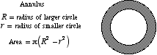

**Washer Method**

A technique for finding the [volume](http://www.mathwords.com/v/volume.htm) of a [solid of revolution](http://www.mathwords.com/s/solid_of_revolution.htm). The washer method is a generalized version of the [disk method](http://www.mathwords.com/d/disk_method.htm). Both the washer and disk methods are specific cases of [volume by parallel cross-sections](http://www.mathwords.com/v/volume_by_parallel_cross_sections.htm).

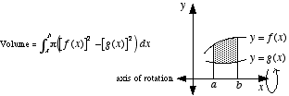

**Work**

The physics term for the amount of energy required to move an object over a given path subject to a given force.

http://www.mathwords.com/w/w_assets/w4.gif