Blogworld Expo: Building Relationships with Bloggers

By Brian Solis, blogger at PR 2.0 and principal of FutureWorks PR


Building relationships with bloggers has been the hot topic over the last year, with an emphasis on the last couple of weeks - courtesy of Mr. Chris Anderson (btw, thank you Chris for sparking some of the most important and invigorating discussions to take place in PR in quite some time).
I was invited to join Marc Harty of PR Traffic to speak about how and why to build relationships with bloggers at Blogworld Expo in Las Vegas.
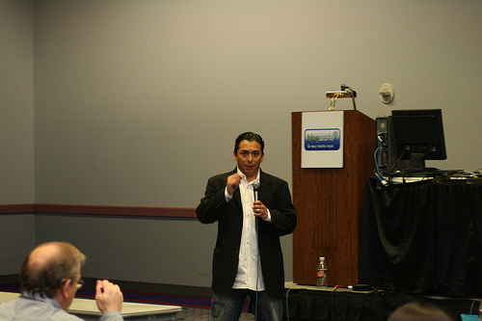
The room was filled with bloggers, entrepreneurs, PR people, corporate executives, and journalists, all looking to engage. I have to say that this was a pleasant surprise as it was one of the last sessions of the entire event.

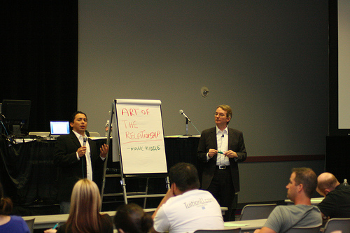
The agenda for the hour was basic, but the ensuing discussions were deep and immersive.
Remember, the point here is that while many of this seems like common sense, but it actually requires a completely different mindset for creating blogger campaigns and measuring their success. Conversations are taking place right now about your company and your competitors. What are you going to do about?
Blogger relations and participation are important to the future of your business.
1. Define Blogger Relations
- Blogger relations is about people, many of whom might be customers and peers. It is not to be underestimated.
2. The Art of Relationships
- Be knowledgeable, transparent, honest, and trustworthy. Add value or don't bother.
- You don't have the "right" to pitch bloggers, so really think about it before you approach anyone.
- Conversation seems to be the "it" word, but it all comes down to respect, articulation, and relevance. Personality helps.
- No one likes to sold "to" or marketed "at" - each person needs to hear things differently, so think about that.
- There is no market for messages.
- You are empowered and expected, as a PR person, to know what you're talking about, it's benefits, and why it matters to the markets you're trying to reach. Become an expert.
- Less is more. This isn't about numbers, this is about doing PR in the Long Tail so that you can develop more meaningful relationships that have a more significant impact on the brand, business, and customers service. Quality vs. Quantity.
- Stop thinking about PR in terms of pitches and audience. The pitch is dead. The audience is dead.
- It's all about trust and respect
- Determine their preferred method of contact - note it might not be email, but rather various social tools.
NOTE TO BLOGGERS: Please help PR help you. Create a page or update your "about" section with tips and recommendations for developing relationships with PR people.
3. Promote and Reach Bloggers Through Social Media
- Submit their posts/articles to social networks and news aggregators such as digg and reddit.
- Link to them.
- Comment before reaching out with meaningful content - participation is marketing.
- Leverage personal networks.
4. Utilize Social Tools
- There are alternative contact channels to email and forms (No spam or invasive tactics allowed)
- Social networks such as Facebook, Yahoo Mash, LinkedIn, Plaxo Pulse.
- Micromedia such as Twitter, jaiku, Tumblr, Utterz, Pownce.
5. Be Creative
- The traditional press release has no business in blogger relations. You're going to have to put things together as building blocks in order to help someone tell a story.
- Video, create short video demos, intros, events, greetings, or skits, that are specific to markets you're trying to reach.
- Podcasts, invite them to co-host a podcast or to be a guest on something like BlogTalkradio. Or create pre-recorded interviews or discussions that matter to bloggers. Think about creating custom content for different people. One shoe doesn't fit all just like one message or one tool doesn't matter to everyone.
- Social bookmarks, Bookmark content that matters to bloggers through services such as StumbleUpon, ma.gnolia, and delicious. Also, create purpose built pages dedicated to providing unbiased market background and perspective to help bloggers gain expertise and context through one link.
- Tagging, Tag items within social networks for specific people.
6. Find the People Who Can Help You
- Google Alerts allow you to be notified if anyone is talking about your company, competition, you, or other important topics.
- Blogpulse reveals blogs and bloggers that have strong authority around relevant memes.
- Technorati allows you to discover blogs that cover certain key words.
7. The Art of Listening
- Read.
- Explore their blogroll.
- Use an RSS aggregator or feed reader to simplify the process of reading the important blogs and their coverage.
- Read the comments (and participate). Sometimes the greatest insight is unveiled outside of the post.
8. The “C”s of Blogger Relations
- Concept: what's the compelling plan.
- Context: why is it relevant to them.
- Consumption: create a package that makes it easy for bloggers to write their story.
- Credibility: what makes you credible? Become the expert.
- Community: join it, participate without expectations.
- Conversation: you are not invited to the conversation as a marketer. This is about people, so be articulate, responsive, honest, smart, and resourceful.
9. Expand the scope
- Don't get caught up in the A-list.
- Blogger relations can be based on news and also stories.
- Focus on the magic middle, bloggers with 20-1000 blogs that link back to them.
10. Read the Social Media Manifesto
----
Lisa Barone liveblogged the session. Click here to read her summary
Special thanks to Barbara Rozgonyi for taking these pictures. And, also thank you to Marc for a great session.
Connect with me on Twitter, Jaiku, Pownce or Facebook.


Brian Solis is Principal of FutureWorks , an award-winning PR agency in Silicon Valley. Solis blogs at PR2.0 , bub.blicio.us , and regularly contributes PR and tech comments and articles to industry sites and publications. Solis is co-founder of the Social Media Club , is an original member of the Media 2.0 Workgroup, and also is a contributor to the Social Media Collective.

