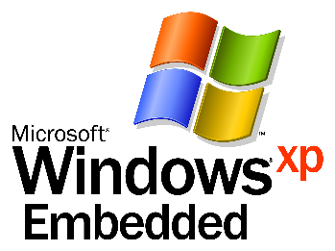

Windows XP Embedded

Step-by-Step Guide

Objectives
For the purposes of this Step-by-Step guide you will work with the Windows XP Embedded tools to build a bootable image of Windows XP Embedded. This tutorial will introduce you to the tools and basic methodologies used to build components, work with the Windows XP Embedded component database and build and deploy an operating system image.

Workstation Configuration

Your workstation should have the following software installed.
- Windows XP Professional
- Windows XP Embedded

Note: You will only be able to complete the entire Step-by-Step guide if you have followed all steps within the Windows XP Embedded Setup Guide, and have two partitions on your development workstation. The first partition should contain Windows XP Professional and the Windows XP Embedded Studio tools. The second partition should be 700 megabytes in size. The second partition is where the Windows XP Embedded image will be placed, and from which you will boot and run during the tutorial.

For More Information
Visit the Microsoft Embedded website: http://www.microsoft.com/windows/embedded/

Scenario

- To get the most from this tutorial you will have the development tools and the bootable image running on the same PC. This is a great way to quickly build and test a Windows XP Embedded image. When deploying to actual target hardware there are a number of additional steps that would typically be taken; for example transferring the image and creating El-Torito bootable media.

Estimated time to complete this exercise: 75 minutes

Creating an Initial Configuration

In this tutorial you will create a Windows XP Embedded operating system in approximately 30 minutes. This initial configuration will not contain all of the components and technologies that you would find on a typical installation of Windows XP on a desktop PC. Instead, it will contain only those hardware components which are specific to the target hardware and features chosen for this tutorial.

- Launch Target Designer and create a new configuration
- Start the Target Designer tool. You will find an icon on your desktop.

- Select “File→New”. This will create a new configuration for Windows XP Embedded.
- You will need to name this configuration. Name the configuration DemoPlatform.
- You will need to select a platform. At this time “Windows XP Embedded Client” is the only available platform and is selected by default.
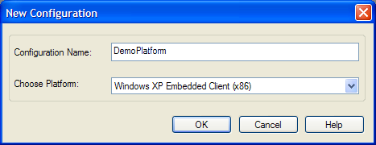

- Personalize the configuration by completing the following fields on the configuration screen (Name, Owner, Author, Description, etc.)
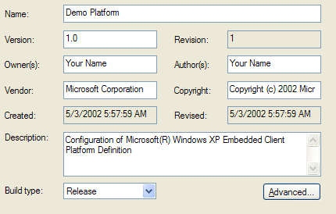
Set Advanced Configuration Parameters
You will now edit some configuration specific parameters.
- At the top of the Configuration Browser (the middle pane), click on Settings. The settings pane on the right side will display the main settings available for the configuration. 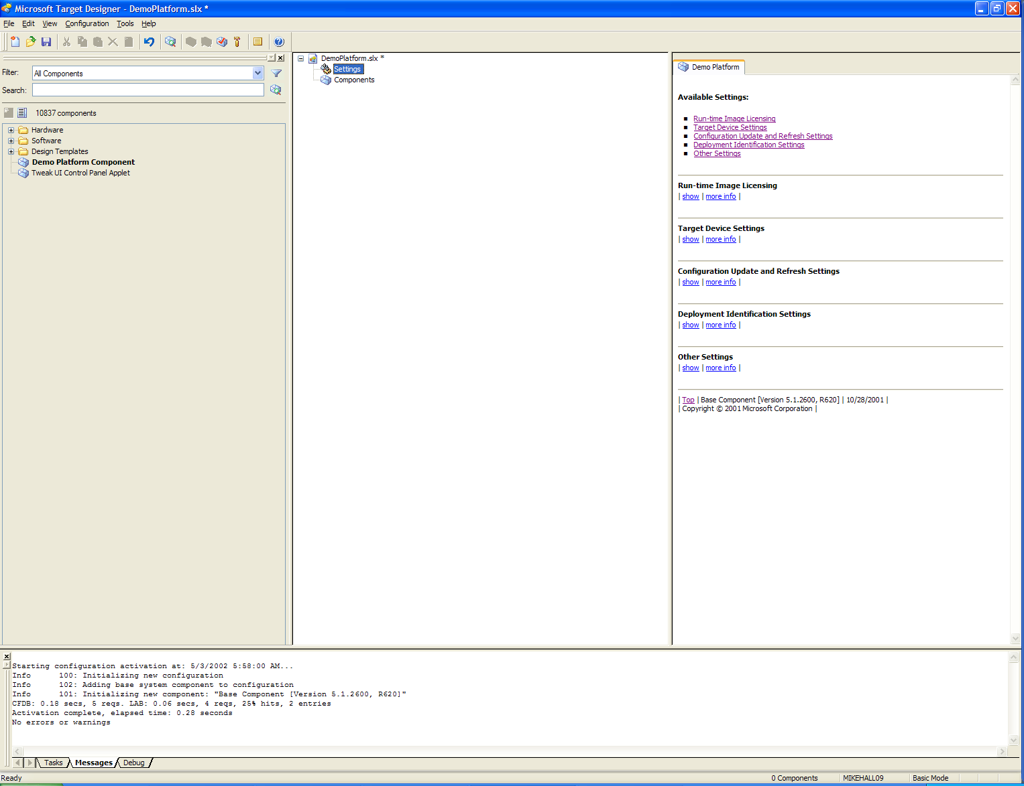
- Under “Target Devices”, click show. The following should be displayed.
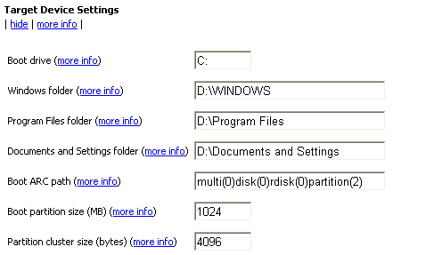

- Modify the following values by editing the information in the text boxes.
      - Boot Drive = C:
      - Windows Folder = D:\Windows
      - Program Files Folder = D:\Program Files
      - Documents and Settings folder = D:\Documents and Settings
      - Boot ARC path = multi(0)disk(0)rdisk(0)partition(2)
      - Boot Partition Size (MB) = 700

- Save your work.
Please save your work in the C:\XPE_Demo directory.

Identifying Target Hardware
Now that you have a blank configuration, you should first include support for the target hardware. For the purposes of this tutorial, your target device is also your development machine.

Windows XP Embedded provides a tool called Target Analyzer to discover what hardware is on the target system. There are two versions of Target Analyzer, TA.EXE and TAP.EXE.

The Target Analyzer tools (TA.EXE and TAP.EXE) both examine the underlying hardware of your target device (which in this case is the development workstation) and produce an XML based output file which describes the underlying hardware; the output file (devices.pmq) can then be imported into Component Designer to create a component that describes your reference platform. You then simply need to select this component in the Target Designer tool, add any additional components and build your operating system image.

TAP.EXE is a 32 bit application which runs under Windows 2000 or XP. It takes advantage of hardware detection which is already done by the O/S.
TA.EXE is a 16 bit application designed to run under DOS. This program is designed for systems in which it may not be possible to install Windows 2000 or XP because of limited resources (ex: a board with only Disk-On-Chip). In this scenario you would typically boot to a DOS floppy disc and run the TA program.
Let’s now run the TAP.EXE program to build a devices.pmq file which describes your development workstation.
- Minimize Target Designer
- Click on “Start | My Computer”
- Open the “C:” drive
- Navigate to: “C:\Program Files\Windows Embedded\Utilities”
- Double-Click on “tap.exe” (Below is sample output displayed as TAP runs.)
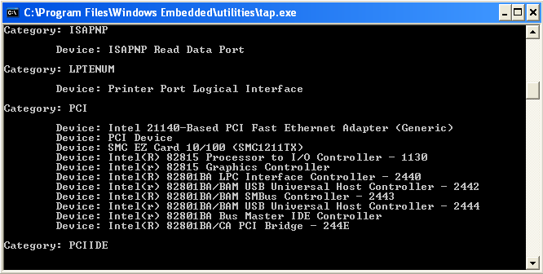
- In Windows Explorer, double-click on the output file of Target Analyzer, called “devices.pmq”. Be aware that you may need to associate the file extension .PMQ with Notepad in order to view the output of TAP.
- Explore the “devices.pmq” XML file. As you will see, this file contains information on different hardware elements in your development system. For example, the picture below shows the “PCI” section of the XML file. In this example it has found an Intel 21140 Ethernet Adapter. (Note: This may be different in your system.) Close this file when done.

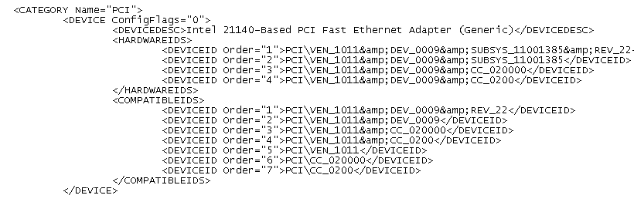

The next step would normally be to convert the “devices.pmq” file into either an XP Embedded component in Component Designer or to import the device list into Target Designer but this process would take roughly 10 minutes to complete, so for the purposes of this tutorial this step has already been completed for you.
Time Saver!

Creating Components
Normally, every embedded device would run one or more “custom” applications and/or additional device drivers. The best way to truly integrate these applications into your device is to create components for those applications and include them in your configuration and run-time image. In general, this is a three-step process:
- Identify the component resources and settings or import them from an INF file.
- Configure the components resources and options within Component Designer.
- Create a repository and add the components files to that repository.
- Save the component information (as a .SLD file).
- Import that component definition into the database using Component Database Manager.
Though the process of creating a component can be as short as 10 minutes, you will not create any components during this tutorial. However, during the setup of this lab you have already created a component and imported it into the component database so you can add it to your image. This is a Control Panel applet called “TweakUI”.
In addition to this “application” you have also imported the Target Analyzer output into Component Designer and created a macro component that you can add to your configuration to support the hardware configured for the Step-by-Step guide. This component is called “Demo Platform Component” and you will add it to your configuration using Target Designer in the next section.

Building the Windows XP Embedded Operating System Image.

- Building the XP Embedded Operating System
- Return to Target Designer

Currently you have a blank configuration. The first component you will add is a macro component. This component was made from the Target Analyzer output, and its purpose is to ensure that all required hardware components are included in the build. There are a number of ways to add components to a run-time image. You can select a macro component (a wrapper for a number of components) or individual components, or add components through dependency analysis.
Note

- In the Component Browser, find the Demo Platform Component. Add the component by double clicking on it, or by right-clicking and select Add.

If you cannot find the component, enter its name in the Search: field of the Component Browser.
Note

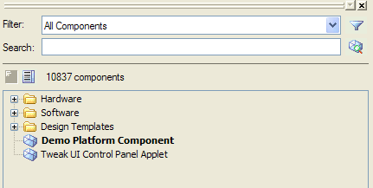

Let’s now create a filter to find the Tweak UI Control Panel Applet component – Windows XP Embedded ships with a large number of components; the filter makes it simple to locate components.
- Click on the Filter Icon () above the Component Browser to create a new filter.
- In the Filter Manager dialog select New
- Name the filter “TweakUI”
- Double click on the filter rule “Component display name contains [substring]” to add the rule.
- Double click on “Component display name contains [substring]” in the Filter Description section of the Filter Editor. You will be prompted to enter a string; enter “Tweak”.
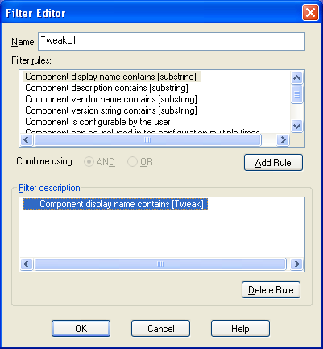
- Click OK to close the Filter Editor.
- In the Filter Manager. The “Available filter list” should show the “Tweak” filter.
- Select the “Tweak” filter and click “Apply Filter”.

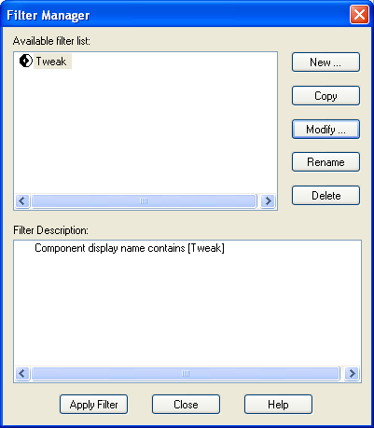

The Component Browser should now only list the Tweak UI Control Panel Applet component.
Now that you’ve located the Tweak UI Control Panel Applet component you can add this to your platform configuration.
- In the Component Browser, find the TweakUI component. Add the component by double clicking on it, or by right-clicking and select Add.
- Change the filter back to “All Components” by selecting it in the pull down Filter list above the Component Browser.

You will now include a Design Template component. The design template component is very similar to the Demo Platform Component previously added in that it will ensure that the necessary components are included to provide the desired functionality. You can consider a Design Template as being a set of components that wrap up a certain device configuration, for example the Windows-based Terminal Professional.

    - Add the Windows-based Terminal Professional component.
    - In the Configuration (middle) pane, expand this component and click on Settings. The right pane now lists the major components that are part of the Windows-based Terminal Professional. You may select/remove individual components from your configuration through this interface.

NOTE: This component can be found under the Design Templates group in the Component Browser.

The next step in configuring your system is to add additional core components. In your case your file system will be the FAT file system. You will need to add the FAT and other necessary components into your configuration.
    - The FAT component can be found under the Software → System → Storage and File Systems → Infrastructure → File Systems group. Double-click on FAT to include it.
    - Also include the FAT Format component located in the Software → System → Storage and File Systems → Applications group.
    - Add the Explorer Shell component to the configuration. This can be found in the Software → System → User Interface → Shells.
    - You must include an OS “Loader.” Select the NT Loader component. It can be found in Software → System → System Services → Base.

Finally you will check dependencies to assure that all required components are included.
    - From the Configuration menu select Check Dependencies

The dependency checker will automatically include all required components. This is optional, and instead you could be informed which components need to be included.
Note

You will receive 1 error which says:
Component: "Regional and Language Options [Version 5.1.2600, R620]" requires at least one additional enabled component not in the configuration.

The dependency checker did not automatically resolve this component because a decision is needed from the user. The “Tasks” list shows dependency issues which you must complete.
    - Click on the Tasks tab at the bottom of Target Designer.
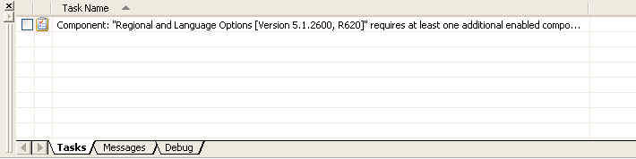

- Double click on the task mentioned above. You will be prompted to select from a limited set of components to resolve the dependency.
- Select the English Language Support component, and click Add. Though other languages are listed in this dialog, they require a separate language pack that is not necessarily installed on your machine.

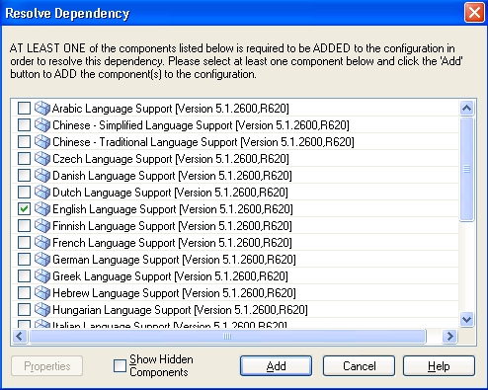

- Start Menu Items
During the dependency check, the User Interface Core component was added to your configuration because it was required by another component. To include basic Start Menu items and short cuts, click on this components Settings entry in the Configuration window, then select the Start Menu items you would like to include. Note that almost all of these items are disabled by default.
Start Menu Items to Select
- Show Control Panel on Start Menu
- Show My Computer on Start Menu
Start Menu Items Not to Select
- Prohibit Access to Hot Keys
- Prohibit Access to Control Panel
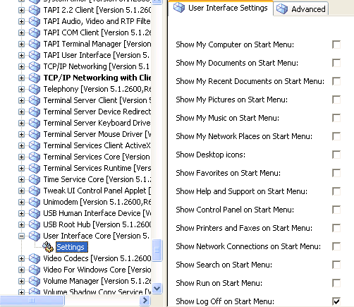
- Check dependencies one last time.
  - From the Configuration menu select Check Dependencies.
All dependencies should be resolved.

Creating and Testing the Run-Time Image

- From the Configuration menu select Build Target Image…
- The destination location should be in the C:\Windows Embedded Images path - You must always specify a sub-directory for the build, since you cannot specify the root of any drive.
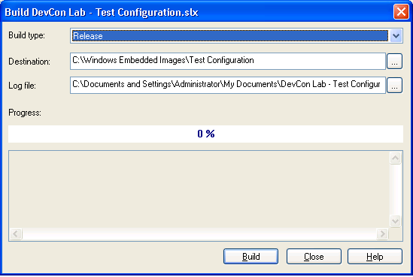
- The log file must be in a location other than the destination location.
- Click Build to start the run-time image build. You may be prompted and warned if the directory specified already has files in it. When complete, the image files should be arranged in a similar fashion to the following:
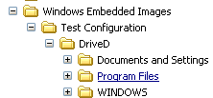
- You may also be prompted to re-run a Dependency Check if changes have been made to your configuration since the last time you did a Dependency Check.
- Target Designer will now build the run-time image and assemble the image in the directory specified. When finished you should see a dialog similar to the one below.
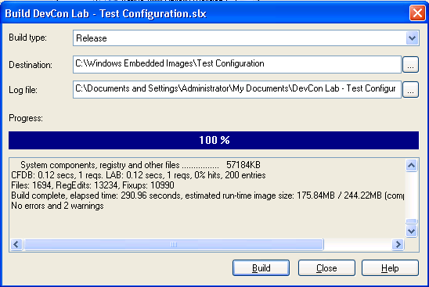
- In the image above, note that there are no errors, but there are two warnings. The first warning occurred because a Windows XP Embedded Product PID was not specified for this build. This results in a timed, evaluation run-time image. The second warning occurred because the Tweak UI component was included in the image, but was not marked as a “Released” component. This has no effect on the image itself.
- When it is finished, click Close.

Note: If you have configured your development PC to have two partitions (as per the Setup Guide instructions) you may now continue to the next section of the document – if you are running the Windows XP Embedded tools on a single partition development PC then you should stop the tutorial at this point, and simply read about the remaining steps.

- Copy the files to the root of the D drive (your second bootable partition). Since the files are in a subdirectory of D: they must be moved to the locations specified in the Configuration Settings pane during an earlier step, before you try to boot the embedded image. Copy the files in the build directory to the root of D: then copy each of the directories in the Drive D subdirectory so that they are at the root of D: as well. When finished, the file and directory structure of D: should resemble this:
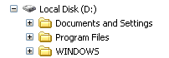

    - Save the configuration (File → Save) again
    - Close Target Designer
    - Reboot the computer

- Test the XP Embedded System
You can now test the image that’s been generated.
  - During the reboot process, two boot options will be presented, either boot into Windows XP Professional, or Windows XP Embedded.
  - Select “Windows XP Embedded”. The list of bootable operating systems is managed by a file called BOOT.INI. A sample BOOT.INI is shown below. You’ve already edited the C:\BOOT.INI file as part of the Setup Guide.

[boot loader]
timeout=30
default=multi(0)disk(0)rdisk(0)partition(1)\WINNT
[operating systems]
multi(0)disk(0)rdisk(0)partition(1)\WINDOWS="Microsoft Windows XP Professional" /fastdetect
multi(0)disk(0)rdisk(0)partition(2)\WINDOWS="Microsoft Windows XP Embedded" /fastdetect

- Exploring the XP Embedded Build

Once the Windows XP Embedded operating system has booted, you can confirm that your build of the Windows XP Embedded o/s contains the Tweak UI Control Panel Applet component.

  - Open the Control Panel application
  - Verify that the Tweak UI Control Panel Applet component is included within the Control Panel (see the screen shot below).

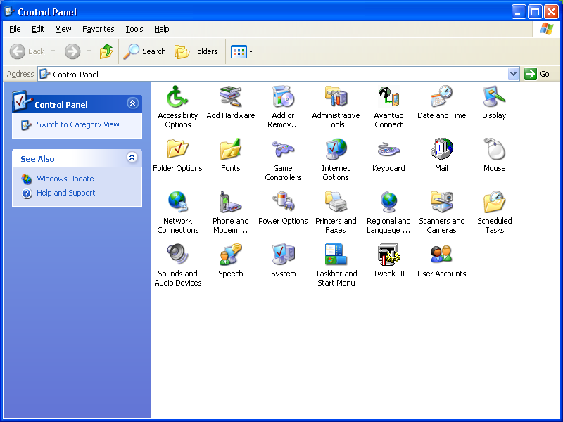
TweakUI Control Panel Applet.

  - Run the “TweakUI” control panel applet by double clicking on the icon.

You should see a dialog display similar to the image below.

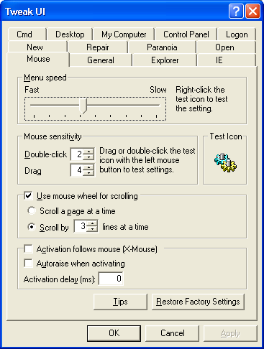

All Steps are Now Complete

