DMVstats 1.0 – A SQL Server 2005 Performance Data Warehouse Application
Author: Tom Davidson
Reviewer: Sanjay Mishra
Contents
DMVstats 1.0 – A SQL Server 2005 Performance Data Warehouse Application 1
Introduction 3
Main Components 3
Getting Started 3
Installing DMVstats 3
InstallDMVstatsDBProcs.cmd 3
DeployReports.cmd 3
Configure DMVstats 4
Figure 1: Configure DMVStats 4
DMV Collection Intervals 5
Figure 2: Configure Baselines 6
Figure 3: Relationship of samples, snapshots, and baselines 6
Key Concepts 7
Execution Model 7
Figure 4: Execution Model – Running, runnable, suspended status, Runnable Queue, Wait List 7
Figure 5: Execution Model – How status changes affect SPIDs 7
Figure 6: Execution Model – After status change 8
Execution Model DMVs 8
Real-Time DMVs 9
Figure 7: Resource, Signal and Total Wait time 9
Historical DMV Statistics 10
How to use DMVstats 11
Configure DMVstats 11
Configure Baselines 11
Wait Stats 11
Figure 8: Wait Stats: Signal vs. Resource 11
Wait Stats: Wait Categories 12
Figure 9: Category waits detail snapshot 12
Drill-Through Guidance 12
Figure 10: Drill-through guidance report 12
Figure 11: Analyze Block Info report 13
DMV schemas 13
DMV data collection 13
Table 1: DMV snapshots 13
Table 2: DMV samples 14
Figure 12: DMVsnapshot schema: collects aggregated DMVs 15
Figure 13: DMVbaseline schema: user-defined collection of snapshots 16
Figure 14: DMVsample schema: associates transient waits to Transact-SQL statements 17
Figure 15: DMVconfig Schema: DMVstats configuration 18
Q&A 19

Introduction
Microsoft SQL Server 2005 provides Dynamic Management Views (DMVs) to expose valuable information that you can use for performance analysis. DMVstats 1.0 is an application can collect, analyze and report on SQL Server 2005 DMV performance data. DMVstats does not support Microsoft SQL Server 2000 and earlier versions.

Main Components
The three main components of DMVstats are:
- DMV data collection
- DMV data warehouse repository
- Analysis and reporting.
Data collection is managed by SQL Agent jobs. The DMVstats data warehouse is called DMVstatsDB. Analysis and reporting is provided by means of Reporting Services reports.

This paper describes the process of DMV data collection, storage, and analysis.

Getting Started

Installing DMVstats
There are two scripts in the installation .zip file that install the DMVstats application. The first script creates the DMVstatsDB database and associated tables, stored procedures, and agent jobs. The second script deploys reports to a report server.

InstallDMVstatsDBProcs.cmd
The first script, called InstallDMVStatsDBProcs.cmd, creates the data warehouse. This .cmd file runs SQL scripts from the DatabaseScripts folder to create the DMVstatsDB database, schema, stored procedures to collect snapshots and samples, and SQL Agent jobs.

You may want to change the create database DMVstatsDB statement by specifying a different size and location (but do not change the database name). If so, edit the create database DMVstatsDB statement in the CreateDMVStatsDB.sql file, in the DatabaseScripts folder. For the DMVstats version 1.0, the DMVstatsDB database must be installed on the same server as the databases it is monitoring.

By default, the SQL Agent jobs run under the owner login name of $(COMPUTERNAME)\Administrator. If you want to change this, refer to CreateDMVstatsSQLAgentJobs.sql in the DatabaseScripts folder.

DeployReports.cmd
The second script, called DeployReports.cmd, deploys Reporting Services reports for DMVstats. Although you can deploy the reports to any location, make sure the DMVstatsDB datasource points to the data warehouse server. To specify a report location other than http://localhost/reportserver, edit the DeployReports.cmd file.

Configure DMVstats
The Configure DMVstats report helps you select databases for DMVstats to monitor. The scheduled jobs can be enabled or disabled as well.

When viewing the report, note the links in red. By default, DMVstats SQL Agent Jobs are disabled. The Configure DMVstats report below shows the DMVstats SQL Agent jobs are enabled which means they are collecting DMVstatistics. To stop the jobs you must disable them by clicking disable jobs.

DMVstats collects statistics for the database that you specify in the Databases Included section of the Configure DMVstats report. To remove a database, click Remove. This will move the database from the Databases Included section to the Databases Not Included section. Similarly, to select a database for inclusion, click Add in the Databases Not Included section.

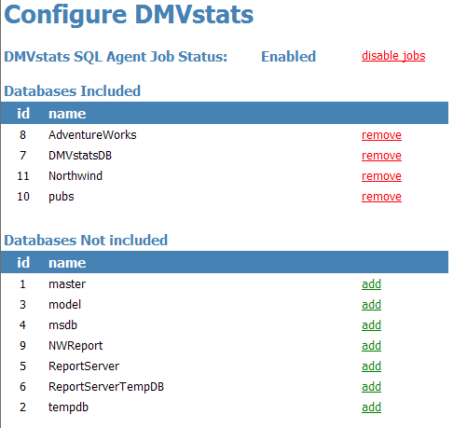

Figure 1: Configure DMVStats

The Util folder also contains sample scripts that can be used instead of the above to enable or disable jobs.

DMV Collection Intervals

Snapshots of DMVs
By default, periodic snapshots of DMVs occur at five-minute intervals. Snapshots are effective for aggregate DMVs such as sys.dm_exec_query_stats or sys.dm_os_wait_stats. The snapshot schedule can be changed to 10-minute intervals as shown:
exec msdb.dbo.sp_update_schedule
@name=N'DMVstats Snapshot Schedule',
@freq_subday_interval=10

Samples of DMVs
Samples are taken more frequently than snapshots. They provide a picture of the highly transient execution model that is made up of sys.dm_exec_requests and sys.dm_os_waiting_tasks. Since sys.dm_os_waiting_tasks show the short term transient waits in the waiter list, samples allow you to associate the Transact-SQL statements to waits in the waiter list. The default sample interval is 20 seconds.

It is recommended that the sample interval not be less than 15 seconds. The sample interval can be changed to 30 seconds as shown:
exec msdb.dbo.sp_update_schedule
@name=N'DMVstats Sample Schedule'
,@freq_subday_type = 2,@freq_subday_interval = 30

Please note that @freq_subday_type=2 is used to set the interval in seconds while @freq_subday_type=4 specifies minutes. The Util folder also contains sample scripts to change the scheduled intervals.

Displaying DMV job schedules
The following SQL statement can be used to display the job schedule for Sample collection. Please note that @freq_subday_type=2 show the interval in seconds while @freq_subday_type=4 are in minutes.

exec msdb.dbo.sp_help_schedule
@schedule_name=N'DMVstats Sample Schedule'

While the SQL Server Management Studio can be used to display job schedule properties, it will only work with @freq_subday_types of 4 (minutes) or 1 (hours). To display job schedule properties with @freq_subday_types of 2 (seconds), use the script above.

The Util folder also contains sample scripts to display job status and intervals.

Baseline
A critical DMVstats concept is the baseline. Analysis reports provided by Reporting Services require the user to define a baseline. Baselines are user-defined aggregations of snapshots over a period of time. That is, baseline=1:N snapshots. You can use baselines may be used for many purposes such as:

- Compare today to yesterday (or any other date and time period)
- Compare performance before and after application changes
- Trending
Use the Configure Baselines report to create a baseline. Baselines consist of one or more snapshots. In the screenshot below, the BL2 baseline was created from snapshots 93 through 105 and covers the time from 9:00 AM to 10:00 AM.

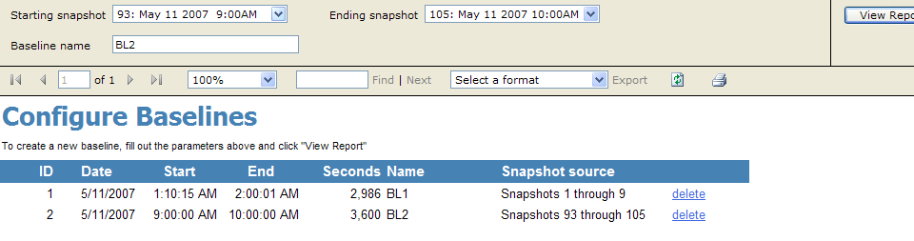

Figure 2: Configure Baselines

The user-defined baseline provides a means to string together a range of snapshots for comparison purposes. Baseline names can also be descriptive. Relationship of Samples, Snapshots, and Baselines are shown below.

Samples | S1 | S2 | S3 | S4 | S5 | S6 | S7 | S 8 | S 9 | S10 | S11 | S12 | S13 | S14 | S15 | S16 | S17 | S18 | S19 | S20 | S21
Snapshots | SS1  11:00 |  |  |  | SS 2  11:05 |  |  |  | SS3  11:10 |  |  |  | SS4  13:00 |  |  |  | SS5  13:05
Baselines | Friday11am_BL |  |  |  |  |  |  |  |  |  |  |  | Friday01pm_BL

Figure 3: Relationship of samples, snapshots, and baselines

Key Concepts

Execution Model
The SQLOS server uses schedulers to manage the execution of user requests. SQLOS schedulers map to CPUs. Assuming server contained four CPUs, there would be four SQLOS schedulers by default. The following diagrams depict a simplified version of execution model using a single SQLOS scheduler. The execution model in Figure 4 shows how SQL Server user requests or sessions (denoted by SPIDs) are scheduled for execution.

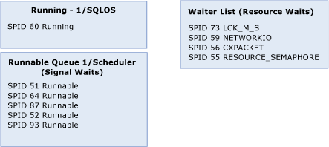

Figure 4: Execution Model – Running, runnable, suspended status, Runnable Queue, Wait List

Figure 5 shows how SQL Server sessions rotate between the following statuses: Running (only one session can be running or executing, per scheduler), Runnable (sessions waiting for CPU), or Suspended. SPIDs with suspended statuses are placed in the wait list until the requested resources are available. If a running session needs a data page that is not in cache, or needs a page that is blocked by another user’s lock, the session is moved to the wait list. The next SPID or session_id in the runnable queue is scheduled to start running.

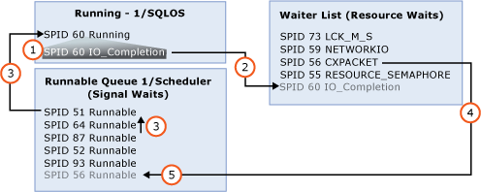

Figure 5: Execution Model – How status changes affect SPIDs

The status change sequence of events is as follows:
- SPID60 needs a page that is not in cache. Its status changes from Running to Suspended with wait type of IO_Completion.
- SPID60 moved to the wait list.
- SPID51 moves from the Runnable queue with a Runnable status to Running status, SPID64 then moves to the top of the Runnable queue.
- SPID56 is waiting for a parallel process to complete. When the parallel process is completed, the status for SPID56 changes from Suspended with wait type CXPACKET to Runnable.
- SPID56 is moved to the bottom of the Runnable queue.

Figure 6 shows execution after session_ids (or SPIDs) have rotated clockwise due to status changes.

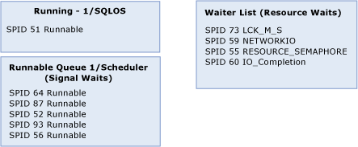

Figure 6: Execution Model – After status change

When a thread has to wait for a resource, it is added to the wait list. Examples of resource waits includes I/Os to complete, a lock to be released, a memory grant, and so on. When the session is moved to the wait list, a wait type is assigned and time is accumulated. When the resource becomes available, the thread is moved to the runnable queue and it executes as soon as the CPU is available. The clockwise rotation between running, runnable and suspended states continues until the user request is completed.

Execution Model DMVs

Sys.dm_exec_requests
Each SQL Server session has a unique session_id in the system DMV sys.dm_exec_requests. The sp_who2 stored procedure provides a list of these sessions in addition to other connection information such as command, resource, wait types, wait time, and status. User queries have a session_id > 50. Common status values are Running, Runnable, and Suspended, as described in the Execution Model section above. A session status of Sleeping indicates that SQL Server is waiting for the next SQL Server command.

Wait List - sys.dm_os_waiting_tasks
The wait list that shows all waiting sessions and the reasons for the waits is in the sys.dm_os_waiting_tasks DMV. You can see the session_id, wait type, and associated wait time. In addition, if the session is blocked from acquiring a lock, the session holding (known as blocking) the lock as well as the blocked resource is shown in the blocking_session_id and resource columns.

All currently running SQL requests shown in figures 4-6 are contained in the sys.dm_exec_requests DMV. The subset of those requests that are waiting for resources in the wait list sys.dm_os_waiting_tasks will also have a status of Suspended in sys.dm_exec_requests.

The key execution model DMVs, sys.dm_exec_requests and sys.dm_os_waiting_tasks, can be highly transient. Tracking down highly transient waits requires small sample intervals.

Sys.dm_os_wait_stats
Sys.dm_os_wait_stats is the DMV that contains wait statistics, which are aggregated across all session ids since the last restart of SQL Server or since the last time that the wait statistics were reset manually using:
DBCC SQLPERF ('sys.dm_os_wait_stats', CLEAR).
Resetting wait statistics can be helpful before running a test or workload.

Any time a session_id waits for a resource, the session_id is moved to the waiter list along with an associated wait type. The sys.dm_os_waiting_tasks DMV shows the wait list at a given moment in time. Waits for all session_ids are aggregated in sys.dm_os_wait_stats.

Real-Time DMVs
Some DMVs provide real-time data whereas others contain historical information. The execution model described above in terms of Running, Runnable, and Suspended statuses are examples of real-time data.

Those requests with a status of Runnable are waiting only for CPU. Thus, the time spent in the runnable queue (also known as signal waits) is a measure of CPU pressure. Other requests in sys.dm_exec_requests having a Suspended status are detailed in sys.dm_os_waiting_tasks (also known as the waiter list). The time spent in the wait list is known as resource waits. Requests in the wait list are due to other resource issues (such as I/O, locks, memory allocation, or network) but not CPU.
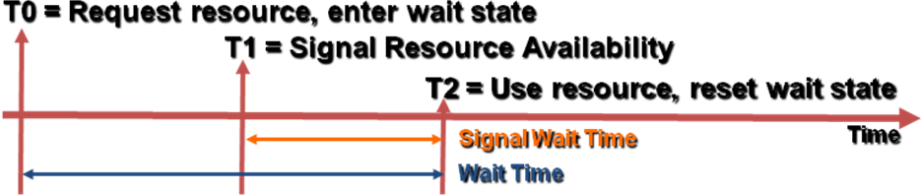

Figure 7: Resource, Signal and Total Wait time

One request can quickly cycle from a Running status, to Suspended (wait list), to Runnable and back to Running status multiple times before the query completes. The advantage of capturing the wait list is that it allows us to associate wait statistics with individual requests.

When Signal wait begins (at T1) the resource wait is over, and the session_id is moved to the runnable queue with a Runnable status. Signal wait time includes the time it takes to move up the runnable queue to a Running status. After the signal occurs at T1, you are waiting to get scheduled back to a Running status. The session_id is running at T2 so the total wait time is the sum of resource and signal waits. To determine the extent to which CPU plays a role in performance, you must compare signal waits to resource waits. High signal (signal accounts for more than 25 percent of total waits) waits indicates CPU pressure.

Historical DMV Statistics
In contrast to the execution model’s real-time transient status changes shown in sys.dm_exec_requests and sys.dm_os_waiting_tasks, aggregated historical query stats for Transact-SQL statements including execution counts, I/Os, worker time, and elapsed time are maintained in sys.dm_exec_query_stats. Waits other than I/O and Worker (approximates CPU) time, and elapsed time are not available at the statement level in sys.dm_exec_query_stats.

Note that statements that are currently executing in sys.dm_exec_requests will not be reflected in sys.dm_exec_query_stats until the query completes. So if a batch job executes for three hours, the stats associated are not updated until the query completes three hours later. Therefore, to understand current bottlenecks such as high CPU, long I/Os, and network or lock waits, you must look at sys.dm_exec_requests.

From the last time SQL Server was restarted, sys.dm_exec_query_stats contains aggregates of query executions. After each query completes, sys.dm_exec_query_stats is aggregated with additional I/Os, executions, worker time, and elapsed time. Unless memory pressure forces query plans to be evicted, query stats will be continuously aggregated until the next time SQL Server is restarted.

To answer historical questions of what queries executed last week, you would need to compare snapshots of sys.dm_exec_query_stats, subtracting execution counts, I/Os, worker and elapsed times. The limitation to this approach is that the association of transient wait states from the execution model sys.dm_exec_requests (and waiter lists in sys.dm_os_waiting_tasks) to individual Transact-SQL statements cannot be made without capturing and comparing these DMVs.

How to use DMVstats

Configure DMVstats
The first step is to configure DMVstats using the Configure DMVstats report. First, specify databases to monitor, then enable DMVStats jobs to collect DMV statistics.
While DMVstats reports can be deployed on any computer, the SQL Agent jobs and DMVstatsDB database should reside on the same computer as the databases you are monitoring. For more information, see the Getting Started section.

Configure Baselines
After collecting DMVstats, the next step is to create a baseline using the Configure Baselines report. For more information, see the Getting Started section.

Wait Stats
After configuring the baselines, the next step is to analyze the data using the Wait Stats report which contains two graphs. The first graph compares signal (time in the runnable queue) to resource waits (time in the wait list) - See Figure 8 below. The second graph breaks down waits by category. Wait Stats can be summarized for the baseline, or shown in more detail with snapshots.

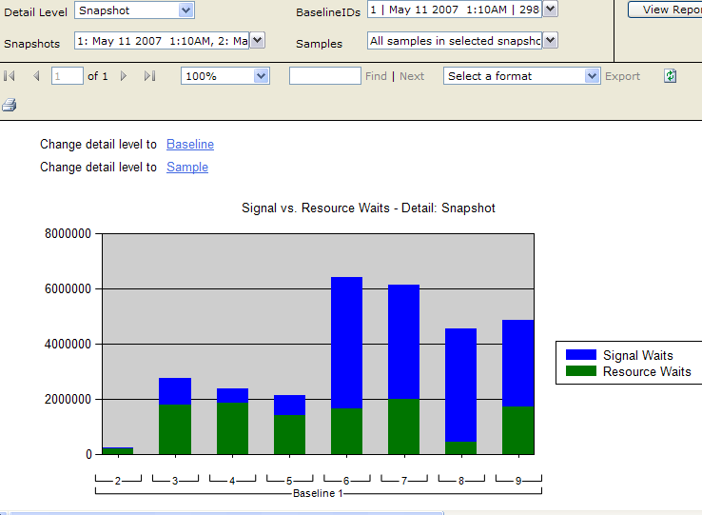

Figure 8: Wait Stats: Signal vs. Resource

Signal waits start to rise significantly during snapshot 6. To see what queries are using the most CPU during snapshot 6, you can drill into the area in blue.

Wait Stats: Wait Categories
There are approximately 200 wait types in SQL Server 2005, organized into 14 categories. The following graph shows the breakdown of waits by snapshot for Baseline 1.

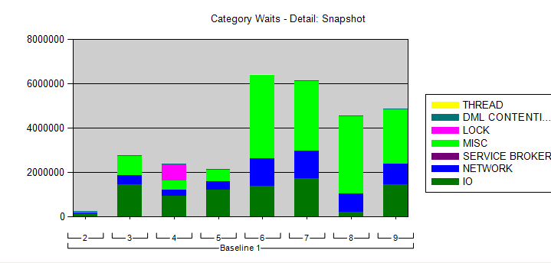

Figure 9: Category waits detail snapshot

Locking waits appear in snapshot 4. To find the statements that can be associated with these lock waits, drill into the pink area of snapshot 4.

Drill-Through Guidance
When you drill into a wait type of the Wait Stats report, you will see the Drill-through Guidance report. Because the wait category you are drilling into is LOCK from the above graph, Drill Through Guidance will display choices for locking.

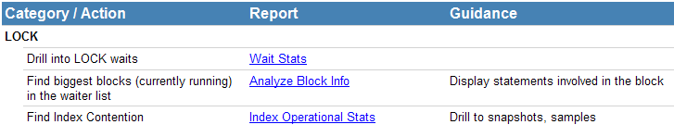

Figure 10: Drill-through guidance report

Selecting the Analyze Block Info report displays the statements involved in LOCK waits, collected from the execution model wait list DMV sys.dm_os_waiting_tasks. These statements were captured during sample collection. Note the waiting and blocking statements along with the associated baseline, snapshot and sample IDs.

The same drill-through approach also works with all the other wait categories.

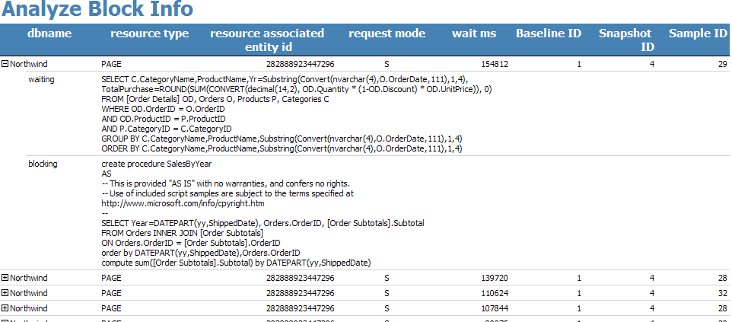

Figure 11: Analyze Block Info report

The Index Operational Stats link displays index contention. Here you can see which indexes have the most contention as measured by lock requests and lock waits.

DMV schemas
These are four main schemas – DMVsnapshot, DMVbaseline, DMVsample, and DMVconfig.

DMV data collection
The automatic collection creates snapshots of the DMV data at given points in time. Regularly scheduled DMV snapshots will include the following six tables:
Description | Table name | Performance issue
File statistics | virtual_file_stats | Database I/O, stalls
Operational index statistics | index_operational_stats | Blocks, hot spots
Query statistics | query_stats | Min, max, average worker and elapsed time, I/O
Wait statistics | wait_stats | Resource and CPU waits (cross reference to performance counters)
Performance counters | performance_counters | Resource capacity and usage
Instrumentation | instrumentation | Records each DMV collection

Table 1: DMV snapshots

Each of the DMV snapshot tables can be rolled up into baselines for Reporting Services analysis reports. The control table for snapshot tables is DMVsnapshot.snapshots and DMVbaseline.baselines for baseline tables. The main purpose of the baseline is for reference, comparison, and trending. Typically, baselines will be compared to other baselines.

Regularly scheduled DMV samples are used to associate transient waits to SQL statements. DMV samples include the following six tables:
Description | Table name | Performance issue
Requests and waiters | requests_and_waiters | User requests currently executing from sys.dm_exec_requests and the wait list from sys.dm_os_waiting_tasks
Blocking | block_info | Finds statements involved in blocking
Schedulers | schedulers | Min, max, average worker and elapsed time, I/O
Wait statistics | wait_stats | Waits, CPU pressure (cross reference to performance counters)
Performance counters | performance_counters | Resource capacity and usage
Instrumentation | instrumentation | Records each DMV collected for overhead purposes

Table 2: DMV samples

Figure 12: DMVsnapshot schema: collects aggregated DMVs

Figure 13: DMVbaseline schema: user-defined collection of snapshots

Figure 14: DMVsample schema: associates transient waits to Transact-SQL statements

Figure 15: DMVconfig Schema: DMVstats configuration

Q&A
- What is the overhead of DMVstats?

The overhead of DMVstats depends on:

- The size of the workload. If the workload is light, DMVstats data collection will account for a larger percentage of overhead compared with the workload.
- The snapshot interval. By default, the snapshot interval is set to five minutes. This means that every five minutes, DMV statistics are inserted into the snapshot tables. Longer snapshot intervals can reduce the overhead.
- The sample interval. The default sample interval is 20 seconds. This means that every 20 seconds, transient execution model DMVs such as sys.dm_exec_requests and sys.dm_os_waiting_tasks are inserted into the sample tables. The 20 second interval allows the association of transient execution model waits to individual Transact-SQL statements. Longer sample intervals can reduce the overhead, but will also reduce the likelihood of associating statements to transient waits.

The rows inserted for wait statistics will be constant for each collection (sample or snapshot). There are 200 wait types; so each wait stats collection inserts 200 rows.

While wait statistics consistently inserts 200 rows for each collection, the rows inserted for other DMV statistics depends on other factors such as object counts. For example, for virtual_file_stats, how many files do you have? There will be one row written for each file. For index_operational_stats, there is one row written for each index. The rows inserted for query stats are affected by the workload and stored procedure (and ad-hoc Transact-SQL) counts, for example.

If you are not tracking down transient execution model waits such as statements involved in locking, or what statements use the most memory, you could set the sample interval higher, for example to 60 seconds.

- What is a baseline? What is it used for?

A baseline is a user-specified collection of snapshots that define a workload for a certain duration of time. In other words, there are one or more snapshots in a baseline. Baseline = 1:N contiguous snapshots.

For example, a Monday morning baseline would consist of all snapshots taken on Monday between 8:00 AM and 12:00 noon. This baseline can then be compared to other baselines, or it can be analyzed individually.

